
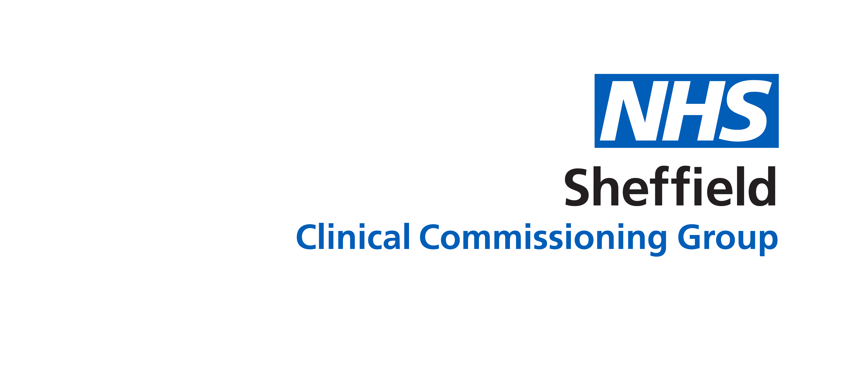
Annual Public Meeting 11 July 2019
Evaluation Form

(Could you please take a few minutes to complete this form
and place it in the box on the reception desk)

Please rate the overall event: | Poor | Fair | Good | Excellent
Venue
Welcome presentation and introduction to the event
Market Place
Overall Evaluation
Would you attend another one of these events? | YES |  | NO  Maybe
Do you have a preference for the timing of this meeting? | 10-12am 2-4pm 6-8pm

The aims of today’s event were:

- To advise you on what we have accomplished in 2018/19.
- To update you on key pieces of work.
- To give you an opportunity to ask questions.
How successful were we in meeting those aims?


1 2 3 4 5 6

Where did you hear about this event?

- CCG website

- Twitter

- Facebook

- Poster

- Email

- Word of mouth

- Other

Any other comments:

‘THANK YOU’

