Prescription Order Line Annual Survey 2018
Introduction
The POL survey was run over a two week period during November 2018. On the hour between 9am and 3pm, staff from the Medicines Optimisation Team asked the caller if they would be happy to take part in the survey. During this time 46 patients completed the survey over the telephone, a further 132 questionnaires were mailed out (of these we have received 66 completed questionnaires). 26 patients preferred not to take part in the survey.
Overview - Findings
Demographics
- The majority of respondents were female 67% (75 / 112).
- The majority of respondents were White/ White British – 96% (108 / 112).
- Of those providing an age, concentration of respondents were aged between 45 and 84 years (95/107).

- Largest cohort of respondents came from Birley Surgery (20/112).

Using the service
- 72% of respondents (81/112) had used the service more than 10 times.
- 73% of respondents (82/112) used the service for prescriptions for themselves.
- 75% of respondents (84/112) would be extremely likely to recommend the service to friends and family (21% likely to recommend). No one was unlikely to recommend the service.
- 95% of respondents (106/112), always use the service for their repeat prescriptions).
- 88 respondents agree that using the telephone is most convenient.

Note: respondents could choose more than one reason.

Under the reason ‘other’,
- It's easy and simple
- Practice website is not very good
- It's quicker than going to the doctors. A lot quicker.
- Simple to do
- Because it's easier
- Didn't know could order online.
- We are ordering on behalf of patients who struggle to order prescriptions (pharmacy)
- I like using the telephone
- Used to have to ring doctors. Didn't always get through. It was only open until 10, very short window.
- Don't want to get in a queue at reception at GP practices. It is better for them and better for me.
- Quicker on order line than anything else.
- Can't park near doctors, enjoy ringing
- My prescription is for life as I have epilepsy
- Have to drive to surgery, not convenient with wife suffering health problems.
- I didn't know I could order online.

Conclusion

The POL service is liked by most and provides an efficient alternative to visiting the surgery or going online to request repeat prescriptions. Patients appreciate the friendliness and helpfulness of the staff. Sometimes having to wait to get through is a recognised and expected occurrence, in most cases patients know when is best to phone.

Of the comments provided, just 3% were not happy with the service.

Additional information – Selection of Comments taken from the survey

User Comments

Staff
72 respondents provided additional comments on why they would recommend the service. In the main the comments were positive, with call handlers being referred to as friendly and helpful.

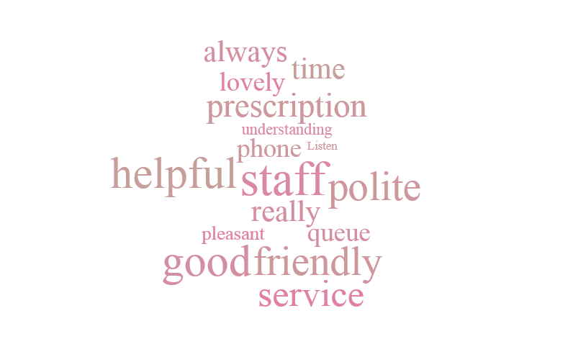

Waiting on the line

For the first part of the service - getting through on the phone - would not recommend. Once you get through - good service -…..

Sometimes it takes a while to get through but it's a prescription order line, everyone is trying to ring at the same time, so I accept that….

While waiting in the "queue" on the phone, would like to know the position in that "queue" a little more often!

…Sometimes queue (i.e. demand is high) to talk to operative however busy times are explained (by pre-recorded message) and place explained in queue…

It was acknowledged that there were waits to get through to the service

You've just got to pick your time. If you phone in the middle of the day you don't have much problem. I rang today for instance, I was only minutes getting through but that was at 11. If you phone at 9 you might be 6 or 7 minutes getting through.

If you ring early in the day you are in a long queue. So I wait until around lunchtime and you are through straight away!

Suggestions/ Issues

I used to use the repeat prescription service that I think was the Porter Brook Medical Centre's own service. It was completely automated, all I need to do was leave a recorded answerphone message. There was no queuing on the phone and I could call it 24 hours a day, 7 days a week. Now we have to use this service instead. I can only call up in the daytime, and usually have to queue on the phone for five minutes. Simply put, the new service is worse - worse customer service.

There were a few negative comments/ issues

Ladies spoken to nice. Prefer to order from doctor as they know me, it's what I'm used to doing.

The only issue I've had is when you say the order has gone through, but the chemist says it needs a Dr. review.

Waiting time 3 hours in which can order could be improved.

Would prefer more opening hours. Would prefer until 6

