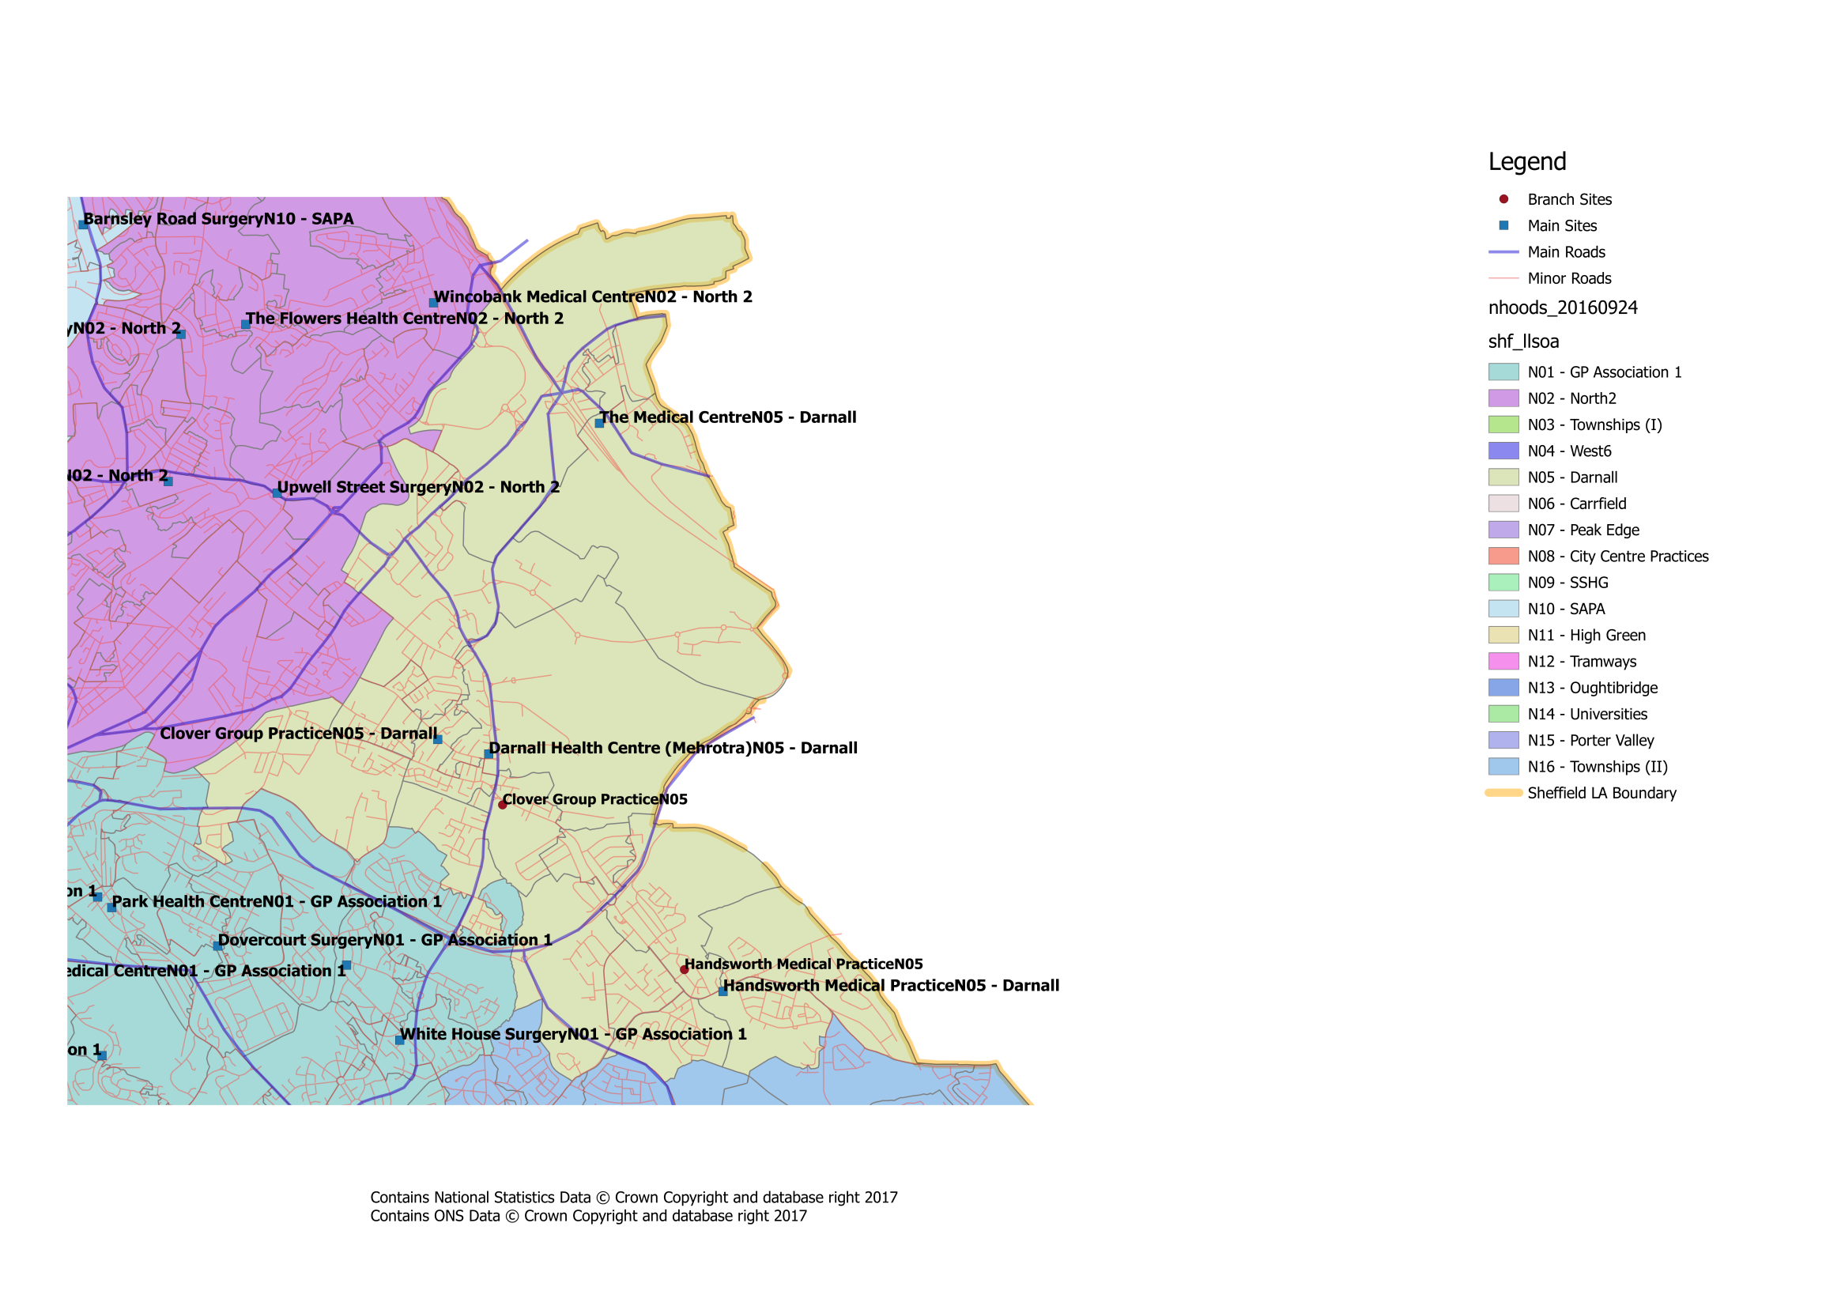
Where is our Neighbourhood?


What about patient travel?
To ensure that the proposed changes made access to services equitable across the city, the travel times between practices within a neighbourhood, as well as to current/proposed central services have been investigated. Within our neighbourhood the likely travel times for patients would be:

Darnall - Travel Times
GP Practice | Postcode | Car time to Darnall PCC | Bus time to Darnall PCC | Bus/Tram Nos | Bus/Tram Frequency | Car time to Darnall Health Centre (Mehrotra) | Bus time to Darnall Health Centre (Mehrotra) | Bus/Tram Nos. | Bus/Tram Frequency | Car time to Fitzalan | Bus time to Fitzalan | Bus/Tran Nos. | Bus/Tram Frequency | Car time to Handsworth Medical Centre | Bus time to Handsworth Medical Centre | Bus/Tram Nos. | Bus/Tram Frequency | Car time to Highgate | Bus time to Highgate | Bus/Tram Nos. | Bus/Tram Frequency | Car time to Minor Injuries Unit | Bus time to Minor Injuries Unit | Bus/Tram Nos. | Bus/Tram Frequency | Car time to NGH | Bus time to NGH | Bus/Tram Nos. | Bus/Tram Frequency | Car time to The Medical Centre | Bus time to The Medical Centre | Bus/Tram Nos. | Bus/Tram Frequency | Car time to WIC | Bus time to WIC | Bus/Tram Nos. | Bus/Tram Frequency
Darnall Primary Care Centre | S9 4QH |  |  |  |  | 2 | N/A | N/A | N/A | 6 | 10 | 52,52a | 5 | 7 | 10 | 52, 52a | 10 | 11 | 40 | X1 52 | 12 | 21 | 33 | 52,52a | 5 | 15 | 28 | 52,1A | 10 | 12 | 33 | 52, Yellow | 5,10 | 14 | 12 | 52,52a | 5
Darnall Health Centre (Mehrotra) | S9 5DH | 2 | N/A | N/A | N/A |  |  |  |  | 8 | 15 | 52,52a | 5 | 7 | 13 | 52, 52a | 5 | 10 | 43 | X1 52 | 12 | 19 | 34 | 52,52a | 5 | 15 | 39 | 52,1 | 5 | 7 | 41 | 52, Yellow | 5,10 | 14 | 28 | 52, 52a | 5
Fitzalan Surgery (Handsworth) | S13 9AW | 6 | 10 | 52,52a | 5 | 8 | 15 | 52,52a | 5 |  |  |  |  | 4 | N/A | N/A | N/A | 15 | 33 | 72 | 12 | 20 | 44 | 52,52a | 5 | 22 | 55 | 52,1 | 6 | 15 | 35 | 72 | 10 | 15 | 37 | 52, 52a | 5
Handsworth Medical Centre | S13 9BZ | 7 | 10 | 52,52a | 5 | 7 | 13 | 52 | 5 | 4 | N/A | N/A | N/A |  |  |  |  | 15 | 31 | 72 | 10 | 20 | 42 | 52,52a | 5 | 21 | 50 | 72,1 | 12 | 13 | 47 | 52, Yellow | 5,10 | 14 | 36 | 52, 52a | 5
Highgate Surgery | S9 1WN | 11 | 40 | X1 52 | 12 | 10 | 43 | X1 52 | 12 | 15 | 33 | 72 | 12 | 15 | 31 | 72 | 10 |  |  |  |  | 25 | 45 | Yellow | 10 | 16 | 40 | 72 , 15 | 10 | 2 | 1 | N/A | N/A | 25 | 34 | Yellow | 10
Minor Injuries Unit | S10 2SZ | 21 | 33 | 52,52a | 5 | 19 | 34 | 52, 52a | 5 | 20 | 44 | 52,52a | 5 | 20 | 42 | 52, 52a | 5 | 25 | 45 | Yellow | 10 |  |  |  |  | 18 | 47 | 51,1 | 5 | 27 | 45 | Yellow | 10 | 9 | 12 | 51 | 5
Northern General Hospital | S5 7AU | 15 | 28 | 52,1A | 10 | 15 | 39 | 52,1 | 5 | 22 | 55 | 52,1 | 6 | 21 | 50 | 72,1 | 12 | 16 | 40 | 72 , 15 | 10 | 18 | 47 | 51,1 | 5 |  |  |  |  | 16 | 52 | Yellow, 83 | 20 | 16 | 41 | 88 | 10
The Medical Centre | S9 1WZ | 12 | 33 | 52, Yellow | 12 | 7 | 41 | 52, Yellow | 20 | 15 | 35 | 72 | 10 | 13 | 47 | 52, Yellow | 5,10 | 2 | 1 | N/A | N/A | 27 | 45 | Yellow | 10 | 16 | 52 | Yellow, 83 | 20 |  |  |  |  | 21 | 33 | Yellow | 10
Walk In Centre | S1 3PB | 14 | 12 | 52,52a | 5 | 14 | 28 | 52, 52a | 5 | 15 | 37 | 52, 52a | 5 | 14 | 36 | 52 | 5 | 25 | 34 | Yellow | 10 | 9 | 12 | 51 | 5 | 16 | 41 | 88 | 10 | 21 | 33 | Yellow | 10

All times are estimates only and may be subject to variation based on a number of factors (e.g. traffic, service disruption) Times/Frequencies highlighted in green indicate there may be quicker/more frequent services but the overall journey was deemed to be worse than alternatives All travel times based on Google Maps estimates during Weekday Daytime Entries with “N/A” indicate that it is significantly quicker to walk, else there is no viable public transport route

