

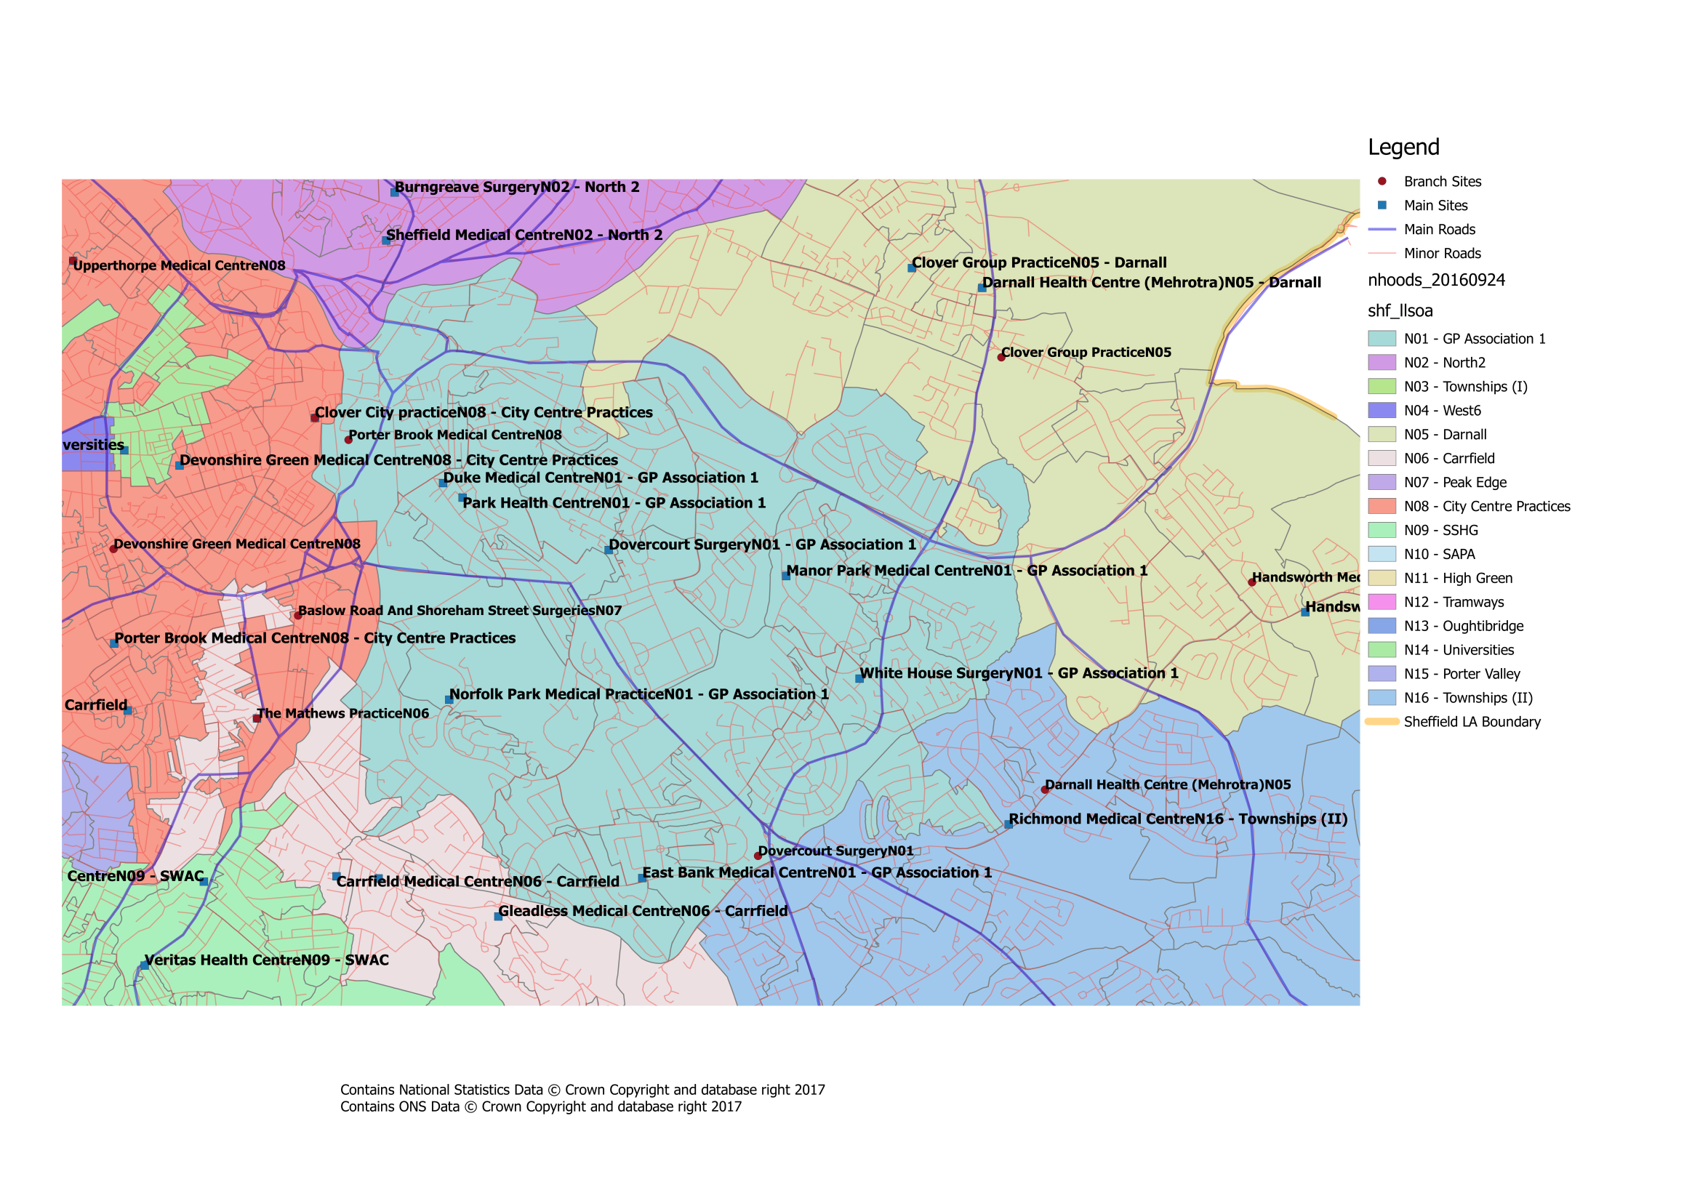
Where is our Neighbourhood?

What about patient travel?
To ensure that the proposed changes made access to services equitable across the city, the travel times between practices within a neighbourhood, as well as tocurrent/proposed central services have been investigated. Within our neighbourhood the likely travel times for patients would be:

GPA1 Travel Times
GP Practice | Postcode | Car time to Dovercourt Surgery | Bus time to Dovercourt Surgery | Bus/Tram Nos. | Bus Frequency | Car time to Duke Medical Centre | Bus time to Duke Medical Centre | Bus/Tram Nos. | Bus Frequency | Car time to East Bank Medical Centre | Bus time to East Bank Medical Centre | Bus/Tram Nos. | Bus Frequency | Car time to Manor Park Medical Centre | Bus time to Manor Park Medical Centre | Bus/Tram Nos. | Bus Frequency | Car time to MIU | Bus time to MIU | Bus/Tram Nos. | Bus Frequency | Car time to Norfolk Park Health Centre | Bus time to Norfolk Park Health Centre | Bus/Tram Nos. | Bus Frequency | Car time to NGH | Bus time to NGH | Bus/Tram Nos. | Bus Frequency | Car time to Park Health Centre | Bus time to Park Health Centre | Bus/Tram Nos. | Bus Frequency | Car time to White House Surgery | Bus time to White House Surgery | Bus/Tram Nos. | Bus Frequency | Car time to WIC | Bus time to WIC | Bus/Tram Nos. | Bus Frequency
Dovercourt Surgery | S2 5FX |  |  |  |  | 4 | 13 | 120 | 5 | 6 | 25 | 120 | 5 | 4 | 18 | 50 | 5 | 15 | 36 | 120 | 5 | 4 | 21 | 50,Blue | 5,10 | 19 | 44 | 120.1 | 5,10 | 3 | 11 | 120 | 5 | 5 | 19 | 24/25 | 10 | 15 | 27 | 120 | 5
Duke Medical Centre | S2 2TD | 4 | 13 | 120 | 5 |  |  |  |  | 7 | 22 | 120 | 5 | 6 | 21 | 24/25 | 10 | 15 | 25 | 120 | 5 | 5 | 20 | Blue | 10 | 18 | 30 | 120,1 | 5,10 | 1 | N/A | N/A | N/A | 7 | 24 | 120 | 5 | 12 | 16 | 120 | 5
East Bank Medical Centre | S2 2AG | 6 | 25 | 120 | 5 | 7 | 22 | 120 | 5 |  |  |  |  | 7 | 18 | 10A | 60 | 20 | 38 | 51/51A | 10 | 3 | N/A | N/A | N/A | 19 | 48 | 51,1 | 5,10 | 6 | 20 | 120 | 5 | 6 | 32 | 51,25 | 5,10 | 13 | 30 | 51 | 5
Manor Park Medical Centre | S2 1QU | 4 | 18 | 120 | 5 | 6 | 21 | 24/25 | 10 | 7 | 18 | 10A | 60 |  |  |  |  | 20 | 28 | 25.52/52A | 10,5 | 6 | 21 | Blue | 10 | 16 | 30 | 25,2 | 10,10 | 6 | 15 | 24/25 | 10 | 2 | 3 | 25 | 10 | 12 | 29 | 25 | 10
Minor Injuries Unit | S10 2SZ | 15 | 36 | 120 | 5 | 15 | 25 | 120 | 5 | 20 | 38 | 51/51A | 10 | 20 | 28 | 25.52/52A | 10,5 |  |  |  |  | 30 | 26 | Blue | 10 | 12 | 31 | H1 | 30 | 24 | 32 | 120 | 5 | 24 | 44 | Blue | 10 | 8 | 12 | 52 | 10
Norfolk Park Health Centre | S2 3TA | 4 | 21 | 50,Blue | 5,10 | 5 | 20 | Blue | 10 | 3 | N/A | N/A | N/A | 6 | 21 | Blue | 10 | 30 | 26 | Blue | 10 |  |  |  |  | 20 | 41 | 1/1A | 10 | 4 | 17 | Blue | 10 | 6 | 21 | Blue | 10 | 20 | 17 | Blue | 10
Norther General Hospital | S5 7AU | 19 | 44 | 120.1 | 5,10 | 18 | 30 | 120,1 | 5,10 | 19 | 48 | 51,1 | 5,10 | 16 | 30 | 25,2 | 10,10 | 12 | 31 | H1 | 30 | 20 | 41 | 1/1A | 10 |  |  |  |  | 14 | 30 | 120,2 | 5,10 | 18 | 41 | 25,1 | 10,10 | 11 | 35 | 1/1A | 10
Park Health Centre | S2 5QQ | 3 | 11 | 120 | 5 | 1 | N/A | N/A | N/A | 6 | 20 | 120 | 5 | 6 | 15 | 24/25 | 10 | 24 | 32 | 120 | 5 | 4 | 17 | Blue | 10 | 14 | 30 | 120,2 | 5,10 |  |  |  |  | 7 | 20 | 120 | 5 | 15 | 16 | 120 | 5
White House Surgery | S2 1SL | 5 | 19 | 24/25 | 10 | 7 | 24 | 120 | 5 | 6 | 32 | 51,25 | 5,10 | 2 | 5 | 25 | 10 | 24 | 44 | Blue | 10 | 6 | 21 | Blue | 10 | 18 | 41 | 25,1 | 10,10 | 7 | 20 | 120 | 5 |  |  |  |  | 19 | 32 | 25 | 10
Walk In Centre | S1 3PB | 15 | 27 | 120 | 5 | 12 | 16 | 120 | 5 | 13 | 30 | 51 | 5 | 12 | 29 | 25 | 10 | 8 | 12 | 52 | 10 | 20 | 17 | Blue | 10 | 11 | 35 | 1/1A | 10 | 15 | 16 | 120 | 5 | 19 | 32 | 25 | 10

All times are estimates only and may be subject to variation based on a number of factors (e.g. traffic, service disruption) Times/Frequencies highlighted in green indicate there may be quicker/more frequent services but the overall journey was deemed to be worse than alternatives All travel times based on Google Maps estimates during Weekday Daytime Entries with “N/A” indicate that it is significantly quicker to walk, else there is no viable public transport route

