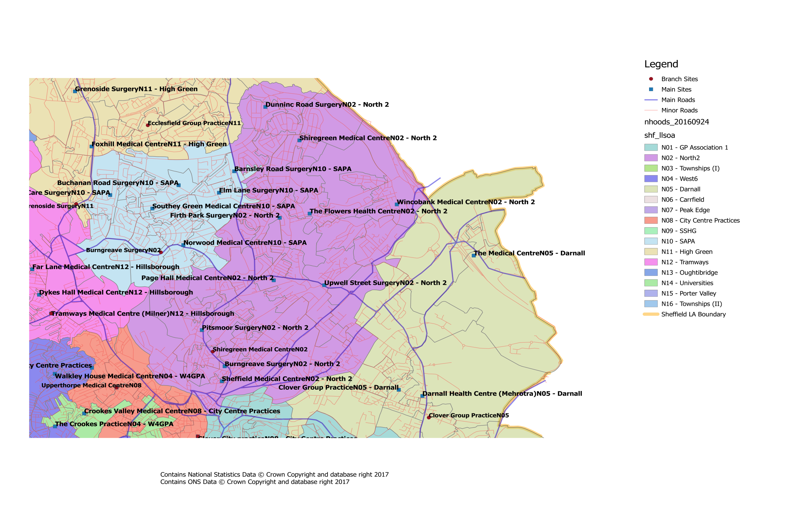
Where is our Neighbourhood?

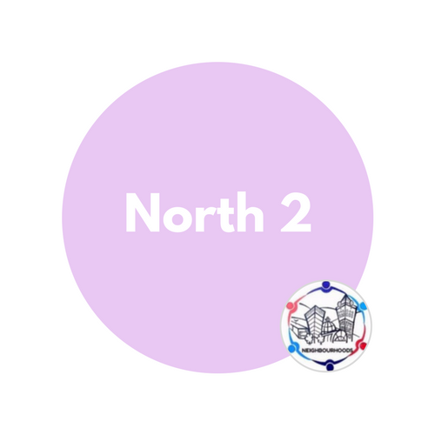

What about patient travel?
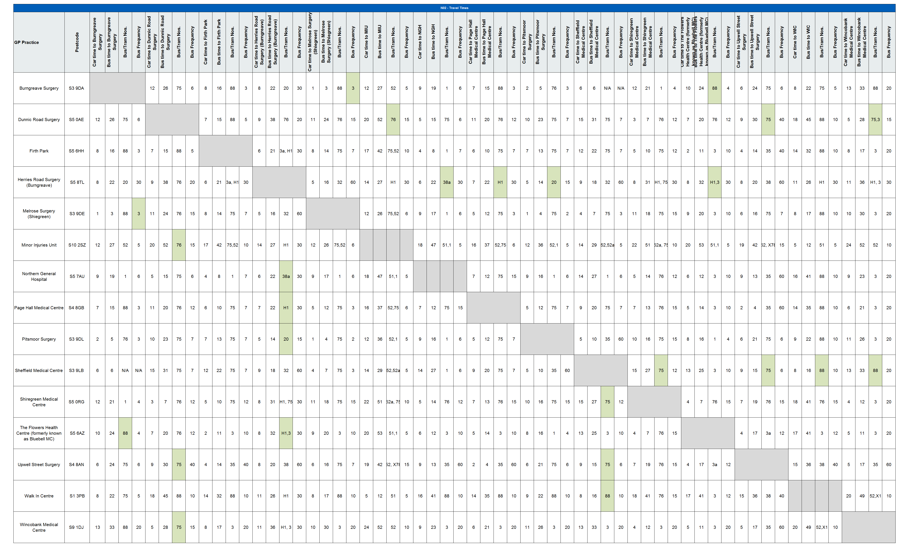
To ensure that the proposed changes made access to services equitable across the city, the travel times between practices within a neighbourhood, as well as to current/proposed central services have been investigated. Within our neighbourhood the likely travel times for patients would be:

All times are estimates only and may be subject to variation based on a number of factors (e.g. traffic, service disruption) Times/Frequencies highlighted in green indicate there may be quicker/more frequent services but the overall journey was deemed to be worse than alternatives All travel times based on Google Maps estimates during Weekday Daytime Entries with “N/A” indicate that it is significantly quicker to walk, else there is no viable public transport route

