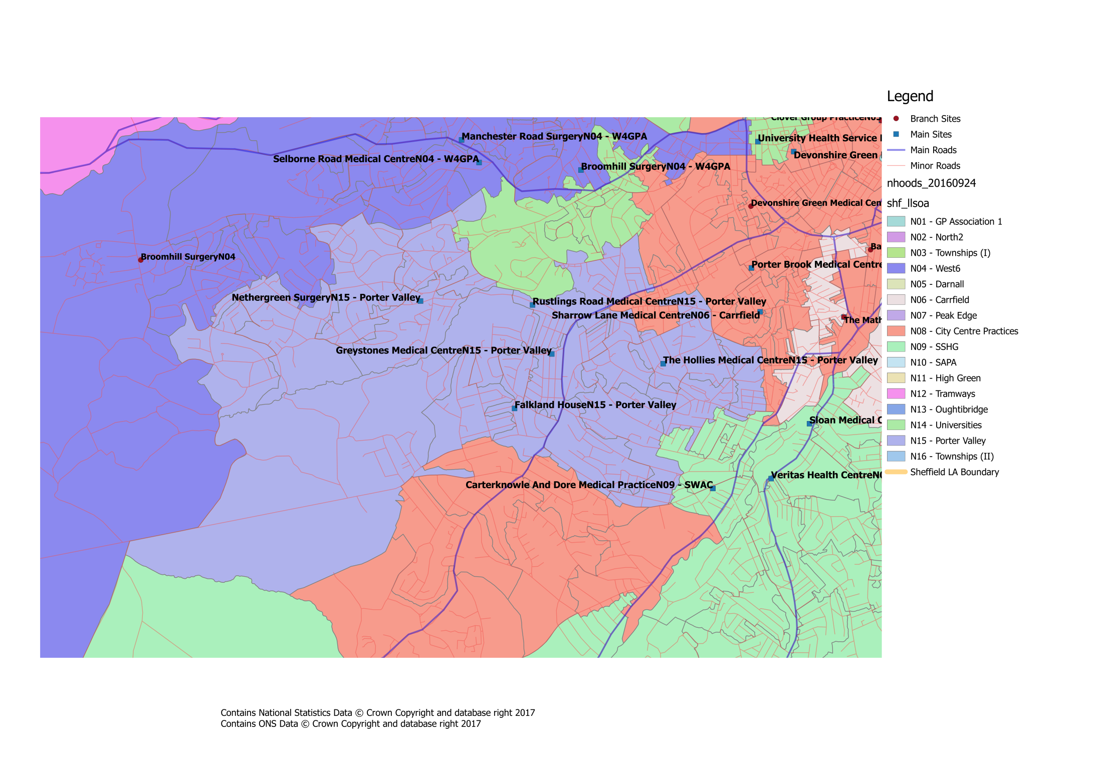


Where is our Neighbourhood?

What about patient travel?
To ensure that the proposed changes made access to services equitable across the city, the travel times between practices within a neighbourhood, as well as to current/proposed central services have been investigated. Within our neighbourhood the likely travel times for patients would be:

N16 - Travel Times
GP Practice | Postcode | Car time to Birley Health Centre | Bus time to Birley Health Centre | Bus/Tram Nos. | Bus/Tram Frequency | Car time to Charnock Health PC Centre | Bus time to Charnock Health PC Centre | Bus/Tram Nos. | Bus/Tram Frequency | Car time to Hackenthorpe Med Centre | Bus time to Hackenthorpe Med Centre | Bus/Tram Nos. | Bus/Tram Frequency | Car time to Jaunty Springs Health Centre | Bus time to Jaunty Springs Health Centre | Bus/Tram Nos. | Bus/Tram Frequency | Car time to MIU | Bus Time to MIU | Bus/Tram Nos. | Bus/Tram Frequency | Car time to NGH | Bus Time to NGH | Bus/Tram Nos. | Bus/Tram Frequency | Car time to Richmond Medical Centre | Bus time to Richmond Medical Centre | Bus/Tram Nos. | Bus/Tram Frequency | Car time to Stonecroft Medical Centre | Bus time to Stonecroft Medical Centre | Bus/Tram Nos. | Bus/Tram Frequency | Car time to The Mathews Practice | Bus time to The Mathews Practice | Bus/Tram Nos. | Bus/Tram Frequency | Car time to WIC | Bus Time to WIC | Bus/Tram Nos. | Bus/Tram Frequency | Car time to Woodhouse Health Centre | Bus time to Woodhouse Health Centre | Bus/Tram Nos. | Bus/Tram Frequency
Birley  Health Centre | S12 3BP |  |  |  |  | 4 | 5 | Blue | 10 | 5 | 14 | Blue | 10 | 5 | N/A | N/A | N/A | 26 | 40 | Blue | 10 | 29 | 43 | Blue, 75 | 10,15 | 7 | 25 | Blue | 10 | 4 | N/A | N/A | N/A | 5 | N/A (Walk) | N/A | N/A | 24 | 28 | Blue | 10 | 15 | 26 | Blue, 7 | 10,10
Charnock Health PC Centre | S12 3GH | 4 | 5 | Blue | 10 |  |  |  |  | 10 | 14 | Blue | 10 | 3 | N/A | N/A | N/A | 27 | 40 | Blue | 10 | 30 | 45 | Blue,75 | 10, 15 | 8 | 23 | 8 | 20 | 2 | N/A | N/A | N/A | 3 | N/A | N/A | N/A | 24 | 28 | Blue | 10 | 14 | 26 | Blue, 7 | 10,10
Hackenthorpe Med Centre | S12 4LA | 5 | 14 | Blue | 10 | 10 | 14 | Blue | 10 |  |  |  |  | 9 | 19 | 8 | 20 | 36 | 56 | 120 | 5 | 27 | 58 | Blue, 97 | 10,10 | 7 | 26 | 120 | 5 | 8 | 21 | Blue | 10 | 9 | 22 | Blue | 10 | 31 | 44 | Blue | 10 | 7 | 38 | 120,7 | 5,10
Jaunty Springs Health Centre | S12 3DZ | 5 | N/A | N/A | N/A | 3 | N/A | N/A | N/A | 9 | 19 | 8 | 20 |  |  |  |  | 28 | 53 | 51 | 10 | 30 | 48 | 8, 1 | 20, 10 | 6 | 16 | 8 | 20 | 3 | N/A | N/A | N/A | 3 | N/A | N/A | N/A | 26 | 38 | Blue | 10 | 10 | 26 | 8,7 | 20,10
Minor Inuries Unit | S10 2SZ | 26 | 40 | Blue | 10 | 27 | 40 | Blue | 10 | 36 | 56 | 120 | 5 | 28 | 53 | 51 | 10 |  |  |  |  | 12 | 31 | H1 | 30 | 20 | 50 | 120 | 5 | 19 | 40 | 51 | 5 | 20 | 42 | 51 | 5 | 8 | 12 | 52 | 10 | 22 | 46 | 95,7 | 10,10
Northern General Hospital | S5 7AU | 29 | 43 | Blue, 75 | 10,15 | 30 | 45 | Blue,75 | 10, 15 | 27 | 58 | Blue, 97 | 10,10 | 30 | 48 | 8,1 | 20, 10 | 12 | 31 | H1 | 30 |  |  |  |  | 19 | 41 | 97,25 | 10,10 | 20 | 42 | 20,Blue | 20,10 | 21 | 43 | 20,Blue | 20,10 | 11 | 35 | 1/1A | 10 | 20 | 60 | 97,25 | 10,10
Richmond Medical Centre | S13 8NA | 7 | 25 | Blue | 10 | 8 | 23 | 8 | 20 | 7 | 26 | 120 | 5 | 6 | 16 | 8/8A | 10 | 20 | 50 | 120 | 5 | 19 | 41 | 97,25 | 10,10 |  |  |  |  | 7 | 24 | 8A | 20 | 6 | 24 | 8A | 20 | 24 | 36 | 25 | 10 | 7 | 13 | 7 | 10
Stonecroft Medical Centre | S12 2LJ | 4 | N/A | N/A | N/A | 2 | N/A | N/A | N/A | 8 | 21 | Blue | 10 | 3 | N/A | N/A | N/A | 19 | 40 | 51 | 5 | 20 | 42 | 20,Blue | 20,10 | 7 | 24 | 8A | 20 |  |  |  |  | 1 | N/A | N/A | N/A | 21 | 28 | Blue | 10 | 10 | 36 | Blue, 7 | 10,10
The Mathews Practice | S12 3GG | 5 | N/A | N/A | N/A | 3 | N/A | N/A | N/A | 9 | 22 | Blue | 10 | 3 | N/A | N/A | N/A | 20 | 42 | 51 | 5 | 21 | 43 | 20,Blue | 20,10 | 6 | 24 | 8A | 20 | 1 | N/A | N/A | N/A |  |  |  |  | 21 | 29 | Blue, 7 | 10 | 12 | 27 | Blue, 7 | 10,10
Walk In Centre | S1 3PB | 24 | 28 | Blue | 10 | 24 | 28 | Blue | 10 | 31 | 44 | Blue | 10 | 26 | 38 | Blue | 10 | 8 | 12 | 52 | 10 | 11 | 35 | 1/1A | 10 | 24 | 36 | 25 | 10 | 21 | 28 | Blue | 10 | 21 | 29 | Blue, 7 | 10 |  |  |  |  | 18 | 52 | 52 | 5
Woodhouse Health Centre | S13 7LY | 15 | 26 | Blue, 7 | 10 ,10 | 14 | 26 | Blue, 7 | 10 ,10 | 7 | 38 | 120,7 | 5, 10 | 10 | 26 | 8,7 | 20,10 | 22 | 46 | 95,7 | 10,10 | 20 | 60 | 97,25 | 10,10 | 7 | 13 | 7 | 10 | 10 | 36 | Blue, 7 | 10,10 | 12 | 27 | Blue, 7 | 10,10 | 18 | 52 | 52 | 5

All times are estimates only and may be subject to variation based on a number of factors (e.g. traffic, service disruption) Times/Frequencies highlighted in green indicate there may be quicker/more frequent services but the overall journey was deemed to be worse than alternatives All travel times based on Google Maps estimates during Weekday Daytime Entries with “N/A” indicate that it is significantly quicker to walk, else there is no viable public transport route

