

Where is our Neighbourhood?
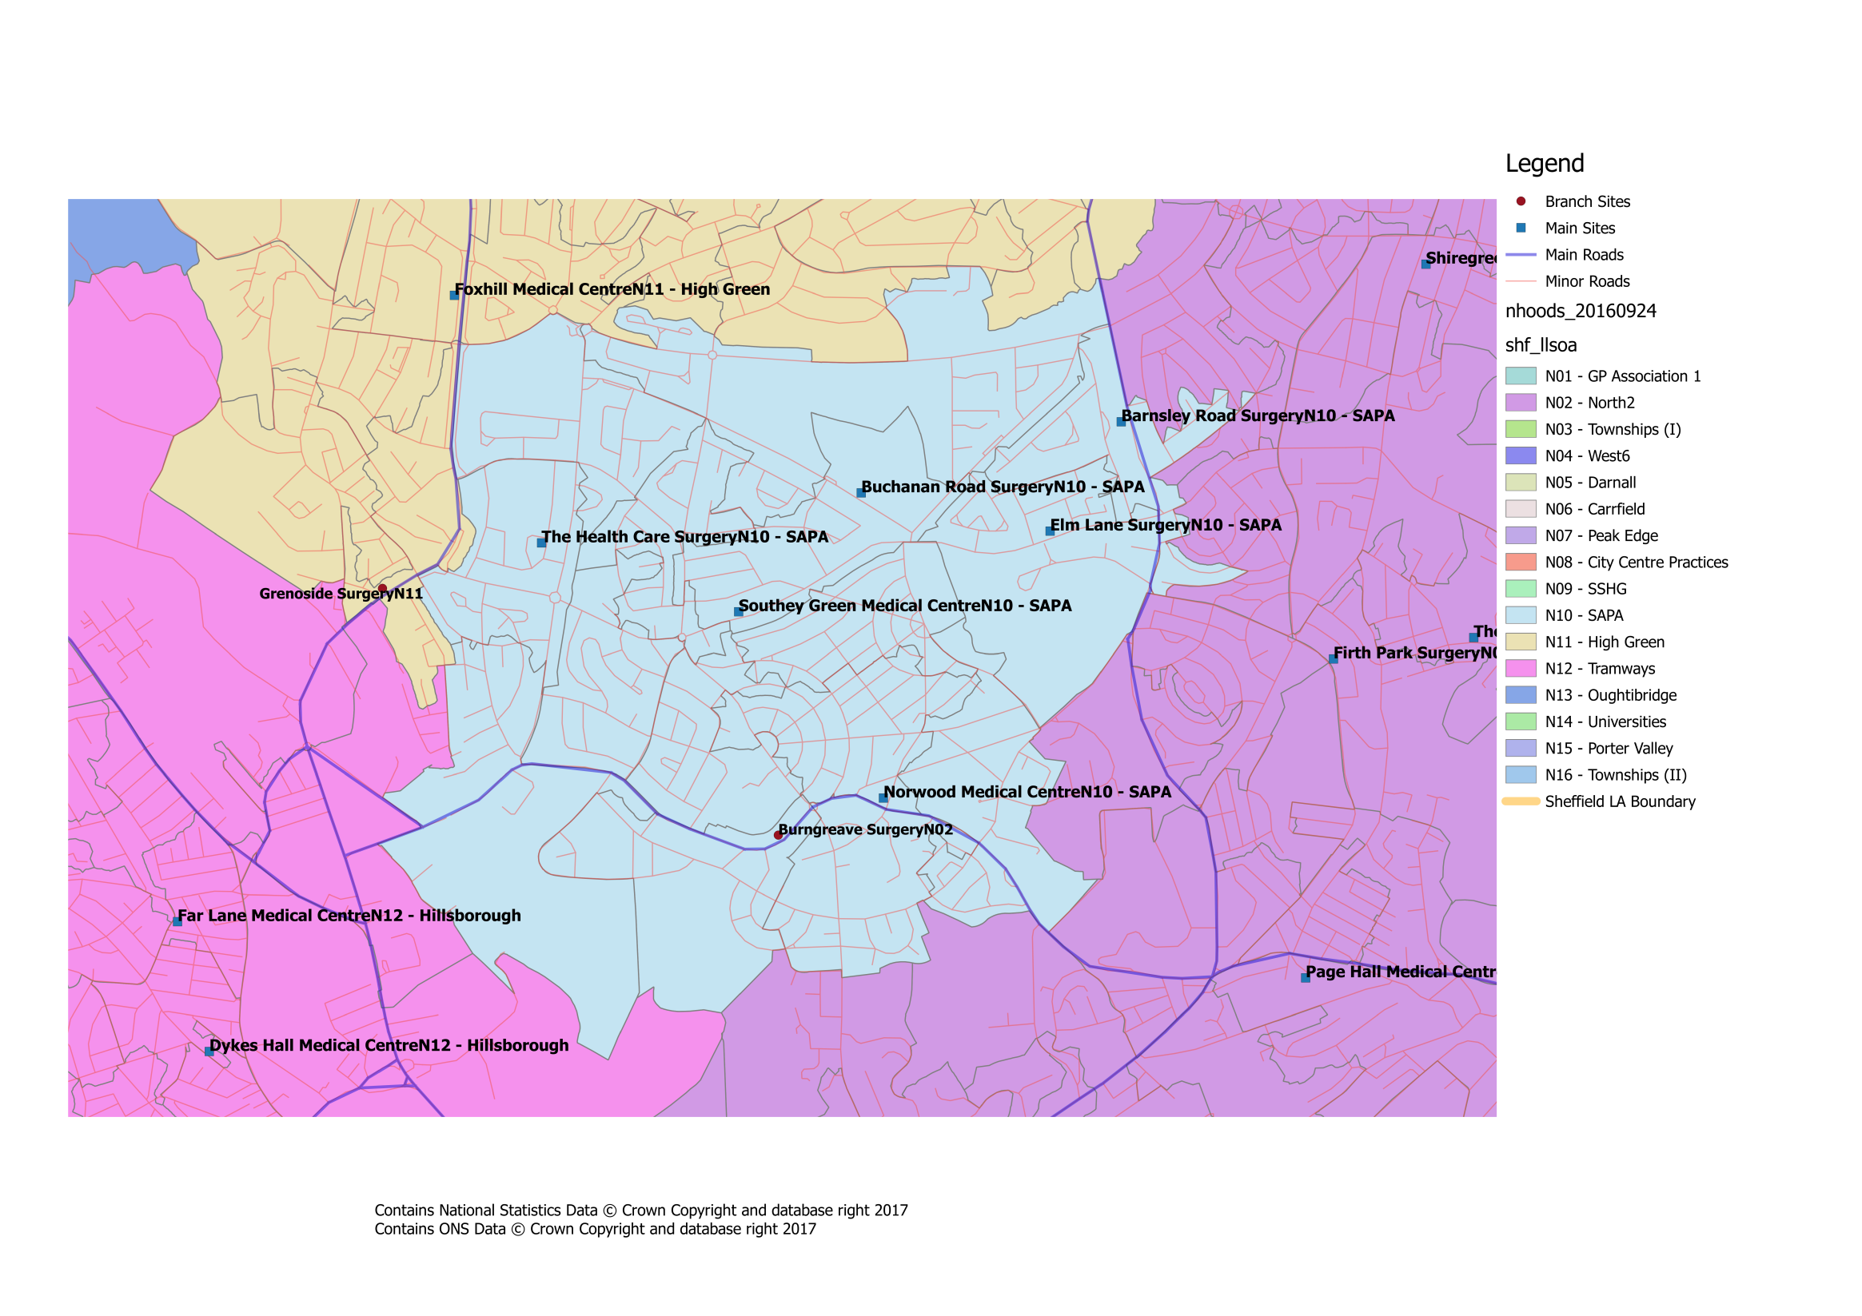

What about patient travel?
To ensure that the proposed changes made access to services equitable across the city, the travel times between practices within a neighbourhood, as well as to current/proposed central services have been investigated. Within our neighbourhood the likely travel times for patients would be:

SAPA Travel Times
GP Practice | Postcode | Car time to Barnsley Road Surgery | Bus time to Barnsley Road Surgery | Bus/Tram Nos. | Bus/Tram Frequency | Car time to Buchanan Road Surgery | Bus time to Buchanan Road Surgery | Bus/Tram Nos. | Bus/Tram Frequency | Car time to Chapeltown Surgery | Bus time to Chapeltown Surgery | Bus/Tram Nos. | Bus/Tram Frequency | Car time to Elm Lane Surgery | Bus time to Elm Lane Surgery | Bus/Tram Nos. | Bus/Tram Frequency | Car time to Minor Injuries Unit | Bus time to Minor Injuries Unit | Bus/Tram Nos. | Bus/Tram Frequency | Car time to NGH | Bus time to NGH | Bus/Tram Nos. | Bus/Tram Frequency | Car time to Norwood Medical Centre | Bus time to Norwood Medical Centre | Bus/Tram Nos. | Bus/Tram Frequency | Car time to Southey Green Medical Centre | Bus time to Southey Green Medical Centre | Bus/Tram Frequency | Bus/Tram Frequency | Car time to The Health Care Surgery | Bus time to The Health Care Surgery | Bus/Tram Frequency | Bus Frequency | Car time to WIC | Bus time to WIC | Bus/Tram Nos. | Bus/Tram Frequency
Barnsley Road Surgery | S5 0QJ |  |  |  |  | 3 | 11 | 35 | 60 | 9 | 14 | 1,1a | 12 | 7 | 10 | 1A | 6 | 17 | 42 | 2,51 | 30,10 | 2 | 4 | 1A,2 | 6 | 3 | 27 | 1,20 | 10 | 4 | 25 | 98 | 10 | 7 | 32 | 1A | 12 | 14 | 31 | 1A | 6
Buchanan Road Surgery | S5 8AL | 3 | 11 | 35 | 60 |  |  |  |  | 12 | 31 | 1 | 5 | 1 | 7 | N/a | N/a | 16 | 46 | 98,52 | 10 | 4 | N/a | N/a | N/a | 3 | 16 | 97,98 | 10 | 1 | 9 | 98 | 10 | 5 | 12 | 97 | 20 | 13 | 39 | 98 | 10
Chapeltown Surgery | S35 1TD | 9 | 14 | 1,1a | 12 | 12 | 31 | 1 | 5 |  |  |  |  | 12 | 20 | 1,1a | 12 | 26 | 62 | 1, 52 | 12 | 11 | 18 | 1,1a | 12 | 13 | 30 | 1a,32 | 12 | 13 | 31 | 1,83 | 12 | 12 | 27 | 1a,7 | 12 | 26 | 51 | 1,1a | 12
Elm Lane Surgery | S5 7TW | 7 | 10 | 1/1A,2 | 6 | 1 | 7 | N/a | N/a | 12 | 20 | 1,1a | 12 |  |  |  |  | 16 | 49 | 98,52 | 10 | 2 | N/a | N/a | N/a | 3 | 16 | 35,83a | 60 | 2 | 11 | 98 | 10 | 6 | 17 | 98 | 20 | 13 | 40 | 1A | 6
Minor Injuries Unit | S10 2SZ | 17 | 42 | 2,51 | 30 | 16 | 46 | 97,52 | 10 | 26 | 62 | 1, 52 | 12 | 16 | 49 | 97,52 | 10 |  |  |  |  | 18 | 47 | 51,1 | 5 | 12 | 26 | H1 | 30 | 13 | 33 | H1 | 30 | 16 | 31 | H1,7,8 | 30 | 9 | 12 | 51 | 5
Northern General Hospital | S5 7AU | 2 | 4 | 1/1A,2 | 6 | 4 | N/a | N/a | N/a | 11 | 18 | 1,1a | 12 | 2 | N/a | N/a | N/a | 18 | 47 | 51,1 | 5 |  |  |  |  | 4 | 14 | 38 | 60 | 5 | 18 | 32 | 60 | 8 | 28 | 1A | 12 | 16 | 41 | 88 | 10
Norwood Medical Centre | S5 7HD | 3 | 27 | 1,20 | 10 | 3 | 16 | 98 | 10 | 13 | 30 | 1a,32 | 12 | 3 | 16 | 35,83 | 60,30 | 12 | 26 | H1 | 30 | 4 | 14 | 38 | 60 |  |  |  |  | 3 | 7 | 20 | 7 | 5 | 15 | 20 | 7 | 10 | 31 | 83 | 10
Southey Green Medical Centre | S5 7QB | 4 | 25 | 97,98 | 10 | 1 | 9 | 98 | 10 | 13 | 31 | 1,83 | 12 | 2 | 11 | 98 | 10 | 13 | 33 | H1 | 30 | 5 | 18 | 32 | 60 | 3 | 7 | 20 | 7 |  |  |  |  | 3 | 9 | 97 | 20 | 12 | 37 | 83 | 10
The Health Care Surgery | S5 8GS | 7 | 32 | 1A,8 | 12 | 5 | 12 | 98 | 20 | 12 | 27 | 1a,7 | 12 | 6 | 17 | 98 | 20 | 16 | 31 | H1,7,8 | 30 | 8 | 28 | 1A,8 | 12 | 5 | 15 | 20 | 7 | 3 | 9 | 97 | 20 |  |  |  |  | 15 | 32 | 7,95 | 10
Walk In Centre | S1 3PB | 14 | 31 | 1/1A,2 | 6 | 13 | 39 | 98 | 10 | 26 | 51 | 1,1a | 12 | 13 | 40 | 1,1a | 6 | 9 | 12 | 51 | 5 | 16 | 41 | 88 | 10 | 10 | 31 | 83a | 10 | 12 | 37 | 83 | 10 | 15 | 32 | 7,95 | 10

All times are estimates only and may be subject to variation based on a number of factors (e.g. traffic, service disruption) Times/Frequencies highlighted in green indicate there may be quicker/more frequent services but the overall journey was deemed to be worse than alternatives All travel times based on Google Maps estimates during Weekday Daytime Entries with “N/A” indicate that it is significantly quicker to walk, else there is no viable public transport route

