**Sheffield Integration and Better Care Fund   
  
Narrative Plan 2017-19**

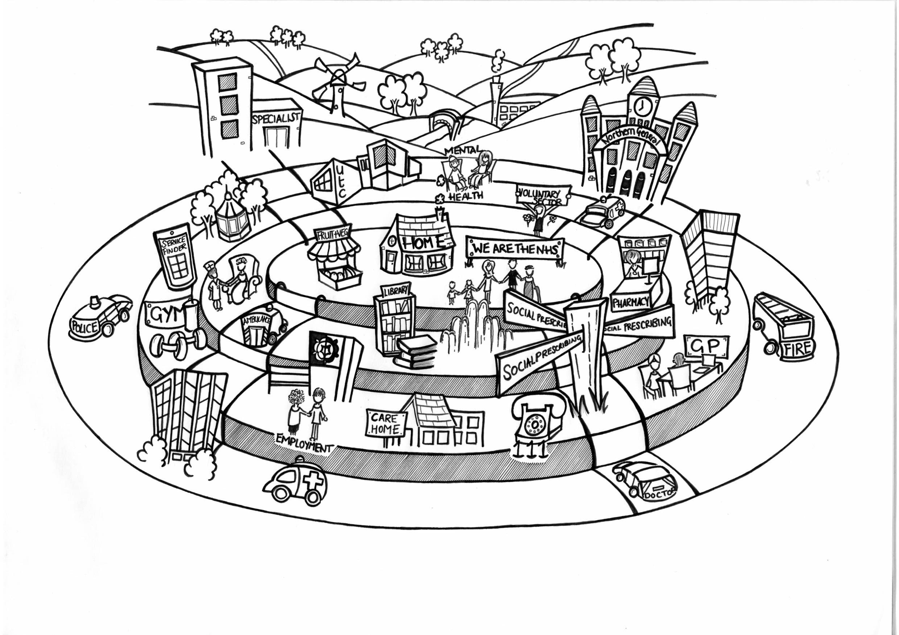

|  |  |
| --- | --- |
| Area | Sheffield |
| Constituent Health and Wellbeing Boards | Sheffield Health and Wellbeing Board |
| Constituent CCGs | Sheffield CCG |

Contents

[Sheffield Better Care Fund Abbreviations 4](#_Toc492910577)

[1. Introduction / Background 6](#_Toc492910578)

[1.1 Background 6](#_Toc492910579)

[1.2 Context 6](#_Toc492910580)

[1.3 About Sheffield 7](#_Toc492910581)

[2. Progress to date 10](#_Toc492910582)

[3. Addressing specific community needs and health inequalities 13](#_Toc492910583)

[4. Examples of our commitment to engagement and health inequalities 14](#_Toc492910584)

[5. Evidence base and local priorities to support plan for integration 15](#_Toc492910585)

[6. Better Care Fund plan 16](#_Toc492910586)

[7. Programme Governance and Management 18](#_Toc492910587)

[8. Our Better Care Plan Priorities 21](#_Toc492910588)

[8.1 People Keeping Well (PKW) 23](#_Toc492910589)

[8.2 Independent Living Solutions 27](#_Toc492910591)

[8.3 Active Support and Recovery (AS&R) 30](#_Toc492910592)

[8.5 Urgent Care 40](#_Toc492910593)

[8.6 Mental Health 46](#_Toc492910594)

[8.7 Children and Young People 51](#_Toc492910595)

[8.8 Capital 56](#_Toc492910596)

[8.9 Primary Care 58](#_Toc492910597)

[8.10 Housing Strategy 61](#_Toc492910598)

[9. Our financial plan 63](#_Toc492910599)

[10. Risk 64](#_Toc492910600)

[11. National Conditions 65](#_Toc492910601)

[11.1 National condition 1: Jointly agreed plan 65](#_Toc492910602)

[11.2 National condition 2: social care maintenance 65](#_Toc492910603)

[11.3 National condition 3: NHS commissioned out-of-hospital services 66](#_Toc492910604)

[11.4 National Condition 4: Managing Transfers of Care 67](#_Toc492910605)

[12. Overview of funding contributions 68](#_Toc492910606)

[13. Assessment of Risk and Risk Management 71](#_Toc492910607)

[14. National Metrics 72](#_Toc492910608)

[15. Delayed Transfers of Care 73](#_Toc492910609)

[16. Approval and sign off 80](#_Toc492910610)

[Appendix 1 81](#_Toc492910611)

[Appendix 2 84](#_Toc492910612)

[Appendix 3 86](#_Toc492910613)

[Appendix 4 90](#_Toc492910614)

### Sheffield Better Care Fund Abbreviations

BCF – Better Care Fund

NHS SCCG – NHS Sheffield Clinical Commissioning Group

SCC – Sheffield City Council

ACS –Accountable Care System

CYPF – Children’s & Young people Fund

PKW – People keeping well

PKW SP – People Keeping Well Social Prescribing

CSW – Community Support Workers

VCS – Voluntary Support Workers

BRC – British Red Cross

KPI – Key performance indicators

STIT/CICS – Short Term Intervention Team

LCS – Locally Commissioned Scheme

PAM – Patient Activation

EOL – End of Life

EPaCCS – Electronic Palliative Care Co-ordination Systems

LTC – Long Term Conditions

AS&R – Active Support & Recovery

STP - Sustainability and Transformation Plan

ACP – Accountable Care Partnership

CHC – Continuing Health Care

STH – Sheffield Teaching Hospital

SHSC – Sheffield Health and Social Care

EMG – Executive Management Group

A&E - Accident and Emergency

SPA - Single Point of Access

AMU – Acute Medical Unit

PDDs – Planned Discharge Dates

CEOs – Chief Executive Officials

ACO – Accountable Care Organisation

VAS – Voluntary Action Sheffield

DFG – Disabilities Facilities Grant

AHH – Adoptions Housing and Health

RSG – Revenue Support Grant

DoLS – Deprivation Liberty Safeguarding

DTOC – Delayed Transfers of Care

ASCOF – Adult Social Care Framework

## Introduction / Background

### Background

In 2013 NHS Sheffield Clinical Commissioning Group (CCG) and Sheffield City Council (SCC) agreed to work towards a single budget for health and social care. The ambition articulated through integrated commissioning of both health and social care was to:

* Ensure service users have a seamless, integrated experience of care, recognising that separate commissioning can be a block to providers establishing integrated services.
* Achieve greater efficiency in the delivery of care by removing duplication in current services.
* Be able to redesign the health and social care system, reducing reliance on hospital and long term care so that we can continue to provide the support people need within a reduced total budget for health and social care.

Our ambition is that we will, over the next few years, have a single budget for all health and social care in Sheffield so that we make decisions about how we use our resource with a focus on what the people of Sheffield need, rather than on individual budgets meaning that we have a shared responsibility for the statutory responsibilities of both organisations. Of equal emphasis is an ambition to ensure that we commission jointly across health and social care which means using a broader range of skills in the procurement and commissioning process.

### Context

This Better Care Fund (BCF) plan for 2017/18 and 2018/19 knits together more recent work on the Sustainability and Transformation Plan for South Yorkshire and Bassetlaw, Sheffield’s own Place-Based Plan and the CCG’s operational plans and has an expanded number of areas for us to work jointly on. Our ambitions have been informed specifically by engagement work led by our Health and Wellbeing Board and by local and national public opinion on integration and by the learning from our existing transformation programmes.

As part of our BCF Plan, we will focus on the delivery of initiatives jointly agreed between providers and commissioners and will develop joint decision making and risk sharing arrangements to establish effective shared responsibility and governance of the pooled budget. This will ensure that we make single, shared decisions on all aspects of care and expenditure within the remit of the pooled budget.

We believe that we will make better decisions about how we use the reducing resource for health and social care together, rather than separately. Together we will be able to use our resources to best effect, pooling health and social care money where business cases support that change, to provide the best care and support to our population. Working together, we avoid the risk that we make separate decisions that have an adverse effect on the services the other commissions, recognising that only savings and improvements to the whole system are helpful.

We are clear about both the potential benefits and the risks involved in our plans. Final sign off of our plans and associated budgets will be by SCC’s Cabinet and by the CCG’s Governing Body. Specifically, our organisations will be assured by our:

a) section 75 agreement, setting out the proposed approach to single decision making and to risk sharing,

b) financial plan for the pooled budget, and

c) our business cases that will be required for the changes proposed in this document.

### About Sheffield

Sheffield is a city and metropolitan borough in South Yorkshire with over 570,000 people. Sheffield has one County Council, one CCG, three leading Foundation Trusts, a single federated Primary Care provider called Primary Care Sheffield, 82 GP practices and around 3,330 voluntary and charity organisations. Sheffield has a strong track record for working in partnership across all public sectors through well-established networks, for example the Working Together Programme. This partnership approach has been recently strengthened by the established Accountable Care Partnership Board.

With the Peak District on our doorstep, excellent culture through our theatres, museums, parks and activities and nationally prominent organisations with a track record for success (Figure 1) and a wealth of national leaders across our public and voluntary sectors, we have one of the greatest opportunities available to us to make Sheffield a person-centred, healthy and successful city. Collectively we spend circa £1.2bn annually on health and care for the city.

In spite of this Sheffield has consistently lagged behind the England average for health and social care outcomes. For the last ten years Sheffield has not delivered its potential to reduce the substantial gap in healthy life expectancy, this will continue until we make a step change in the delivery of our programmes of work. We will continue to see:

* Over 20 years between the most and least deprived men; 25 years for women; up to 20 years for people with serious mental illness or learning disability,
* 40% of current illness in the city is either preventable or ‘delay-able’ and the financial benefit of reducing this matches the moral imperative to do so,
* We know why: because no one organisation has it in its power to deliver this, it requires whole system solutions where every member understands their role.

In the State of Sheffield 2017, it states that ‘Sheffield has a higher than average proportion of those aged 65 and over who are not in good health and those whose daily activities are limited by ill health or disability. It continues ‘if Sheffield could raise the ageing well rate among the least well off to that of the better-off, hundreds of lives would be saved and many of the chronic conditions that restrict people in later life and reduce their quality of life would be prevented.

What is the local vision and approach for health and social care integration?

Our vision, as set out in our Place-Based Plan, is:

**To be recognised nationally and internationally as a person-centred city that has created a culture which drives population health and wellbeing, equality and access to care and health interventions that are high quality and sustainable for future generations.**

**We will have a reputation for working in partnership to co-produce, improve outcomes, experience and inclusion and to influence national policy and regulation; this will be visible in our success.**

**Our aims as set out in our Place Based Plan are:**

* To develop Sheffield as a healthy and successful city.
* Increase Health and Wellbeing.
* Reduce Health Inequalities.
* Provide children, young people and adults with the help, support and care they need and feel is right for them.
* Design a health and wellbeing system that is innovative, affordable and offers good value for money (see Figure 4).
* Be employers of caring and cared for staff with the right skills, knowledge and experience and supported to work across organisational boundaries.
* Deliver excellent research, innovation and education.
* To develop and expand specialised services for children and adults across the region.

**Crucially:**

* We believe that integrated commissioning is essential to the development of integrated services. The national and local evidence is that integrated services result in better service user experience, increase efficiency and improve outcomes and the clear public message that services should be integrated.
* We believe that we will make better decisions about how we use the reducing resource for health and social care together, rather than separately. Together, commissioning jointly, we will be able to use our resources to best effect, shifting money from health to social care where business cases support that change, to provide the best care and support to our population. Working together we avoid the risk that we make separate decisions that have an adverse effect on the services the other commissions, recognising that only savings and improvements to the whole system are helpful.

Our Key Workstreams have been developed and refreshed to reflect current priorities in order to support and deliver our aims and vision as set out in our Place-Based Plan. These are outlined below.

|  |  |
| --- | --- |
| **Theme** | **Strategic Objectives** |
| Theme 1 - People Keeping Well | The Strategic Objective for this scheme is to increase the wellbeing of people at greatest risk of declining health and loss of independence – reducing demand and dependency on the formal health and social care system. This will involve local information and advice to support self-care, community interventions to enable people to remain independent and GP led care planning. As a result patients at medium to high risk of admission to hospital will be better motivated and supported to self-care, will have improved health and reduced reliance on health and social care services. |
| Theme 2 - Active Support and Recovery (AS&R) | AS&R is the commissioner term that has been given to the range of services, predominantly community based, which support the public, patients and clients in their own homes to remain as independent as possible despite the fact that they may have multiple health and care needs. These services do not consistently meet individual needs in a coherent and co-ordinated way. The commissioners require that in addressing these services options should be developed that:  • support people to remain at home and avoid unnecessary admissions.  • respond quickly to the additional needs of people in this cohort and support them to remain out of hospital.  • make sure that people are discharged home with the appropriate support, minimising their hospital stay and maximising their recovery and level of independence. |
| Theme 3 - Independent Living Solutions | The Strategic Objective for this scheme is to develop and promote the provision of independent living solutions in Sheffield so that more people can maintain and build their wellbeing and independence. This is mainly through the Community Equipment Service which is funded from the BCF pooled budget. This service provides loans of community equipment and minor adaptations for disabled children and adults across the city. The service was contracted out to the British Red Cross in July 2015, having previously been run by the local NHS provider. |
| Theme 4 - Ongoing Care | The overall aim of this is to integrate the assessment, placement and contract management functions related to ongoing care to improve quality, outcomes and process. |
| Theme 5 Adult inpatient Emergency Admissions | The overall aim is to undertake activity to reduce demand for admissions and to ensure that the patient stay whilst in hospital is as short and effective as possible. Additionally it allows monitoring of the impact of other BCF activity to reduce demand for hospital emergency admissions. |
| Theme 6 - Mental Health | The aim is to deliver a truly integrated commissioning approach which will offer more effective joined up commissioning (and therefore care), leading to better patient outcomes which will, by default, deliver better value for money. |
| Theme 7 - Capital Expenditure | The scheme will deliver home adaptations funded from the Disabled Facilities Grant to enable people to remain in their own homes and live independent lives and reduce their need for organised care.  Other Capital Grants will be used to deliver better systems to administer ongoing care. |

## Progress to date

Sheffield people have told us:

* + “If things go wrong it’s difficult to receive the care I might need quickly enough”
  + “I find it hard to find my way around all the variety of services – or even to know if what I need is actually provided by someone”
  + “We have to constantly repeat information from one person to another”
  + “I have little control over the care I do or don’t receive”
  + “My psychological needs are not met as part of care for my physical needs”
  + “Services often aren’t available at night or weekends like they are during the week”
  + “Why don’t services plan in advance – surely they should know if I get unwell I’ll struggle to cope but don’t necessarily want or need to go into hospital”
  + “Why can’t I just have one care plan?”

The key priorities in 16/17 were to:

* + Increase wellbeing of people at risk, or emerging risk, of declining health and loss of independence.
  + Support people to remain at home and avoid unnecessary admission, responding quickly when necessary.
  + Minimising hospital stay and discharging with the appropriate support and maximising their recovery and independence.
  + Integrate assessments, placement and contract management of services looking after people needing ongoing care.
  + Reduce demand for admission.
  + People will find it simpler to get round the care system and experience fewer delays.
  + We will build on, and further develop, people’s self-care and health condition management skills, knowledge and abilities.
  + There will be improved quality of life for those in active care.
  + Services will be more equitable and accessible.
  + Services will be much more based in Sheffield’s communities and closer to where people live, working seamlessly together so Sheffield’s citizens only have to tell their story once.
  + Working collaboratively to achieve the best outcomes for Sheffield People.
  + Ensure people have a seamless, integrated experience of care, recognising that separate commissioning can be a block to providers establishing integrated services.
  + Achieve greater efficiency in the delivery of care by removing duplication in current services.
  + Be able to redesign the health and social care system, reducing reliance on hospital and long term care so that we can continue to provide the support people need within a reduced total budget for health and social care.

Successes in 16/17 include:

* + A Sheffield developed systemwide Memorandum of Understanding has been signed by the major organisations – Sheffield CCG, Sheffield City Council, Primary Care Sheffield, Sheffield Teaching Hospitals FT, Sheffield Care Trust, Sheffield Cubed (umbrella third sector organisation, South Yorkshire Housing Association. It provides a framework and process for collaborative working in Sheffield.
  + As well as a substantial integrated commissioning budget, we have set up an Accountable Care Partnership (ACP) Board to provide overall leadership represented by commissioners and providers. Chief Executives from Sheffield CCG, Sheffield City Council, Primary Care Sheffield, Sheffield Teaching Hospitals FT, Sheffield Care Trust and Sheffield Childrens’ Trust sit on the Board.
  + Sixteen neighbourhoods have been set up across the city made up of groups of GP practices and forming stronger partnership working with community services and the Voluntary, Charity and Faith (VCF) organisations to address specific local needs in their communities.
  + The establishment of community partnerships across the city whereby larger and smaller VCF groups come together in partnership and identify any gaps in their services to meet the needs of their communities.
  + The establishment of a clear way for services to refer people who need some additional low level support through a form of social prescribing.
  + Further development of person-centred care planning and developing an outcome measure to assess whether people feel more activated in the management of their own care. Please see our case studies in Appendix 2 and 3.
  + The introduction of technological schemes to improve the digital literacy of people and testing out new technology to help people manage their care in a more pro-active way.
  + Discharge at weekend is now supported by Planned Discharge Dates for patients which are shared with transport providers enabling them to plan additional capacity when required to support the hospital at times of peak demand.
* Implementation of the Teaching Hospitals Excellence in Emergency Care – Assessment model in Admissions units.
* Implementation of a planned approach to discharge management and themes of safer, better, faster.

## Addressing specific community needs and health inequalities

The City has a Health Inequalities Action plan which was signed off by the Health and Wellbeing Board in 2014. We are looking to refresh this plan in December 2017.

We had a substantial discussion around this priority in May 2016 and reaffirmed the commitment to the principles agreed in the 2014 plan including:

* Continued commitment to an asset based, community development based approach to Health and Wellbeing.
* Continued investment in and commitment to primary care, and within this General Practice, especially in the most disadvantaged parts of the city.
* Continued commitment to the principle of implementing effort and change where greatest need is identified.
* Refocused effort on the link between employment and health
* Making the health choice the easiest and default choice. we are currently in discussion as to how we can build system-wide agreement to short, medium and long term interventions to reduce health inequalities at all levels within health and social care

Our agenda around health inequalities in our wider programme includes work on inclusive growth, fairness commission and the City work on poverty.

The City is increasingly clear that the ongoing commitment to the policy of austerity is almost certainly making inequalities worse not better

## Examples of our commitment to engagement and health inequalities

The CCG and the Local Authority Public Health team have supported a development programme called the “Alliance of the Willing” that brings together GPs working in disadvantaged communities and their sister voluntary organisations who are also working in those communities. The programme builds on the experience of the Glasgow Deep End group - a network of GPs in Scotland who work in neighbourhoods with very high health inequalities. The Alliance of the Willing aims to capture good practice and influence key health strategies in the city.

On a wider scale, our new neighbourhoods which cover the whole city have the opportunity to work with local groups and the communities to identify what the needs are for their neighbourhood and how, as neighbourhoods covering statutory and non-statutory organisations, they can meet those needs and fill gaps. This could range from opportunities to bring more specific services and different access from that which the city normally would offer to ensure services can be accessed by their communities to develop local plans to provide specific low level support to reduce social isolation.

We are committed to meeting our statutory obligations in relation to patient and public involvement. Our plans are continually being shaped by our citizens. In addition to the active participation in our workstreams so far this year we have sought views from our most vulnerable communities on access to health and care and is in relation to the [Health and Social Care Act 2012](http://www.legislation.gov.uk/ukpga/2012/7/contents/enacted), [The Equality Act 2010](http://www.legislation.gov.uk/ukpga/2010/15/contents), the [NHS Constitution](https://www.gov.uk/government/publications/the-nhs-constitution-for-england/the-nhs-constitution-for-england) and the [latest NHS England guidance](https://www.england.nhs.uk/wp-content/uploads/2017/04/ppp-guidance.pdf). The most recent pre-consultation engagement activity also demonstrates our commitment to the Gunning Principals, particularly ‘engaging when proposals are still in their formative stage’. In order to inform development of options, it was important to utilise public health data to recognise groups who hadn’t been given specific opportunities to share their experience or usage of services in the previous two engagement activities on urgent care in 2015 and 2016. In the month of March 2017, the following groups were identified, approached and asked for their views:

* Homeless community
* Substance misuse community
* Asylum seekers and those living in temporary accommodation
* Communities with greatest deprivation
* Students
* City workers

With reference to children, young people and families a range of public health data has been used to assess local need and ensure that we are identifying the correct priorities. This has included the completion of a number of health needs assessments including Emotional Wellbeing and Mental Health and Children with Complex Needs. Alongside this there has been intensive consultation facilitated through voluntary sector partners (Health Watch Sheffield and CHILYPEP) to speak with children, young people and families to identify their views and needs on service provision and priorities. There have been a number of consultation events facilitated with hard to reach groups and service users (CAMHS, SEND (special educational needs and disabilities) to understand their experiences of services and generate ideas for service redesign. The feedback has confirmed the need for the alignment and joining up of budgets to establish seamless services and therefore supporting the integration of children and young people into the BCF from 2018 onwards.

## Evidence base and local priorities to support plan for integration

Our original priorities were shaped by extensive public engagement by the Health and Wellbeing Board, by local and national public opinion on integration and by the learning from our provider-led Right First Time (RFT) programme, which sought to integrate our system response to urgent care needs. The Better care Fund builds on wider local partnerships and our Foundation Trusts (FTs), in particular, have been involved in the work that has led to our plans. Our FTs are fully supportive of the ambition to reduce non-elective admissions. The Programme for Integrated Commissioning was a logical build and continuation of the work delivered by the RFT Programme.

Our original evidence and case for change can be found in our Better **Care Fund Submission: Part 1 September 2014.**

**http://www.sheffieldccg.nhs.uk/Downloads/get%20informed/Sheffield\_Better\_Care\_Fund\_Submission\_-\_September\_2014.pdf**

Revisions to our plans are reflective of our emerging financial challenges and our extensive work in Shaping Sheffield in 2016 and developing Sheffield Place Based Plan. As new workstreams come on board with mental health and children’s, and our new ACP becomes more established, we will need to review our priorities accordingly.

## Better Care Fund plan

Our Better Care Fund has 7 formal areas of work with Children and Young People added almost as a shadow run for full inclusion into the pooled budget from April 2018. This is providing valuable time to review which children and young people’s priorities will be included in the BCF and enabling robust financial modelling and planning to ensure that the correct budgets are identified for inclusion. We actively review the areas which the Better Care Fund cover and the following demonstrates how we are evolving.

Describe the progress that has been made to integrate health and social care and support more people to be supported closer to home.

This section should set out:

* the existing approach to integration and the main points of the current BCF plan;
* review progress to date through the BCF;
* current performance on national metrics, and;
* successes

|  |  |  |  |  |  |
| --- | --- | --- | --- | --- | --- |
| **In the 2016/17 BCF** | | | | | |
| **People Keeping Well** | **Urgent Care (reducing emergency admissions)** | **Independent Living Solutions** | **Active Support and Recovery** | **Ongoing Care** | **Capital** |
| **New to the BCF 17/18** | | | | | |
| **Mental health** | | | | | |
| **New to the BCF 18/19** | | | | | |
| **Children’s and Young People** | | | | | |

Later sections of this BCF document talk about how we will measure these areas and what the financial plan for each is.

**What will change?**

Our plan will set out change in a number of areas which are building on our past Better Care Fund plans. Sections three of this document will set out what will change in each area.

Our Place-Based Plan sets out a range of things that we will be doing in the preventative space, which are not part of this BCF Plan. This includes:

* Primary Care.
* Our Heart of Sheffield programme: a radical upgrade in prevention.
* Our Work and Health programme: supporting people moving into meaningful economic activity or meaningful employment.[[1]](#footnote-1)

The changes we plan should mean that, by 2020:

* More people, including children, young people and adults, will be getting the right care, at the right time and in the right place.
* People and their communities will be supporting each other to a greater extent and we will have improved and maintained their safety, wellbeing and greater levels of independence.
* Organisations will work together to a greater extent to help people and their communities to build and strengthen the support they provide to each other.
* More expert support will be available to help people to take control of their own care so that it is genuinely person-centered and complements and builds on the assets they already have.Health and care services will be more focused on a person’s needs and organisational boundaries will not get in the way

The context in which the Better Care Fund sits is changing. With the fast development of Sheffield’s Accountable Care Partnership and Accountable Care System, we are working on ensuring that all our priorities align and we make best use of our resources.

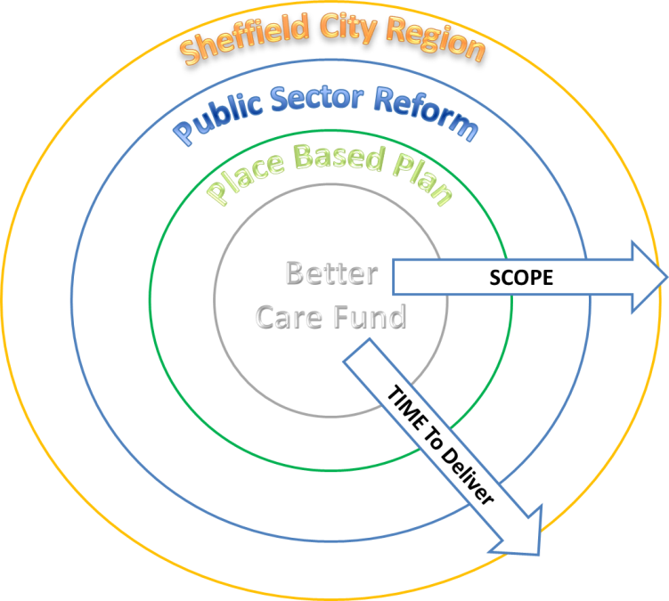

## Programme Governance and Management

The Executive Management Group (EMG) is responsible for development of commissioning strategies within the overall direction set by the Health and Wellbeing Board, implementation of agreed commissioning strategies, oversight of the Service Contracts and other matters detailed in the terms EMG Terms of Reference and underpinned by our section 75 arrangement.

The governance of the BCF is currently being reviewed in light of the wider programme of transformation taking place in terms of the ACP Board, the Sheffield Place Based Plan, ACS and Public Sector Reform within the Sheffield City Region.

During the early part of 2017, a review of the EMG highlighted a need to reflect the need for more focus to EMG and to separate out the strategic functions of the group with the operational requirements of delivering a broad and complex programme. As a result the EMG has now split into two groups: EMG Strategy group which has a strategic oversight and high level responsibilities of managing the fund; and EMG working group, the latter reports to the former. EMG working group fulfils the programme management function, assesses monthly highlight reports, tracks progress through highlight reports (Appendix one) and manages risk on an exception basis, mitigates risks and manages the interdependencies to ensure we deliver our successes.

Where matters requiring a decision are determined not to be within scope of an Executive Management Working Group member’s delegated authority, the subject matter is escalated to the EMG’s monthly meeting. Additionally a summary of key issues and actions from the Executive Management Working Group meeting will be provided to the Executive Management Group.

**The diagram below illustrates the proposed BCF Governance** which aims to support the continued progression of the BCF programme, within the existing BCF arrangements, in a way that compliments the developing Accountable Care Partnership Programme.

It is acknowledged that because of the huge savings needed in Sheffield it is reviewing its cross system assurance process to ensure all workstreams are on track and will ensure success and realise our benefits.

We will constantly review our reporting processes to ensure that the system leaders are assured that all the workstreams are on plan to deliver. All the risks have been mentioned in each of the workstreams and are being managed within each of their own governance arrangements and highlighted to Executive Management Group on an exception basis as described above.

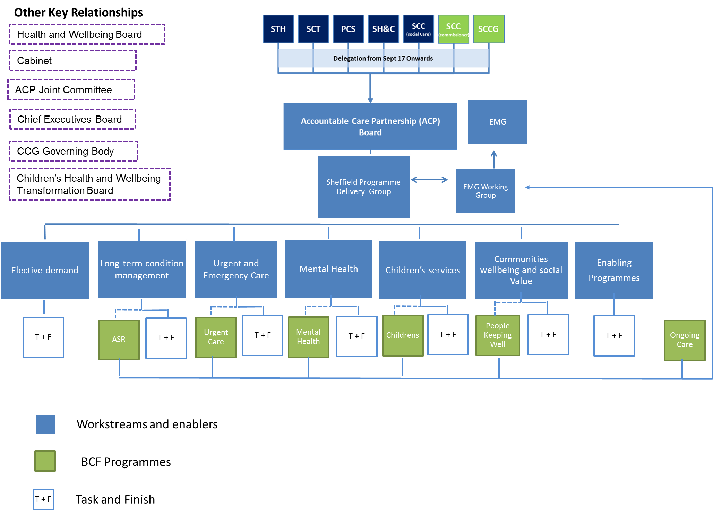Proposed Better Care Fund Governance Structure

## 

## 8. Our Better Care Plan Priorities

Our priorities, covered in detail below, make up an ambitious programme which cuts across so many parts of our health and care economy and potentially affect most of our citizens in their life cycle. The programme is described in the Governance structure above.

We are describing our governance arrangements as transitional and, as the ACP programme develops, we would expect the programmes increasingly to be managed within the ACP Programme Management Office (PMO) and that the EMG function will reduce in direct proportion – potentially replaced by the joint commissioning function. From a resource perspective we need to think through the business analytics (which we have learned from experience needs development and a critical part of what we need to do). In discussion with colleagues we feel there is potentially merit in developing that through the ACP infrastructure.

Below each of the priorities describes its aims and objectives, successes to date, key plans for 2017-19, its risks and mitigations and developing outcomes, metrics and governance. These have been informed by each of the workstreams programme plans which, in turn, have been developed and signed off by the Boards which manage each of the priorities. Sitting on these Boards are representatives from commissioning, providers, voluntary and third sector organisations which manage progress monthly, manage risks and steer the direction of the programmes.

The Outcomes Frameworks as shown in both Active Support and Recovery and People Keeping Well are emerging and not finalised yet.

**Learning and Sharing**

As a Pioneer Site we remain involved in the Pioneer Network and actively take part in events and shared learning. We have recently contributed to the annual interview process for the evaluation and indicators dashboard. We also attend Pioneer Events to learn more about how other sites are developing as well as share our progress.

We have presented at National Commissioning for Health and Care on Delivering Joint Commissioning and Pooled Health and Social Care Budgets.

We have visited many sites as part of the New Models of Care programme to learn more about how others are integrating, especially looking at out of hospital schemes and primary care at scale. We have also purchased schemes from other areas to deliver training programmes for our practices in Sheffield.

Person Centred Care and patient activation – we have been involved in:

* A member of the NHS England (NHSE) commissioning for person centred care working group.
* Sharing at the Kings Fund Event in April 2017 applying tools and measures to support person centred care.
* Contributed to the Health Foundation National Report on patient activation.
* Our report ‘a reflective document with recommendations’ on our contracting with practices and patient activation has been shared widely across local and national networks. We have also shared the report on the national CHAIN (Contact, Help, Advice and Information Network). The link to the report is below.<http://www.sheffieldccg.nhs.uk/Downloads/About%20US/Documents%20Policies%20and%20Publications%202017/Person%20Centred%20Care%20in%20Sheffield%20%202016%202017.xps>
* Four learning and sharing events in Sheffield across our practices and we share good practice and learning on our internal intranet.
* We are also on the RCGP Integrated Personal commissioning network
* We also update immediately via social network on blogs on Person centred care progress..

**People Keeping Well –** Our leads have spoken at seminars and network events on the ‘’‘ups and downs’ of combined predictive modelling and our People Keeping Well model.’’

**Delayed Transfers of Care (DTOC) – Newton Europe**

Following the development of an action plan we are keen to share our learning so far, and have shared documentation with colleagues across the ACS. We are also inviting colleagues to our next city wide workshops on DTOCs.

DTOC leaders in the city are now also speaking at events regionally about our work so far with Newton Europe.

We are also sharing all our documentation about our care out of hospital programme and the setting up of our neighbourhoods across our ACS network.

### 8.1 People Keeping Well (PKW)

Lead director: Dawn Walton Sheffield City Council

**What will this area of work do and what will change as a result?**

* There is growing recognition that by ensuring people are connected to and feel part of their local community we can help them stay independent and well for longer and increase quality of life.
* Social prescribing is a way of linking people with sources of support within the community. It provides a non-medical referral option that can support people to improve health and wellbeing.
* Alignment of locality working including Asset Based Community Development and Housing Plus offer to tenants.
* Supporting demand management activity for ASC and primary care.

**What will happen in 2017/18 and 2018/19?**

* Implement a social prescribing model in all areas of the City.
* Develop a central referral hub.
* Clear and consistent approach to management information and measuring impact.
* Workforce development to have empowering conversations with people.
* Integrate access to Social Prescribing (SP) model in all referral and assessment pathways.
* Risk Stratification needs developing to include social indicators as well as health and to obtain ownership and sign up by all stakeholders.
* Alignment of approach with CYPF locality based provision.

**Deliverables:**

* Develop the financial plan and further funding mechanism for the PKW. partnerships and Community Support Workers (CSW)
* Review SCC/CCG funded key workers in relation to delivery of PKW SP and demand management to determine future need.
* Identify long term funding for PKW.
* Tender community dementia monies.
* Tender community carer monies.
* Continue to support partnership development.

**What are the main benefits of this area of work?**

The key benefits of this approach are:

* For the individual: improved health, greater independence, less social isolation, a route to building social capital and resilient communities, enabling and supporting individuals to manage their condition.
* For the system: Demand Management – shifting from reactive to proactive approaches means we reach people earlier and begin to develop a “self-management” culture within the organisation and in communities.
* Financial efficiencies: anecdotal evidence from community support workers and local GP practices is that it has reduced demand on services but this is difficult to quantify.
* For the system: financial efficiencies which could lead to public sector cost reduction and/or releasing capacity to better manage demand, making best use of health and care practitioners’ time and a means of promoting a shift to preventative interventions.
* For the community: making optimum use of local community support and stimulating improvements in the quality and effectiveness of the Voluntary, community and Faith sector community offer.

**Metrics:**

* 75% of partnerships with social prescribing monies have a success matrix rating of 4 (good / minimal issues) for their partnership.
* 75% of partnerships with social prescribing monies have a social prescribing process.

**What are the main risks and issues?**

**Risks**

* Lack of long term financial investment means it is difficult to plan.
* Costs Benefits Analysis is unable to prove categorically that the PKW model is saving the Health and Social Care System money.
* CBA proves savings in secondary health services and social care but no agreed mechanism in place to release funds for reinvestment in PKW.

**Issues**

* Need to invest in management information systems and workforce development but have little resource
* Currently commissioning activity is via SCC Ideally it would be beneficial to have one portal for all activity across the system
* Sign off for the strategic approach is complex as decisions have to be agreed in more than one place.

**What consultation has been carried out?**

* Significant consultation with providers as the framework, outcomes and principles of PKW were developed.
* Co-production is at the heart of all PKW commissioned services. All Community Partnerships have had to evidence their approach to co-production to ensure local people have had the opportunity to engage fully.
* Partnerships working with local residents.

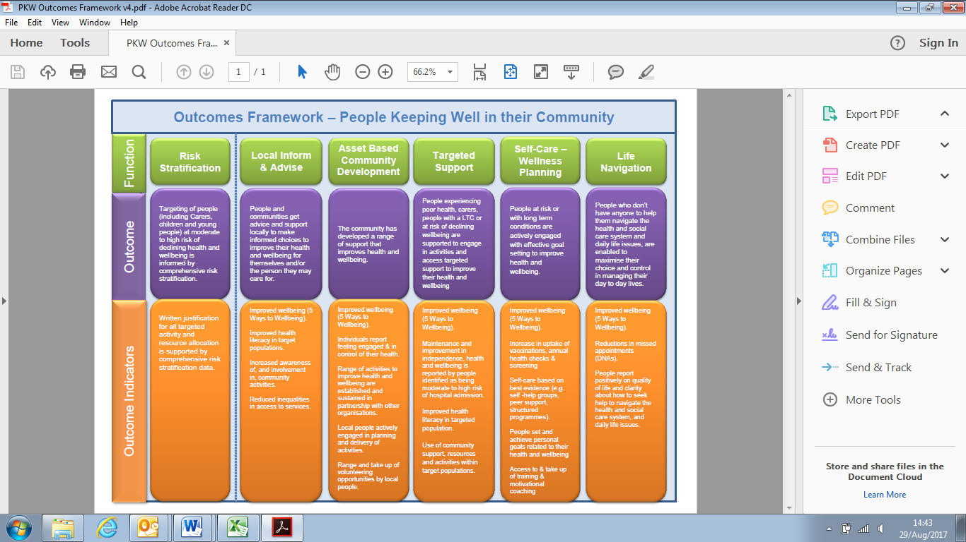

### 

### 8.2 Independent Living Solutions

Lead director: Penny Brooks Sheffield CCG/Phil Holmes, Sheffield City Council

**What will this area of work do and what will change as a result?**

This jointly procured contract was awarded in July 2015 and runs for up to 5 years. It is paid for from a true pooled budget into which the CCG pays around 2/3 of the total and SCC the remaining 1/3.

**What will happen in 2017/18 and 2018/19?**

British Red Cross (BRC) accept referrals from over 2000 health and social care workers for people needing equipment in their homes to enable them to continue living independently. They deliver the equipment from their warehouse in Darnall, Sheffield(and then maintain and service the equipment before collecting it again when it is no longer required.

**What’s changed since the last BCF submission?**

No changes to the service since last year. It is proposed to create a new social care capital scheme to separately capture the costs of high value community equipment. These tend to be more specialist items of equipment that are capital in nature.

**What are the main benefits of this area of work?**

The service is demand driven. Equipment is delivered within the timescales required by prescribers – ranging from same day delivery in urgent cases to 5 day delivery in routine cases. BRC consistently meet KPI targets and very few deliveries miss their target timescale.

* A large proportion of the equipment is loaned to people who have recently been discharged from hospital thereby facilitating discharge. If the equipment is on the standard catalogue it can be in place very quickly to allow the person to return home on the planned date.
* When a person is assessed in their home, equipment can be provided to enable them to retain independence from services and to remain at home for as long as possible.
* Where a person does have care needs, the appropriate equipment can be loaned to assist carers and in many cases reduce the amount of service needed (e.g. single handed calls as opposed to double handed).
* As the equipment service is now funded through a true pooled budget there is no longer delay caused by identifying who is responsible for payment.

**Initiatives and new policies**

A number of initiatives and new policies have already been or are currently being put in place:

• Care Home Policy: Aims to standardise the equipment going into care homes by clarifying what the home should be providing and what the CES (Community Equipment Service) can reasonably be expected to lend.

• Bed policy: Profiling beds are the most commonly prescribed item and although the unit cost is not high (£375), numbers issued are very high. We now require a more detailed description of the patients’ needs and reasons for issue.

• Seating Policy: Specialist chairs can cost up to £4,500 and, although this is low volume, we have introduced a more thorough criteria to ensure that only essential clinical need is being considered by prescribers.

• Additional Staff: The contract is currently managed by a single member of staff (based at SCC but funded from the pooled budget). Other areas have teams of clinicians and others in this role who can challenge prescribers and proactively follow up loaned equipment for collection. A business case is being developed to create more posts. Information from other local authorities (e.g. Nottinghamshire and Derbyshire) suggests this would save money equal to several times the staff salaries.

• Capitalisation: A proposal is being finalised to utilise Disabled Facilities Grant (Capital) to fund those high value items of Community Equipment that are capital in nature. This should increase the overall funding available for Community Equipment.

**What are the main risks and issues?**

**Risks**

* Financial risk: Although measures are in place, and new ones are being developed to contain unnecessary spend, it is highly likely that spend in 2017/18 will not be any lower than in 2016/17. In fact, demand is expected to increase in line with increased use of other health and social care services.

The measures being put in place in conjunction with implementation of a new capital project to bear the costs of high value items are hoped to address some of the total pressures on this service which currently amount to £600k. It is acknowledged that the measures outlined above will be effective but due to the continuous increasing demand, reducing the spend is unlikely, but potentially the increase in spend will be slowed down.

**Issues**

* Whilst there is a continued financial pressure in this service it is an area that has so far been shielded from large scale budget cuts.

**Mitigation**

* A number of initiatives and new policies have already been or are currently being put in place as listed above.

**What consultation has been carried out?**

Consultation has taken place about the service quality and performance with prescribers for the service in partner organisations and with patients/service users. An annual report will be produced summarising these views together with the overall performance data.

### 8.3 Active Support and Recovery (AS&R)

Lead director: Nicki Doherty Sheffield CCG/Phil Holmes Sheffield City Council

**What will this area of work do and what will change as a result?**

Our vision is: “to provide accessible, person centred and fully integrated services in the heart of each community in Sheffield, preventing avoidable hospital and long term care admissions, and enabling those patients with ongoing complex needs to maximise their independence.”

The aim is to develop and redesign out of hospital services, to:

* Support people to remain at home and avoid unnecessary admissions.
* Respond quickly to the additional needs of people in this cohort and support them to remain out of hospital.
* Make sure that people are discharged home with the appropriate support, minimising their hospital stay and maximising their recovery and level of independence.

The programme will potentially benefit all patients within the Sheffield area who are at risk of a hospital admission, with an emphasis on the proactive identification of those patients whose health is deteriorating.

The programme will have the following key components:

* Developing integrated out of hospital care across Sheffield, delivered through a range of services both from within Neighbourhoods and those provided City wide.
* Have clear links with other key strategies such as primary care, urgent care, long term conditions and mental health.
* Have the provision of care closer to home and person-centred care as its primary objectives.
* Is principally aimed at those patients with one or more long term conditions and aimed at helping them to maximise their independence in their own home.

To be clear, the Active Support and Recovery Programme will transform the way in which our reactive services are delivered (Intermediate Care, Rapid Response (STIT/ CICS), Community Nursing, Falls, SPA etc.). It will rebalance our resources by correcting the investment in less acute interventions that will allow a redistribution of activity from high cost interventions that are not needed to better value interventions that support, develop and promote independence. At the same time as increasing spend in less acute interventions the redesigned services will also release system savings.

**What will happen in 2017/18 and 2018/19?**

The following high-level activities are planned for the coming period:

* Social Prescribing: Full roll-out of social prescribing to all neighbourhoods and an action plan for each that develops them along a maturity index; continuing embedding the community support workers. The purpose is to optimise community support and intervention, support increased person activation and self-care and to increase access to the benefits and support packages that Sheffielders are entitled to.
* Person Centred Care: Develop a self-care strategy for Sheffield and an implementation plan;, continuing the Care Planning Locally commissioned scheme with introduction of Patient Activation Measures (PAM) improvement metric linking to self-care strategy; develop Behaviour Change Academy as a partnership approach for Sheffield.
* Rapid Response: Implement revised rapid response service that addresses the current system limitations (needs to link to Independent Sector and Domiciliary Care solutions).
* End of Life (EoL): Progress Electronic Palliative Care Coordination Systems (EPACCS), implementation of One Chance to Get it Right (last few days), increase number of people who die in their place of choice, increased support to care homes for EoL pathways.
* Carer Support: Support to carers to enable respite or temporary support whilst in hospital to keep people at home when carers cannot look after them.
* Care Homes: Increase nursing support to care homes to help meet increasing needs outside of hospital.
* Virtual Ward: Review evidence for virtual ward pilot in GPA1 Neighbourhood and consider best model for citywide approach (links to urgent care programme).
* Case Management/Care coordination and navigation: People at increased risk of admission receiving case management support and, where care needs are increased, there is a coordinated response that ensure the most appropriate service provides the response.
* Intermediate Care beds: Re-profiling of intermediate care beds in response to increased community offer, will require shorter programmed length of stay with measureable outcomes, will also include step-up removing the need to admit in order to access this level of intervention.
* Recommission the write number and type of beds to minimise spend.
* Community IV: IV delivered at home and either removing the need for admission or where admission is required reducing the associated length of stay.
* Review care home and home care capacity in order to increase resilience

**What’s changed since the last BCF submission?**

* All 16 neighbourhoods in Sheffield are in place and are working on a development plan for 2017/18.
* Primary care and community care practitioners are working together to improve patient care/experience e.g. district nurses and practice nurses working together on wound care.
* Further development of person-centred care including care planning, PAM embedded as outcome measure.
* Roll out of Virtual Ward pilot to City Centre Neighbourhood incorporating 21 Practices – June 2017
* Alignment with Test Bed technologies development.
* Intermediate Care Beds re-profiled and reduced.
* Digital Literacy pilot established in two Neighbourhoods (Porter Valley and South Sheffield Health Group) to support people with LTC/complex needs.
* Revised and strengthened programme Governance.
* Initiation of Virtual Ward/Enhanced Case Management pilot across Central Locality.
* Digital Literacy projects in place in 2 Sheffield neighbourhoods in partnership with the Good Things Foundation.
* Initiation of falls prevention pilot in Sheffield in partnership with Aesop and Yorkshire Dance.
* Initiation of work on Active Recovery service to deliver greater efficiency through integration.
* Business case in development to support community IV

**What are the main benefits of this area of work?**

Standard KPIs include:

* Reduction in non-elective admissions.
* Reduction in permanent admissions to long term care (ASCOF 2a2)
* Reduction in delayed transfers of care (ASCOF 2ci).
* Improvement in the number of patients still at home 91 days post admission (ASCOF 2bi).
* Improvement in the proportion of older people (aged >65) who received reablement/rehabilitation after discharge from hospital (ASCOF 2b2).
* Improvement in the overall satisfaction of people’s care and support who use services (ASCOF 3a).
* Delivery of financial savings equating to £4.6m in 2017/18.

**Targeted support**

**Promote Self Care**

**Co-ordinated Care**

**Timely access and support unity Development**

**Asset Based Community Developmentmote Self Care**

**Best value**

People with multiple LTC/complex needs identified through a risk stratification process are supported to remain at home and avoid unnecessary hospital admissions or excess stays Hospital

People who need services will receive integrated co-ordinated person centred care which takes acount of their holistic needs.

People at risk are actively engaged with developing their own Care Plans and take responsibility for their own Health and Wellbeing .

People who need services will receive integrated co-ordinated person centred care which takes account of their holistic needs

The system is able to respond quickly and effectively to the additional needs of people in this cohort to support them to remain out of hospital or minimise length of stay.

The community has developed a range of support that improves health and wellbeing and wherever possible is accessible close to peoples homes.

The provision of services provides the best value for the citizens of Sheffield.

Providers identify and share with others details of patients at high risk of admissions.

Practices engage in Virtual ward and have patients on Virtual Ward list

Complex wound care clinics are provided in hubs

Patients have a Person Centred Care Plan.

Patients /practices involved in improving access to Digital solutions/Literacy

Dance to Health available for people at risk of falling.

Patients have an Ok to Stay plan where appropriate.

Patients have access to Social Prescribing services .

Providers have access to shared care records

Fast response services are available in the community to prevent transfer to Hospital.

Integrated Active Recovery services available to prevent admission and facilitate discharge processes.

Community IV services are available

Neighbourhoods develop population focused services that meet the needs of people living there

GP practice is key co-ordinator of Health and care needs.

Neighbourhood has developed community nursing, social work and voluntary sector links

Reduction in secondary care activity

Intermediate care beds used effectively

Resource allocation to support care delivery in the community

Achievement of

AS&R QIPP targets

Aim

Outcome/result

Outcome Indicators/Activities

**Draft Outcomes Framework – ACTIVE SUPPORT AND RECOVERY**

**VI**

**v**

**VISION - To provide accessible, person centred and fully integrated services in the heart of each community in Sheffield, preventing avoidable hospital and long term care admissions, and enabling those patients with ongoing complex needs to maximise their independence**

|  |  |  |  |  |  |
| --- | --- | --- | --- | --- | --- |
| **SK Description** | **Imp** | **Prob** | **Risk Score** | **Mitigation Action** | **ID & Target Mitigation Date & Owner** |
| RISK – Risk that projects will not fully deliver until robust plans in place and resources for delivery identified  CONSEQUENCE – Slippage in project plan milestone | 4 | 3 | **12** | Detailed project plans to be developed to include any resource requirements and milestones | Project Leads –  July 2017 |
| RISK – Risk that stakeholders do not fully engage in new ways of working  CONSEQUENCE – system reverts to previous behaviours | 4 | 4 | **16** | Comms engagement via Neighbourhood news and ongoing liaison with Locality Managers / key stakeholders | LMs/LW/KD - ongoing |
| RISK – Risk that programme is not fully aligned with other interdependent projects  CONSEQUENCE – Mismatch in aims/expectations | 3 | 3 | **9** | Overarching Better Care Fund PMO approach to align project dependencies | SB /LW – monthly update |
| RISK – Risk that the required QIPP is not achieved in year  CONSEQUENCE – Financial gap for city has to be met from other schemes | 4 | 2 | **8** | QIPP trajectory across financial year agreed with project leads and finance – delivery monitored on a monthly basis |  |

**What consultation has been carried out?**

The projects of work have not progressed to a point where a consultation is required, however there has been active discussion with provider partners through Active Support and Recovery Workshops, Active Support and Recovery Delivery Board and Active Support and Recovery Programme Board along with Locality Meetings. Public engagement has happened through multiple avenues including the 2020 Vision, urgent care (which covers the same ground), and the citizen’s reference group.

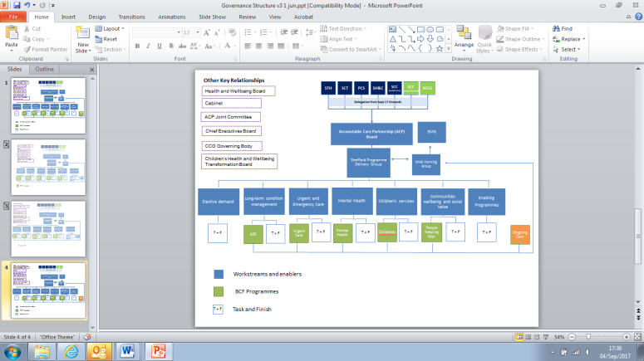8.4 Ongoing Care

Lead directors: Penny Brooks Sheffield CCG/Phil Holmes Sheffield City Council

**What will this area of work do and what will change as a result?**

The Ongoing Care programme is redesigning and integrating Continuing Health Care (CHC) and adult social care to achieve a single integrated assessment, with shared market management function and integrated group decision making on funding decisions. This has a focus on planning and delivery of support to meet the ongoing care needs using a joined-up approach from the Clinical Commissioning Group (CCG) and Sheffield City Council (SCC) and commissioning and contracting relevant services in the long term.

The Ongoing Care programme in partnership with CCG and SCC has been working through solutions to improve quality, process and outcomes within a financial envelope. By establishing the right care and the right package, there are opportunities for savings and the patient and carer experience should be measurable improved.

**Sheffield citizens will experience:**

* Improved patient experience through streamlined patient pathways through a joined up approach from the CCG and SCC, in relation to the determination of their care needs and the planning and deliver of support to meet these needs.
* Well-trained and supportive staff who are confident of providing robust and lawful advice, assessment and support.
* A clear approach to charging for care including care provided free at the point of use where primary health needs are identified.
* Access to clinical leadership and support that is appropriate to their situation.
* Access to information, advice and early intervention that will prevent avoidable deterioration in physical and/or mental health.
* Being supported to leave acute beds as soon as they have no further need of treatment in that setting.
* More emphasis upon support at home and less likelihood of having to move into a care home.
* Care and support arrangements that will best meet their needs.

**Sheffield’s care providers will experience:**

* A consistent approach with respect to fee rates, payment and contract management.
* A consistent approach with respect to quality improvement and safeguarding.
* A collaborative commissioning approach that builds good relationships, celebrates innovation and enables early problem solving.

**Attached CCG and SCC staff will experience:**

* Practice configured around the person rather than the organisation.
* Reduced bureaucracy and streamlined decision-making.
* Greater trust and joint working, including emphasis on early intervention and problem solving.
* Encourage professional development.

**What will happen in 2017/18 and 2018/19?**

**Single integrated assessment and care management pathway**

* Review the current pathway and processes.
* Reduce bureaucracy and streamline processes.
* Gap analysis of workforce.
* Review of all high cost CHC and Social Care packages to ensure clients are receiving appropriate and cost effective care.
* Exploring scoping options of shared Information Technology system.

**Engagement and Stakeholder involvement**

* Engagement workshops with carers to develop joint practice principles for short breaks allocation.
* NHS England commissioning a video to support ‘For Pete’s sake!` initiative to develop culture across the whole system.
* Shared workforce training across CCG and SCC.

**Improved contracting and market management**

* New commissioning arrangements for homecare and Supported Living (by October 2017).
* Review of commissioning arrangements for care home placements locally (TBC).
* Discussions across STP/ACP for equity and economies of scale.
* Review of commissioning arrangements for Direct Payments and Personal Health Budgets (timescale TBC).
* Integration of CCG and Council contracting and market management functions with respect to registered care settings and Direct Payment/Personal Health Budget markets (by April 2018).

**Reduction in Delayed Transfers of Care and Rates of Readmission**

* Pilot home first (5Q) approach to ensure long-term needs are not assessed in acute beds (by September 2017). 5Q is a tool that has been implemented to support teams in ensuring that  patients who may require some form of additional support on discharge to be directed to the most appropriate place. It has been found to support more people getting home and to help reduce in hospital delays where patients are better assessed for ongoing care in a non-acute setting
* Review the outcome from the 5Q pilot with a view to rolling out if pilot successful.
* Work with the Active Support and Recovery work stream to review and plan step down intermediate care capacity; to provide discharge to assess; to commission step-down intermediate care capacity; to provide a “Plan B” where D2A cannot be provided at person’s own home (by September 2017)
* Formal arrangements for integrated assessment and support planning underpinned by appropriate alignment of budgets and processes (timescales TBC) to support
  + 0-25 inclusion programme
  + Mental Health and Transforming Care programmes
  + Active Support and Recovery & Urgent Care programmes

**What are the main benefits of this area of work?**

Reduction in bed days for patients in scope at both STH and SHSC, including reduction in DTOC

* 85% of Decision Support Tools (DST) to be completed outside of hospitals.
* 80% of DST’s completed within 28 days (we expect to numbers to reduce as DTOC workstreams progress) .
* Reduction in care home placements.
* Increase in uptake of Personal Health Budgets.
* Patients receive appropriate and value for money care.

**What are the main risks and issues?**

|  |  |
| --- | --- |
| Risks | Mitigation |
| Release savings from redesign to other parts of the system | Joint working with Clinical Commissioning Group (CCG) and Sheffield City Council (SCC) and all parts of the system. Working with finance and business intelligence to develop a financial model to enable smart data and costing to inform decisions to support other parts of the system. |
| Need to invest in shared information systems but limited resource | Phase 1 scoping of shared information exercise has been completed, phase 2 of exploring options for shared solution to be developed with proposed costing. CCG and SCC working together to reduce duplication streamline processes and align paperwork. |
| Meeting assurance frameworks and timeframe | The Continuing Health Care (CHC) process and pathways are being jointly reviewed with colleagues from CCG and SCC to ensure that we are compliant with the framework. Legal training has been completed for all CCG nurses and SCC social workers to ensure staff are update with current legislation. |
| Capacity and demand on resources and growth internally and across the system | Regular Ongoing Care Integration meetings discuss any capacity and demand issues. Capacity and demand modelling has been carried out in CCG to identify any issues and to develop ways to support the service. |

**Trajectory until 2018:**

CCG and SCC spend should remain similar to 2017 ie absorb growth via efficiencies

Trajectory of activity until 2018:

* Residential and nursing homes under and over national indicators ASCF Reduction in delayed transfer of cares.
* 85% of Decision Support tools (DST) to be completed outside of hospitals.
* 80% of DST’s completed within 28 days.
* Reduction in care home placements.
* Increase in uptake of Personal Health Budgets through increased delivery of annual review to review three months after discharge to pick up the over prescription of care levels.

Outcomes starting to be developed:

* Capturing staff, patient/service user feedback.
* Measuring the reduction in bed stays.
* Reviewing the financial model on the 5Q
* Reviewing the progress from the intensive management reviews.
* Capturing patient stories/journeys.

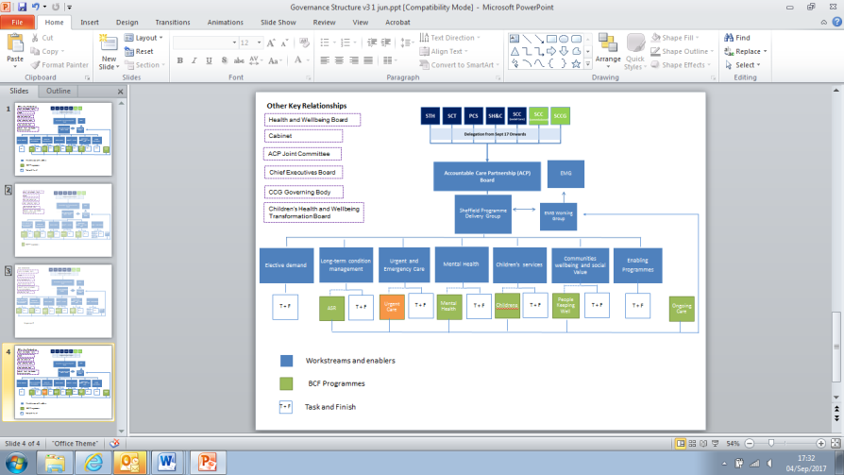

### 8.5 Urgent Care

Lead director: Brian Hughes Sheffield CCG/Phil Holmes Sheffield City Council

**What will this area of work do and what will change as a result?**

This programme will deliver:

* A consistent and equitable offer for urgent and on the day primary care across the city.
* Assessment and reduction in non-elective admissions.
* Reduction in delayed transfers of care (DTOCs).

**What will happen in 2017/18 and 2018/19?**

* Review and redesign of the urgent care in primary care system in Sheffield with implementation of some aspects having commenced.
* Further improvements will be made to the assessment and step up facilities when patients’ needs can no longer be met in Primary Care.
* Patient flow through hospitals will be improved with care optimised and discharges planned on admissions.

**What’s changed since the last BCF submission?**

* The review and redesign of urgent care in primary has commenced and progressed to the NHS England 2nd gateway (
* Implementation of STH Excellence in Emergency Care: revised assessment models have been implemented in the Admissions units, implementation of the planned approach to discharge management has commenced and themes of safer, better, faster have been adopted.
* A system wide taskforce has been established to reduce the number of DTOCs in the city which is being support by Newton Europe.

**Key developments/successes in the last year:**

Sheffield Children’s Hospital (SCH):

* The Children’s Hospital continues to be one of the top three highest performing A&Es in England.

Sheffield Teaching Hospitals (STH):

* Conveyance rates by ambulance to A&E where patients then receive no treatment or diagnostic (or walk out before seeing a clinician) have reduced by 50% this year compared to last which is approximately 2000 less patients.
* There has been a step change in reducing the numbers of patients regularly attending A&E. Data from STH suggests a more than 10% reduction and a continuing downward trend.
* Following the relocation of the GP collaborative to effectively co-locate it with A&E, there has been a steady improvement in the number of patients who are redirected there from A&E with 15-20 patients redirected every weekend day.
* Pathway protocols for assessment pathways for GP urgent referrals have been strengthened via the SPA. Patients are now actively encouraged wherever possible to self-convey to hospital when accessing assessment pathways. This reduced travel time to 45 minutes (as opposed to 2-4 hours) greatly increases the opportunity for patients to return to their own home that day (and access other supporting services in the community) rather than being admitted.
* Circa 45% of patients attending the reconfigured Medical Assessment Unit (MAU) and Acute Medical Unit (AMU) are now being discharged rather than being admitted into the core hospital as in the past.
* Discharge of patients at weekends is now supported by volumes of Planned Discharge Dates (PDDs) which are shared with transport providers enabling them to plan additional capacity when required to support the hospital at times of peak demand.

**What are the main benefits of this area of work?**

* Patients requiring urgent primary care being seen in the most appropriate setting.
* Reduction in conveyances to hospital which do not result in provision of significant care or diagnostics.
* Reduction in non-elective admissions.
* Reduction in DTOCs

**What are the main risks and issues?**

* That system wide flow issues (particularly with regard to patients requiring short term re-enablement support) leading to high levels of DTOC are not resolved, leading to high levels of DTOC.

**What consultation has been carried out?**

* Urgent care in primary care: Broad community engagement to develop the Urgent Care Strategy with further specific engagement with vulnerable groups on urgent care in primary care. Additional engagement with local and potential providers to develop options for the future. A formal public consultation will be undertaken September – December 2017.
* Discussions at A&E Delivery Board and elsewhere around assessment model and non-elective admissions.
* Taskforce joint working across STH/SCC/CCG.

|  |  |  |  |  |  |
| --- | --- | --- | --- | --- | --- |
| **Outcome** | **Metric** | **How will this be Achieved** | **Risks** | **Mitigations** | **Current Performance** |
| **Decreasing A&E Waits** | The National 4 hour target (95% of A&E attendances <4 Hour wait by March 2018 and beyond) | Supporting workstreams to improve system flow and remove unnecessary delays in pathways (e.g. reducing DTOCs)  GP Streaming to be expanded to in include in hours to reduce number of unnecessary A&E attendances.  A cohort of 25 patients has been identified who are frequent A&E attendees and care plans formulated in conjunction with Social Health and Social Care (  Analysis of the variability of performance and looking at leadership issues / staffing. This includes analysing periods of weaker performance against similar time periods where performance has been good and highlighting potential causal factors.  Improved modelling of expected demands and surges in demand | Winter Pressures | System wide winter resiliency plan | Currently STH is performing above the agreed STF trajectory. SCH consistently performs above the 95% target even during times of pressure. |
| Implementation of ARP | Close partnership working across the region via Lead Commissioner networks (999/111 CMBs |  |
|  | | |

|  |  |  |  |  |  |
| --- | --- | --- | --- | --- | --- |
| **Outcome** | **Metric** | **How will this be Achieved** | **Risks** | **Mitigations** | **Current Performance** |
| **Increase number of same day discharges from assessment units** | Increase the % of 0 LOS spells on assessment units | A large body of work has been undertaken to identify opportunities in assessment pathways to improve efficiency and in some areas entirely new pathways have been developed.  It has been recognised too that the sooner the patient arrives into the assessment units the greater the chance of a same day discharge. Where appropriate and safe, patients are being advised to transport themselves to the assessment units rather than waiting for transport. | Winter Pressures will overwhelm supporting services both within the hospital and wider health and social care system. A lack of responsiveness could have a significant impact on the ability of these pathways to function effectively | System wide winter resiliency plan  Supporting initiatives to support system resiliency as a whole e.g. Weekly Flow Group meetings and Newton Europe work | YTD performance is 45% of spells are now 0 day LOS up from last year (circa 30%) |

|  |  |  |  |  |  |
| --- | --- | --- | --- | --- | --- |
| **Outcome** | **Metric** | **How will this be Achieved** | **Risks** | **Mitigations** | **Current Performance** |
| **Reducing LOS on spells less than 4 days in 5 identified specialities** | Reduction in the average LOS across the 5 identified specialities | Improve patient flow in the identified specialities by rolling out the Excellence in Emergency Care programme:   * Creating the “Vital Room” community within the STH to improve cross-speciality working * Introduction of the SAFER 10 Flow principles onto wards initiatives such as “Give it a Go Week” to encourage new ways of working | Winter Pressures will overwhelm supporting services both within the hospital and wider health and social care system. A lack of responsiveness could have a significant impact on the ability of these pathways to function effectively | System wide winter resiliency plan  Supporting initiatives to support system resiliency as a whole e.g. Weekly Flow Group meetings and Newton Europe work | Short LOS (< 4 Days) has been reduced by 0.4 on average in the 5 identified specialities. |

|  |  |  |  |  |  |
| --- | --- | --- | --- | --- | --- |
| **Outcome** | **Metric** | **How will this be Achieved** | **Risks** | **Mitigations** | **Current Performance** |
| **Reducing the number of Delayed Transfers of Care (DTOCs)** | DTOCs to be reduced to 50 by September 2017 and beyond | A cross city taskforce has been assembled and initiatives identified to reduce DTOCs via a number of methods across the system. The initiatives have been grouped into 3 separate workstreams each led by a city organisation executive. This work is being supported by Newton Europe who have a deep level of experience in improving the performance of health and social care system systems | Independent Sector capacity during winter | Additional funding from Local Authority during winter | DTOCs have currently been reduced to 62 as of the last weekly report (historically in Sheffield this would be over 100 consistently). The expectation is that the target of 50 will be achieved by September 2017 |

### 8.6 Mental Health

Lead directors: Brian Hughes Sheffield CCG/Dawn Walton Sheffield City Council

Developing our approach to transforming Mental Health Services requires us to focus on prevention, improved access to early support and help and to better support those with complex and crisis needs. Our plan requires a move towards an all age approach and therefore integration between Children’s, Young People’s and Adult Mental Health Services.

**What will this area of work do and what will change as a result?**

The aims of this piece of work are to ensure:

* Pooled commissioning budget.
* Single/integrated commissioning team.
* Single vision for mental health services across Sheffield.
* Ability to commission whole pathways of care.
* Development of a single transformation programme, delivered jointly with main provider.
* Begin to instil Accountable Care Organisation (ACO) principles; joint delivery and joint accountability; and
* Integrated transition between Children’s and Adults services.

This area of work links to the [Five Year Forward View for Mental Health](https://www.england.nhs.uk/wp-content/uploads/2016/02/Mental-Health-Taskforce-FYFV-final.pdf) and [Implementing the Five Year Forward View for Mental Health](https://www.england.nhs.uk/wp-content/uploads/2016/07/fyfv-mh.pdf).

**What will happen in 2017/18 and 2018/19?**

Initiation of large scale transformational programme including:

* Full review of dementia care pathway.
* Development of primary care mental health service.
* Implementation of Core 24 Liaison Mental Health Service (LMH) (which starts outside of hospital).
* Development of neighbourhood based ‘low level’ provision (social prescribing), Maximising our range of prevention and early help services.
* Review of long term nursing and residential care.
* Better access to step-up and step-down provision.
* Better integration between physical and mental health provision (parity of esteem).
* Reduction in long term high cost out-of-city packages through targeted investment in local community based services.
* Improved access to training and employment.

**The overarching objectives/outcomes of the programme**

The overarching objectives/outcomes of the programme are as follows:

1. To improve the quality of services and the experience of those who use them

2. To reduce reliance on long-term bed based care

3. To promote preventative person centred care delivered at the earliest opportunity; and

4. To deliver £4m financial efficiencies in 2017/18.

**What are the main benefits of this area of work?**

**Key Benefits**

* Greater focus on early intervention, reducing severity and complexity by tackling illness earlier.
* Greater choice and personalised care.
* Delivery of care closer to home, adopting least restrictive principles.
* Better integration of physical and mental health care, delivery of holistic services.
* Driving efficiency through the delivery of less resource intensive services tailored to the needs of each individual.
* Improved access to training and employment.
* Reduced pressure on crisis services across Social Care and the Police.

**Metrics**

* Better patient feedback and satisfaction scores.
* Utilisation of overall mental health spend.
* Less activity delivered by secondary care mental health services.
* Reduction in acute hospital lengths of stay, outpatient attendances and accident and emergency presentations for those with a comorbid mental health diagnosis.
* Reduction in mortality gap between those with and those without a mental health diagnosis.
* Reduction in long-term nursing and residential care.
* Reduction in out-of-city placements.
* Development of robust neighbourhood based portfolio of services; evidenced through increase in social prescribing.

**Trajectory of spend until 2018**

The transformation programme is forecast to deliver a £4m efficiency in 2017/18 and a further £2m in 2018/19. It is difficult to provide a simple trajectory of spend given a large proportion of the efficiency will be delivered from service areas outside of the pooled budget. It is possible therefore that the programme will be delivered, yet the overall pooled budget does not reduce. Further work will be required before a trajectory can be provided.

**What are the main risks and issues?**

* Delivery of transformational programme is reliant on all parties working collaboratively and jointly. There is not statutory requirement for them to do this.
* Transformation programme does not deliver efficiencies within required timescales which may therefore generate financial instability.
* The transformation programme is very ambitious and will require dedicated resource to ensure full delivery. Although a joint post has been created and filled, working across all three organisations, the delivery of each respective programme area is being undertaken on top of a number of individual’s current roles. This will need to be reviewed regularly. It is important to acknowledge that whilst the Mental Health Transformation Programme is focused on system wide financial challenges, it does not yet have a formally constituted delivery mechanism.

**Mitigation on highlighted risks**

|  |  |  |
| --- | --- | --- |
|  | Risk | Mitigation |
| Risk 1 | Delivery of the transformational programme is reliant of all parties working collaboratively and jointly. There is not a statutory requirement for them to do this. | A governance arrangement has now been agreed by respective CEOs, which ensures cross organisational  involvement at every stage of the decision making process. This is supported by a delivery structure which is overseen and monitored by the Transformation Steering Group, consisting of an Executive Director sponsor from each organisation. In addition, the Mental Health, Learning Disability and Dementia Delivery Board, which is chaired by Kevan Taylor (SHSC CEO), has now been constituted as being the main forum at which major decisions will be taken. The membership of this group includes senior staff from each of the partners, plus other interested parties, including service user and carer representation. The Delivery Board reports to the Accountable Care Partnership Board.  Significant work has also been undertaken in terms of engagement, ensuring that the aims and objectives of the transformation programme are well known and, importantly, well understood. This has included targeted one-to-one engagement as well as presenting to various forums across the city. The key message has however been consistent; this is a jointly owned programme of work aimed at improving the quality of services and the experience of those who use them. |
| Risk 2 | Transformation programme does not deliver efficiencies within required timescales - this may therefore generate financial instability. | A series of additional schemes are currently being developed to mitigate against potential underachievement. This includes exploratory work around reducing the number of ‘loss making’ services in Sheffield, considering options for further joint working (including, but not limited to, sharing back-room functions), expediting and agreeing stretch targets for existing projects such as the CHC review process and the development of new ‘stand-alone’ projects. |
| Risk 3 | The Transformation Programme is very ambitious and will require dedicated resource to ensure full delivery. Although a joint post has been created and has been filled, working across all three organisations, the delivery of each respective programme area is being undertaken on top of a number of individual’s current roles.  This will need to be reviewed regularly. | Resourcing continues to be an issue and has therefore been raised via the Executive Management Group. A number of solutions are being considered and explored including an invest-to-save approach, whereas additional resource is secured against an increased target which ensures the investment is, as a minimum, cost neutral. Options for developing a joint delivery team are also being considered. As noted, this will continue to be reviewed regularly. |

**What consultation has been carried out?**

* Service User and Public consultation will form a key element of individual project delivery plans.
* Engagement with providers has already been undertaken, in part through the Mental Health and Learning Disability Delivery Board.

### 8.7 Children and Young People

Lead director: Penny Brook Sheffield CCG/Dawn Walton Sheffield City Council

There is a growing need to develop an all age life cycle approach to our services ensuring long term plans to complex care needs are addressed

**What will this area of work to and what will change as a result?**

* **Emotional Wellbeing and Mental Health:** Through our Local Transformation Plan we are transforming our mental health services for children and young people by improving access to services by increasing capacity and developing new models of care, delivering more early intervention and providing better support for the Sheffield workforce.
* **Community Health:** Joining up Children’s Primary and Secondary Care, Children’s Education, Social Care and Family Support Services to ensure families get early help and care close to home.
* **Maternity and Best Start:** Improving the health and wellbeing of women and babies by ensuring we plan together between health and public health and provide evidence based models of care that ensure every child has the best start in life. Revise the local offer of Maternity care within localities.
* **Children with Complex Needs:** Increase personalisation of care between health, social care and education. Develop new provision to meet future need.
* Locality based working to improve access to Early Help Services through schools and primary care.

**What will happen in 2017/18 and 2018/19?**

**Inclusion in the BCF**

* The main activity in 2017/18 will be to understand which areas of children’s expenditure will benefit the most from integrated working.
* To identify which areas would benefit most from integrated working. We will analyse our projected spend and activity for 2018, 2019 and 2020 and develop a trajectory of spend and activity based on the delivery plans already developed for each of the above priority themes.
* This work will be coordinated by our Children’s Joint Commissioning Group which is currently overseeing the development of a children’s Integrated Commissioning Unit.
* It is anticipated that this work will lead to the formal inclusion of children’s activity in the BCF in 2018/19.
* We anticipate that the first two areas of work to be included in the BCF for activity and delivery in 2018/19 will be Emotional Wellbeing and Mental Health and Children with Complex Needs (SEND), as we have already developed strong integrated working in these areas. This will also further consider the plan to move towards an all age approach and integration between children, young people’s and adult mental health services.
* For each of our transformation areas we have developed a Work Stream Summaries to outline priorities, governance and activity plans for up 2019. Included are the outlines for the following work stream priorities:
* Emotional Wellbeing and Mental Health
* Community Health Programme
* Maternity and Early Years
* Complex Needs

**Emotional Wellbeing and Mental Health**

* Improve access to crisis support by providing a wellbeing café and dedicated section 136 suite for young people.
* Improve access to community mental health specialist services by reducing waiting times and embedding evidence based treatment pathways.
* Provide CAMHS in-reach into primary and secondary schools through our Healthy Minds Framework roll-out.
* Provide a one stop shop for young people in need of emotional wellbeing support in the city centre.
* Transform our CAMHS service for vulnerable children and young people by developing a service to provide emotional wellbeing and mental health support for vulnerable young people from early intervention to community settings.

**Community Health**

* Link primary care and secondary care within localities in Sheffield and ensure rapid access to specialist healthcare when needed.
* Develop the skills of primary care and local communities in making sure children stay well and managing minor ailments, by working with GPs, schools and parenting practitioners.
* Link Children’s and Families support services and health within localities into one integrated local offer.
* Redesign community nursing so that children with long term conditions can be cared for at home instead of in hospital.

**Maternity and Best Start**

* Consult with women to find out how we should provide care for them.
* Work with the Local Maternity System across South Yorkshire and Bassetlaw to improve maternity care.
* Increase the personalisation of maternity care.
* Ensure access to support is available to women as near to their home as possible to ensure they have a healthiest pregnancy possible.
* Develop atonement and attachment between infants and families.
* Improve the pathway of maternal mental health

**Children with Complex Needs**

* Joined up assessment and review between health and care for children with complex needs and SEND.
* Provide support earlier when families are struggling and support children to be within their communities.
* Joint agreements to placements of children in Health, Education and Social Care settings

**What are the main benefits of this area of work?**

* Emotional Wellbeing and Mental Health: Transformation of the support available so that young people are supported earlier and closer to home, whilst those young people who need community support will be seen more quickly.
* Community Health: Reduced attendances and admissions.
* Maternity and Best start: Reduced complexity and intervention, increase in midwifery lead care.
* Children with complex needs – Reduction in placements out of area.

**What are the main risks and issues?**

|  |  |
| --- | --- |
| **Risk/Issues** | **Planned mitigation** |
| Lack of engagement from clinical staff | Planned Protected Learning Initiative Events and full staff consultation to engage clinicians particularly in relation to community health redesign. |
| Diversion in approach and methodology with providers/ SCC/CCG | Through the Children’s JCG align and agree joint methodology and delivery processes |
| Other agendas and initiatives such as in adult services with competing priorities on resource and direction of travel | Through the governance structures of the Children’s Transformation Board and the Children’s Joint Commissioning Group and agreement reached on priorities, activities and timescale to avoid distraction and competing priorities. |
| Demand on resources and growth in need could delay implementation of early help and early intervention and prevention models | Joint partnership commitment to the delivery of a new Early Help model. |
| Public health resources being challenged which could impact on need | Thorough assessment of C&YP’s needs so as to ensure evidence base to manage and challenge PH grant budget reductions |
| Statutory duties still being met through changes in pathways and shared governance and accountability framework | Robust service specifications which maintain delivery and performance and strong provider/commissioner relationships which flag any potential issues. |
| Meeting assurance frameworks and timeframe for mobilising new models of care  Resources to deliver the changes needed within timescales needed. | Comprehensive review of our Children’s Transformation Board priorities and capacity with identified project delivery capacity agreed via each partner: SCC, SCCG and SC NHS FT |

**What consultation has been carried out?**

* Co-production in place with young people.
* Joint programme planning in place with providers.
* Consultation with local users of maternity care services being undertaken.
* Joint programme planning in place with Healthwatch and Voluntary Action Sheffield.

### 

### 8.8 Capital

Lead director: Penny Brooks Sheffield CCG/Phil Holmes Sheffield City Council

**What will this area of work do and what will change as a result?**

With Disabled Facilities Grant (DFG), work has started to see if there is potential to use some of the money more strategically to help with Delayed Transfers of Care and Out of Hospital targets. There are strict rules on how the money must be spent and so it will take some time during 2017/18 to scope out what is possible. The first potential new strategic capital proposal for DFG is the use for high value community equipment. If further scoping is successful then some additional capital funding may be available to support other health and social care capital initiatives.

The social care capital grant is being rolled forward into 2017/18. This grant will be used to help fund the cost of the replacement of the Care First – Sheffield City Council’s social care case management system.

**What will happen in 2017/18 and 2018/19?**

* DFG scoping to identify strategic opportunities for capital investment.
* Maximise the increased grant value by further promoting the service.
* Replacement of Care First.

**What are the main benefits of this area of work?**

* The DFG currently funds (subject to eligibility) work to provide safe access into and around a person’s home so that they and their carers can remain living there as comfortably as possible. Works that can be funded include large equipment such as stair lifts, hoists, through floor lifts and ramps and major adaptations such as level access showers. For more complex needs structural alterations and extensions can be funded.
* Need is assessed by Occupational Therapists and clients are further assisted through the financial and construction process by officers in the Adaptations Housing and Health (AHH) Team. The AAH team work closely with clients to help them achieve adaptations that are appropriate to their personal circumstances, offering to support them to carry out alternative works to meet their personal aspirations where possible. Around 400 people per year benefit from these grants.
* DFG strategic scoping is a new area of work for 2017/18 which will consider if there are other ways this grant can be used for the benefit of patients.
* The replacement of Care First will improve the efficiency of the system leading to better service to patients. The project will also help in improving the integration of systems between Health and Social Care.

**What are the main risks and issues?**

* DFG may provide some strategic capital investment opportunities but there is no additional revenue funding to support these initiatives. The scoping may not find any meaningful projects to support.

**What consultation has been carried out?**

* For Care First this will be covered within the project.
* For DFG scoping this will be uncovered as the work progresses.

### 

### 8.9 Primary Care

**Our vision for general practice**

Our vision for primary care in the city is threefold and our primary care strategy developed in 2016 outlines how the future of primary care in Sheffield might work together. If the changes in our strategy are implemented we can expect the following outcomes:

* better equality in health outcomes for people living in Sheffield; this means improving how people manage their own health and ill health and making sure they have access based on need to the support they need, regardless of their social circumstances.
* stable primary care services with sufficient numbers and skill mix of staff to manage the demand plus IT and buildings that support and enhance service provision.
* people receive the right interventions at the right time from the right professional – mostly in their local neighbourhood.

The above objectives and outcomes are what we are setting out to achieve. This will require a change in behaviour and culture for patients, providers and commissioners alike.

The public will be encouraged and enabled to seek support and interventions from a wider range of professionals and not use their GP as the default option for all health queries - they will play a much bigger part in managing their own health.

Providers of primary care services will be encouraged and enabled to work differently – from the way they interact with patients to their working relationships with the health, social care and voluntary sector, to sharing contracts and resources with other providers.

Commissioners of health and social care services will need to make changes to enablers within the system i.e. change the way they contract and pay for services, shift more resource into primary care and lead on the changes needed to grow the primary care workforce and develop the right IT and estate infrastructure.

**Transforming Primary Care**

General Practice plays a highly significant role in our Sheffield system wide transformation agenda. They provide the foundations to enable us to shift resources and services from hospital to the community. Whilst our primary care budget is not within the BCF, the work we are doing is a vital component of the BCF programme’s vision and aims.

The CCG is working with GP practices in Sheffield to transform primary care in order to respond to transferring services out of hospital over the next 3-5 years.

We expect to achieve the following key outcomes:

* primary, secondary and community care providing a seamless pathway for patients with GPs as the linchpin for care.
* Patients able to self-manage their conditions from home utilising technology to connect with healthcare professionals.
* Reduction in health inequalities by delivering appropriate access, ensuring greater need has greater access, achieving equity of access (versus equity of outcome) with patients accessing equivalent, consistent standard and high quality services.
* Increase of the wider workforce within general practice to improve consistency in patient experience.
* A programme of patient education and engagement with strong outcomes.
* Support of the requisite infrastructure in Information Technology (IT) and estates in order to deliver sustainable primary care.
* A programme of service shifts from traditional hospital settings to community bases.

Two of our major programmes to transform general practice, are the development of Neighbourhoods and our transformational support funding/at scale working and resilience to support practices to a fit modern sustainable general practice. (

**Neighbourhoods**

As mentioned at the start, we now have 16 neighbourhoods covering the whole of Sheffield.

Neighbourhoods are defined as a geographical population of around 30-50,000 people supported by joined up health, social, voluntary sector and wider services to support people to remain independent, safe and well in their community.

Neighbourhoods will make the best and most effective use of services for local people with the following aims;

1. Improve health and care outcomes (such as improving the quality of life for people in the neighbourhood).
2. Improve quality of care (particularly for those living with long term conditions).
3. Reduce unnecessary health and care service use and provide health and care services closer to home where possible (particularly through reducing avoidable, unplanned hospital admissions).

Patients will receive:

* Co-ordinated health and social care to enable themtotake better control of their own health and wellbeing, to live independently and stay healthy for longer.
* Know who to contact and when to contact them when their needs increase.
* Receive appropriate care closer to their home.
* Have the opportunity to contribute to the development of services within their local area.

Our 16 neighbourhoods equates to 82 independent businesses working togetherin groups in their communities, with their patients, hospital services, community services, mental health, and voluntary organisations to improve care for their community.

The Neighbourhoods are now developing new ways of working, such as:

* A neighbourhood integrated care team (a Primary Care home style/virtual ward style team) is being rolled out across one locality in the first instance. The team is made up of all services: voluntary, health and care coming together to focus on their patients in a more co-ordinated way to increase primary and community care and support to reduce inappropriate admissions and reduce unnecessary stays in hospital.
* Exploring the use of Mental Health and Wellbeing workers linking to their community partnerships.
* Looking at the expansion of a successful primary mental health care project to support the needs of patients with severe and enduring mental illness.
* Evaluation of a paramedic service providing home visits.
* Neighbourhoods are also a route to build primary care resilience and sustainability. Some initiatives starting in some neighbourhoods include sharing workforce, agreeing terms of reference in order to make decisions on behalf of the neighbourhood, exploring workforce planning such as the use of physician associates in the future.

Neighbourhoods are a key aspect of delivering our Sheffield Plan. We recognise that neighbourhoods are at varying degrees of development and maturity and need different kinds of support. We are exploring how best we can support neighbourhoods by starting to develop a maturity index to describe our ambitions of neighbourhoods and what we expect, in order to identify how best to support them.

**Transformational Support Funding**

The 2017/18 Planning Guidance identified that CCGs should plan to spend a total of £3 per head as a one off non-recurrent investment commencing in 2017/18 from within their NHS England allocations for CCG core services.

Sheffield CCG will spend the £3 per head over the two year period 2017/18 and 2018/19. This equates to £883,000 for 2017/18.

The Sheffield GP Forward View Plan was launched at a practice management event in February 2017 which included a number of work programme offers for all GP practice and will continue in 17/18. These include:

* Building the workforce to include modern apprenticeship programme, advanced care practitioner, nurse practitioner.
* Supporting the workforce/succession planning – including Institute of Leadership and Managment training to support the managers of the future.
* Increasing resilience by learning from others across the country in regards to care navigation and clinical coding.

### 8.10 Housing Strategy

Our 10 year Housing Strategy was agreed in 2013. We are currently developing a mid-term Housing Strategy statement that will be tabled at Cabinet in November 2017. This will not change the strategy overall but will set out what the current main issues that we need to prioritise in the next 3-5 years and how the Strategy will complement other key high level strategies. It will also reflect the changes that have been made nationally since the strategy was agreed including funding and government legislation. The main strategy is supported by a number of sub-strategies. The Strategy is set by the Council but it is delivered by a range of partners including registered housing providers and developers.

***Vision:*** Provide more homes and for housing to be at the heart of high quality, safe and distinct places to enable Sheffield’s communities to thrive

**Priorities**

• Increase the supply of new homes in the city.

There is a shortage of new homes in the City and there is a need to increase the numbers to meet a range of housing needs and aspirations for sale and rent for all budgets. This includes the supply of Affordable Housing which is available for rent or shared ownership. Having the right supply of housing is critical to meeting the City’s social and economic ambitions.

• Make Best use of the city’s existing housing stock

The majority of residents will continue to live in the current housing in the City which offers a rich variety in different neighbourhoods. Some of this stock requires investment to maintain or address poor housing standards in the private sector. There is the need to make sure that the best use is made of what is available, for example through letting’s policies or bringing empty properties back into use. We prioritise sustainability and affordable energy because of the environmental impacts of housing and on health.

• Help younger, older, vulnerable people to live independently

Some of our residents need additional support or specialist provision to meet their housing needs or aspirations. We therefore prioritise this through specific strategies and commissioning plans. New strategies in development include our Homelessness Prevention and Older Person’s Independent Living Strategy.

## Our financial plan

**Overview**

The Sheffield Better Care Fund Pooled Budget was £272m in 2016/17 and the budget for 2017/18 is £364m. The figures for 17/18 are the initial budgets as agreed by the Executive Management Group on 15 May 2017 as adjusted for the inclusion of the new iBCF funding stream. A provisional budget for 2018/19 has been prepared for inclusion in the planning template and this narrative plan but, at this stage, this budget is draft and is subject to change since the formal budget setting process for 2018/19 has not yet completed.

The biggest proposed change to the BCF in 2017/18 is the addition of a new theme in relation to Mental Health which is the main reason for the c£92m increase in value of the BCF budget in 17/18. Sheffield NHS CCG and Sheffield City Council have agreed to pool their mental health budgets and to risk share the combined financial position.

The other major change to the budget from 2016/17 is the inclusion of the iBCF enhanced government funding which was announced in the Spring Budget to support social care and relieve pressures on the NHS. This is discussed in more detail in the funding contributions section later in the document.



Note - the reduction in ongoing care in 2017/18 is predominantly a transfer of Mental Health purchasing costs into the new theme for Mental Health.

**Management of the Pooled Budget**

The legal contract that governs the Better Care Fund is called the Section 75 Agreement. A variation to this agreement has been drafted to reflect the revised programme of work and budget for 2017/18. This variation should be signed in September.

The Community Equipment Service (budget £2.8m) and Mental Health (budget £102m) are jointly managed schemes with a risk share arrangement for any over or underspends. These schemes represent nearly 30% of expenditure lines within the BCF, with the balance being solely managed or jointly managed schemes that are funded solely by the partner responsible for that scheme.

The Section 75 agreement clearly sets out the process for dealing with over and underspends from all scheme types and has worked well during 2015/16 and 2016/17. Work will continue in-year to explore whether there are more services which would benefit from alternative mechanisms for the organisations to share risk when implementing integrated activities.

## Risk

The strategic leadership and delivery assurance of the Better Care Fund is undertaken by our Executive Management Group (with separate groups managing strategy and delivery) underpinned by a recently revised section 75 agreement The Executive Management Group includes representation from Executive Directors and Directors leading the workstreams from both CCG and Local Authority.

The group was originally constituted as part of the integrated work between Sheffield CCG and the Local Authority 3 years ago when the provider landscape, national direction and financial challenges were different. The focus has changed now following the Five Year Forward View to more of a partnership approach for commissioners and providers together. Sheffield now has a broader plan as demonstrated in the Sheffield Plan, works in a South Yorkshire and Bassetlaw accountable care system, and the Better Care Fund and its governance needs to ensure it remains fit for purpose going forward to deliver all of our ambitions.

With this in mind, the group is reviewing its governance, roles and responsibilities to ensure it can:

* Work seamlessly within a joint commissioner/provider partnership.
* That due to the ambitious savings plans, it can take responsibility to project manage progress, manage risks and inter-dependencies across all our workstreams.
* It uses resources smartly and does not duplicate any existing functions.

Please see chapter 7 on programme governance and management and chapter 13 on risk and risk management.

## National Conditions

### 11.1 National condition 1: Jointly agreed plan

Each of our priorities has set its aims and objectives, key plans for 2017-19, its risks and mitigations and developing outcomes and metrics and governance. This has been informed by each of the workstreams programme plans, which in turn have been developed and signed off by the Boards which manage each of the priorities. Sitting on those Boards are representatives from commissioning, providers, voluntary and third sector organisations which manage progress monthly, manage risks and steer the direction of the programmes.

Because of key guidance being issued after our most recent Health and Wellbeing Board, the Board signed off the most recent draft in July 2017. Our Health and Wellbeing Board has representatives from Commissioners and a range of statutory and non-statutory organisations as well as representatives from the CCG, Council and Health Watch.

The Health and Wellbeing Board agreed to delegate final responsibility to officers from both organisations.

### 11.2 National condition 2: social care maintenance

The CCG mandatory BCF expenditure is shown below.



The increase in the BCF CCG minimum spend has been split to give an increase in both Community Health and Social Care. In Sheffield the total contribution to the BCF from the CCG is much larger than the minimum mandated value. It is more meaningful to review the total expenditure than just the minimum which is shown below.

|  |  |  |
| --- | --- | --- |
| **National Condition 1 - NHS Total Spend** | |  |
|  | **2017/18 Plan** | **2018/19 Plan** |
|  | **£** | **£** |
| Acute | 56,505,210 | 59,739,462 |
| Community Health | 42,874,000 | 43,038,879 |
| Continuing Care | 53,897,000 | 53,051,918 |
| Mental Health | 67,822,100 | 68,782,201 |
| Primary Care | 1,332,000 | 1,254,667 |
| Social Care | 21,991,000 | 22,952,646 |
| **Grand Total** | **244,421,310** | **248,819,773** |

Sheffield CCG recognises the pressures in adult social care and continues to provide support in this area to ensure services can be maintained. The full value of the iBCF grant has been retained by the Council and the CCG has not reduced investment as a result of the Council receiving additional funding.

The changes to expenditure are focussed around the key BCF themes. Community Services in Sheffield represent Community Nursing, Intermediate Care beds and reablement. Despite these services being redesigned the investment has been maintained.

Continuing Care is forecast to reduce following in part a number of initiatives put in place during 2016/17 and 2017/18 namely high cost package reviews and a move to assess more patients outside of an acute setting.

Mental Health services have been added to the BCF for the first time in 2017/18. A truly integrated commissioning approach for mental health will offer more effective joined up commissioning (and therefore care), leading to better patient outcomes which will, by default, deliver better value for money.

The increase in social care by the CCG in 2017/19 is partly as a result of the new risk share arrangements for mental health. The investment in social care payments is very much focussed around the overall health benefits for residents and is best evidenced by the new joint approach to managing mental health services. A lot of the investment in this area is planned to reduce acute admissions and prescribing costs.

The change in investment levels and detailed budget plans were discussed by the CCG and Council in detail in January/February 2017 to ensure the combined planned activities hung together and did not destabilise any areas of the health and social care system. This detailed review of CCG and Council plans also considered the potential impact on any individual providers.

### 11.3 National condition 3: NHS commissioned out-of-hospital services

At present there is no system-wide agreement with providers to implement a risk share arrangement for reduction of spend on non-elective admissions.

Sheffield City Council and Sheffield CCG are working together to identify contingency plans to secure financial balance that allows us to continue upstream investment that secures reduced activity in acute hospital services, including impact through delays in transfers of care.

As part of our clear commitment to investment in out of hospital services we have supported specific out of hospital service developments through non-recurrent funding or through different ways of working  in order to evaluate impact on hospital based activity and on reducing delays in transfer of care and, where relevant, to support business cases for longer term investment. For example:

* Virtual Ward: A virtual ward provides wrap-around care to people in their own homes to reduce the need for hospital admission.  For a person with complex health conditions, a virtual ward is about better self-care, self-awareness and confidence to handle common flare ups at home. This has been piloted across 21 GP practices in Sheffield and is currently being evaluating: early findings are very positive.
* People Keeping Well: Investment in Community Support Workers who are now permanent employees in the system. These ………??
* IV in the community: Currently developing the ability to increase community IV which will support earlier discharge for a significant cohort of patients such as the frail elderly, and those suffering with cellulitis.
* Creating together an out of hospital multi-disciplinary team to provide a single point of access into out of hospital services.

Additionally we continue to work with inter-connected programmes of work such as Accountable Care Partnership workstreams and the primary care development agenda including the commitment to invest a additional non-recurrent £3 per head over a two year period.

### 11.4 National Condition 4: Managing Transfers of Care

Please see our section on Delayed Transfers of Care in section 15

## Overview of funding contributions

Is there a confirmation that the components of the Better Care Fund pool that are earmarked for a purpose are being planned to be used for that purpose and this is appropriately agreed with the relevant stakeholders?

The funding contributions to the BCF from Sheffield City Council and Sheffield NHS CCG are shown below.



A new funding source for BCF activities called iBCF funding was announced some time ago. This iBCF funding was released in two tranches, but has since been combined. The values of the iBCF grant for Sheffield are shown below.



The first tranche was a planned increase in social care funding from Central Government. This additional funding stream to the BCF was more than offset by the continuing annual reduction to Revenue Support Grant received by Local Authorities. Sheffield City Council has used this first tranche of BCF funding to protect the BCF budget from its share of Revenue Support Grant cuts.

The second tranche of iBCF funding was announced in the Spring 2017 budget and is non-recurrent investment funding to stabilise the social care market, reduce delayed transfers of care and relieve pressures on the NHS. This second tranche of funding has been added to the BCF budget and further details of this investment plan can be found in the iBCF grant section of the plan below.

The recurrent investment from Sheffield City Council into the BCF in 2018/19 is constant with 2017/18. The fall in total Council expenditure in 2018/19 from £120m to £114m is due to the reduction in the enhanced iBCF grant from £12.6m to £7.7m and the cessation of non-recurrent capital funding of £1.5m.

It must be noted that the figures shown are budgeted levels of spend. Within Sheffield City Council in the current year forecast expenditure on adult social care and related adult services is running £11m higher than budget. This reflects recurrent pressures that are forecast to worsen by a further £15m in 2018/19. There remains a significant challenge for the Local Authority to balance their financial position. The CCG is also facing significant financial challenges in 2017/18 partly due to the necessity to create an overall £22m QIPP plan in order to meet CCG commissioning requirements including our share of the South Yorkshire and Bassetlaw CCGs’ control total. This required QIPP in most areas of spend including mental health, other ongoing care (CHC) and hospital emergency admissions, so budgets included within the BCF. Potential non delivery of some of this QIPP and other demand pressures may mean that the CCG also overspends against some or all of the budget areas in the BCF which it is looking to manage through use of reserves and other measures.

The CCG contribution to the BCF budget is set to provisionally increase in 2018/19 by £4.4m but this is stated before the setting of 2018/19 QIPP requirements which will be determined as part of the 2018/19 planning and contracting round commencing in September 2017.

Agreement on funding for carers has been in place for some time. There is a Carers Core Service which provides information and advice, including carers assessments. There is also community outreach via People Keeping Well activities, and breaks from caring also delivered via People Keeping Well partnerships. The CCG were party to the development of the Carers Strategy which is implemented by the Council.

Care Act duties are partly funded by the CCG contribution to social care which is discussed in more detail under national condition 1.

Considerable reablement services are provided both by the Local Authority and CCG as part of the commissioned out of hospital services within Theme 2 AS&R. Funding agreement for these services has been in place for some time.

**IBCF Grant**

As set out in the 2015 spending review and the BCF Policy Framework, Sheffield’s iBCF commits available funding to the three priorities set out below. The plans were were recently approved by SCC Cabinet, outlining the conditions as set out in national guidance, pooling the grant funding into the local BCF, working with the CCG and Providers and providing quarterly reports. The paper can be viewed in the following link.

<http://democracy.sheffield.gov.uk/documents/s27399/Additional%20Budget%20funding%20to%20spend%20on%20Adult%20Social%20Care%20services.pdf>

There has been extensive consultation with NHS partner organisations, both CCG and Providers in Sheffield, to ensure that the balance of investment helps the whole health and care system provide better outcomes for local people. The three key priorities are:

* The need to invest in development, innovation and infrastructure that will address underlying issues, rather than continuing to work within the existing health and care system and its constraints. £5.900m investment earmarked to support this priority over three years.
* The need to build the sustainability and resilience of the adult social care provider market so that capacity is there to support the whole health and social care system, particularly in times of high demand. £9.813m investment earmarked to support this priority over three years.
* The need to ensure that adult social care needs can still be met where there is significant financial constraint that might otherwise result in a service reduction. £8.287m investment earmarked to support this priority over three years.

The year one delivery has been allocated to individual themes.

* **Greater efficiency within the Short Term Intervention Team (STIT) within Theme 2 Active Support and Recovery**

To invest in assessment and review capacity so that access and length of stay to this intermediate care service become more optimal. STIT’s internal efficiency programme will make this self-financing after one year, so funding is phased over the second half of 2017-18 and the first half of 2018-19.

* **Improving medication management for people who receive care at home. Within Theme 1 People Keeping Well.**

Developing a single approach to recording the administration of medication in peoples’ own homes will create considerable benefits both for Sheffield citizens and to those managing and administering medication. A greater degree of consistency in recording will reduce the risk of errors and also make it much more straightforward for NHS colleagues in the community and in hospital when medication is reviewed.

* **Whole system innovation to reduce Delayed Transfers of Care and improve outcomes for Sheffield people after their hospital stay. Within Theme 2 AS&R.**

Innovation fund to support the rapid development of schemes to reduce Delayed Transfers of Care and care home placements from hospital with immediate effect from this winter. Support key priorities like enhancing the ability of health and social care staff to support people with complex needs in their own home, supporting care homes to better manage the health conditions of residents, supporting voluntary and community organisations to give that little bit of help

* **Sustainability of the social care provider market supporting older people. Within Theme 4 Ongoing Care.**

A further increase in the market rate that Sheffield City Council pays, with the proviso that this investment directly improves employment terms and conditions for front-line staff, is likely to significantly enhance stability and improve quality of life for people living in their own homes and care home residents. In turn, this should improve use of resources for both the NHS and the Council, leading to less usage of both acute and care home beds. The challenge for Sheffield will be to use resources released by lower usage of acute and care home beds to sustain these benefits beyond the three year allocation of funding.

We expect the total homecare hours and packages to increase. It is impossible to quantify by how much because influences are multifactorial. We expect the number of care home placements to decrease, it is impossible to quantify because influences are multifactorial but we already make too many placements in relation to comparators and a key DTOC strategy will relate to extending Discharge to Assess and therefore reducing the number of placements made from acute setting.

* **The need to develop the health and care workforce to support delivery. Within Theme 4 Ongoing Care.**

Key objectives need to be translated into a practice framework that supports individual interactions between staff and citizens. Staff and citizens need to be involved in designing the key tools and forms that will underpin individual interactions and be significant ingredients in the new Case Management System. New service models, for example locality working, also need support to embed. Social care workforce development will better enable a shift into integrated working rather than just lifting and shifting current practice into new locations.

## Assessment of Risk and Risk Management

As displayed in our programme chart, each workstream has its own Board which, through normal programme management rules, assesses risk on a monthly basis. For ease in Appendix 4, are all our risks and mitigating actions.

EMG working party, which receives highlight reports from each workstreams, and again programme manages on an exception basis only, manages risks on a system wide basis.

As outlined in chapter 7, it is acknowledged that because of the huge savings needed in Sheffield it is reviewing its cross system assurance process to ensure all workstreams are on track and will ensure success and realise our benefits.

## National Metrics

Targets for 2017/18 and 2018/19

The number of mandatory BCF targets has been reduced in 2017/18. An overview of the mandatory targets is shown below.



1. **Delayed transfers of care** have recently been remodelled and the target shown above corresponds to the recent resubmitted target to NHSE
2. **Non Elective Admissions**

Non Elective admissions performed better than target in 2016/17. The cost of non-elective admissions was higher than budget in 2016/17 but this was predominantly due to excess bed day costs associated with a higher level of delayed transfers of care. The target for 2017/18 is based on reductions delivered primarily from activities within AS&Rand urgent care.

1. **Admissions to residential and nursing care**

The number of admissions in 2016/17 has fallen 17% compared to 2015/16 and achieved target. The target for 2017/18 is based on the ASCOF submission and assumes a 6% reduction in admissions compared to 2016/17. This will primarily be achieved via the implementation of the 5Q rollout.

1. **Reablement**

The proportion of older people still at home 91 days after discharge is forecast to increase to 80% in 2017/18. The final position for Q4 2016/17 was 75% which was affected by a higher number of deaths than in the year prior. The target for 2017/18 is based on the ASCOF submission is 80%.

Our planned national targets will be achieved through our workstreams’ metrics as outlined in each of the workstream details, especially through Active Support and Recovery, Ongoing Care and Urgent Care, DTOC programme and the iBCF plan.

Summarise the metrics you have set for each of the four national metrics.

You should include an explanation for how each target has been reached, including an analysis of previous performance and a realistic assessment of the impact of BCF schemes on performance in 2017-19.

**Non-elective Admissions**

Describe how this metric has been reached, including an analysis of previous performance and a realistic assessment of the impact of BCF schemes on performance in 2017-19

Specify whether a further reduction in Non Elective Admissions, additional to those in the CCG operating plan, been set.

If you have not set an additional metric, briefly say why.

If you have set a target for further reductions in Non Elective Admissions, set out whether funding has been held in contingency from the ring-fence for NHS commissioned services.

If a target has been set, provide a brief explanation of how it will work and what any funding released for meeting the targets will be spent on.

**Admissions to residential care homes: How will you reduce these admissions?**

Provide an explanation of how this target will be reached, including an analysis of previous performance and a realistic assessment of the impact of BCF schemes on performance in 2017-19?

**Effectiveness of re-ablement: How will you increase re-ablement?**

Describe how the metric for re-ablement will be reached, including an analysis of previous performance and a realistic assessment of the impact of BCF schemes on performance in 2017-19?

## 15. Delayed Transfers of Care

As a national outlier in Delayed Transfers of Care (DTOC), the CCG, Sheffield Teaching Hospitals and the Local Authority agreed to bring in the expertise of Newton Europe, a specialist in working with whole systems to work together to get to the root of why our delayed transfers of care remain a challenge and to work with us to develop an action plan ready for delivery for this winter.

The work was launched at a city summit on 23 May to which all stakeholders were invited to learn of the outcomes of the two week diagnostic which Newton Europe had undertaken  to identify the underlying problems and then, facilitated by Newton Europe, work together to identify how we can improve our discharge services for patients.

What was recognised in the first instance was what we do well:

* We all have a common purpose to always put the patient first
* Some outstanding best practice
* Significant progress made to increase reablement capacity
* Common view of the behaviours needed in a good system
* Unanimous high desire to improve.

Key facts on delayed transfers over the last 12 months which Newton Europe had highlighted in their diagnostic:

* People in Sheffield have spent **72,000** more days in hospital over the last year than they needed to.
* 32% of those impacted on DTOC are waiting for a pathway to be allocated to them.
* 30% of those  impacted by DTOC are on a pathway to either intermediate, nursing and residential care.
* 31% of those impacted by DTOC are waiting to go home with some extra support.

The key workstreams agreed at the Summit were to:

* Get people home
* Rapid Community care
* Assessment at Home.

**Current Position**

Based on the work and outcomes of the summit, STH, the Local Authority and the CCG have worked together to develop the plans for the next stages of the programme. Our action plan is attached in a separate document, titled ‘Sheffield DTOC Action Plan’. These have been presented to Chief Executives of the Council, CCG and STH who supported the plans. Our agreed reduction of numbers of DTOCs is to 50 with locally managed stretch targets.

In summary, we agreed that we will work towards developing only three routes out of hospital (replacing the myriad of current pathways), these being:

1. People who just need to go back to what they had before (i.e. no D2A)
2. People who might need more and should be assessed at home to determine what that might be (D2A at home).
3. People who might need more but MDT are anxious about them returning straight home so they go to step down for assessment (D2A in stepdown which would include Intermediate Care beds).

To develop these routes, we are establishing three workstreams:

1. Work in hospital to navigate people into one of these 3 routes as quickly as possible on admission.
2. Work in community to ensure rapid response community services are there to enable D2A.
3. Work in community to ensure rapid capacity and response assessment is there to enable D2A.

Our improved service model will be underpinned by the Improved Better Care Fund Direct Grant as described in section 4.

Key activities to help deliver the above workstreams will include:

* Understanding the perceived barriers to discharge.
* Increase support to therapists to develop a more holistic risk conversation with patients.
* Integrate active recovery to provide a seamless service to patients to improve outcomes and productivity.
* Increase resilience of Independent Sector Homecare.
* Improve outcomes and productivity in regards to intermediate care beds.
* Increase complex discharges via discharge to assess/more home based assessments.

This will be underpinned by robust metrics and governance. Our main action plan is outlined in the diagram below

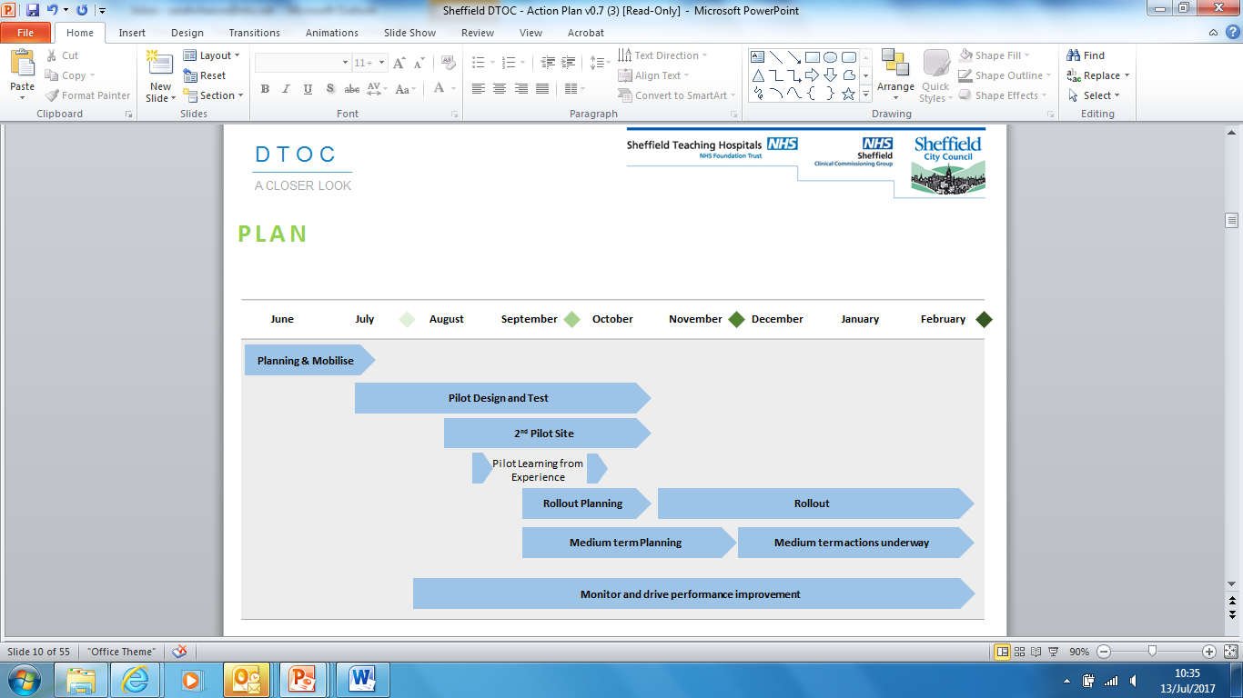

**Use of the High Impact Change Model**

Sheffield’s approach will explicitly incorporate the High Impact Change Model to enable maximum benefits to be delivered in the shortest possible time.

Change 1 : Early Discharge Planning.  In elective care, planning should begin before admission.  In emergency/unscheduled care, robust systems need to be in place to develop plans for management and discharge, and to allow an expected dates of discharge to be set within 48 hours.

Workstream 1, work in hospital to navigate people into one of the 3 discharge routes as quickly as possible on admission, will focus on mainstreaming Changes 1, 2, 3 and 7.

Change 2 : Systems to Monitor Patient Flow.  Robust Patient flow models for health and social care, including electronic patient flow systems, enable teams to identify and manage problems (for example, if capacity is not available to meet demand), and to plan services around the individual.Change 3 : Multi-Disciplinary/Multi-Agency Discharge Teams, including the voluntary and community sector.   Co-ordinated discharge planning based on joint assessment processes and protocols, and on shared and agreed responsibilities, promotes effective discharge and good outcomes for patients

Change 3 -The adult social care re-structure (Sep 2017) implements the formation of a new hospital and OOH SW team, the main aim of which is to support multi-disciplinary discharge planning for patients with social care needs. From September Social Workers will be located in the Single Point Of Access (SPA) Front Door Response Team (FDRT) and visiting wards to support known social care customers. These social care staff will act as point of liaison between ward staff, patients, families, providers and locality based teams to facilitate discharge back to the patients’ home with their previous package of support. Social Workers will be able to provide information to ward staff about existing support in place for patients and also support with more complex cases e.g. where safeguarding issues are perceived to prevent discharge. Further developments are planned to put  in place an MDT ‘hub’ that will receive, screen, and allocate all referrals for people being discharged from hospital who require further assessment (part of AR project plans).

Change 4 : Home First/Discharge to Access.  Providing short-term care and reablement in people’s homes or using ‘step-down’ beds to bridge the gap between hospital and home means that people no longer need wait unnecessarily for assessments in hospital.  In turn, this reduces delayed discharges and improves patient flow.

Change 4 - We will continue to expand the scope of discharge to assess in order to support people with more complex needs, to allow wraparound support for people who may previously have been viewed as ‘too complex’ for D2A.

Change 5 : Seven-Day Service.   Successful, joint 24/7 working improves the flow of people through the system and across the interface between health and social care, and means that services are more responsive to people’s needs.

The Sheffield Children’s Hospital NHS Foundation Trust (SCH) and STHFT are pioneer sites for implementing 7 day hospital services and have a clear plan to deliver the four priority standards. We will continue to work with the acute Hospital Trusts to support and ensure delivery of the action plan.

In regards to some of our projects and plans for the next two years, as part of the Urgent Care strategy and the 5 high impact interventions, we will be optimising patient flow through acute settings; to ensure implementation of national best practice (including 7 day working); to enhance patient flow including proactive admission avoidance and discharge planning; and ensuring incentives and behaviours are aligned so that ‘assess to admit’ and ‘discharge to assess’ trusted assessor models are implemented through collaborative work with all key partners.

SCC are using additional social care funding to develop 7 day services for our in-house reablement service (STIT) from November 2017. This will allow receipt and action of referrals to the same timescales (24hr pick up) 7 days per week. SCC have also invested in OOH Social Work team capacity which will be based on site at NGH to facilitate more support for discharge planning over 7 days including evenings.

Change 6- We already have elements of a Trusted Assessor model in Sheffield – Transfer of Care (Health) staff assess what services are required from social care on discharge and this is procured without the need for assessment in hospital by Social Workers. This work has been re-energised as part of the Active Recovery redesign work. Further planned developments include a Trusted Assessor role for independent care home providers and trusted assessment roles and documentation for health, social care, and independent sector homecare providers (including reablement and intermediate care services). Change 6 : Trusted Assessors.  Using trusted assessors to carry out a holistic assessment of need avoids duplication and speeds up response times so that people can be discharged in a safe and timely way..

Change 7 : Focus on Choice.  Early engagement with patients, families and carers is vital.  A robust protocol, underpinned by a fair and transparent escalation process, is essential so that people can consider their options, the voluntary sector can be a real help to patients in considering their choices and reaching decisions about their future care.

Change 7 - Workstream one is creating leaflets for patients to communicate a clear message that manages expectations.

Change 8 : Enhancing Health in Care Homes.  Offering people joined-up, co-ordinated health and care services, for example by aligning community nurse teams and GP practices with care homes, can help reduce unnecessary admissions to hospital as well as improve hospital discharge.

Change 8 - We have a Locally Commissioned Service in place that aligns GPs to care homes. This works well in places but is challenging with some care homes; we are reviewing the LCS and model of delivery to assess if we can improve it and in parallel working with our quality teams to look at quality across care homes. At present the community nursing teams do not have capacity to support care homes but this is recognised as part of our future model of care and the steps to put this in place are being actively worked through as part of our 17/18 programme of work.

**Seven Day Access**

We have committed in both our Commissioning Plan and Operational Plan to 7 day working. It is a theme that runs through our plans, including the specific DTOC workstreams which have been established. Seven day access is critical to minimising any delays in transfers of care.

Our advantagein Sheffield in particular is in regard to our Children and Acute hospitals, which are pioneer sites for implementing 7 day hospital services and have a clear plan to deliver the four priority standards.

In regards to some of our projects and plans for the next two years, as part of the Urgent Care strategy and the 5 high impact interventions – we will be **Optimising patient flow through acute settings** – To ensure implementation of national best practice (including 7 day working) to enhance patient flow including proactive admission avoidance and discharge planning and ensuring incentives and behaviours are aligned so that ‘assess to admit’ and ‘discharge to assess’ trusted assessor models can be implemented through collaborative work with all key partners. There will be fewer people readmitted following a hospital stay.

Ensure incentives and behaviours are aligned so that **discharge to assess trusted assessor models** can be implemented through collaborative work with all key stakeholders.

Graph showing DTOC performance YTD 2017/18 and projection through to end of September 2017 when National Target begins.

Please refer to the [Sheffield DTOC](file:///H:\DTOC%20Presentation.ppt) plan for further actions on reducing the Delayed Transfers of Care.

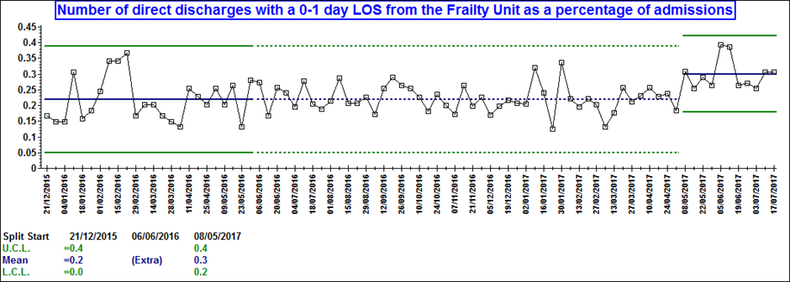

The above graph shows a 6% increase in number of 0-1 day discharges on the Frailty unit after the new assessment pathways have been put into practice

## Approval and sign off

Health and Wellbeing Board signed off the final draft of the Better Care Fund Submission at its meeting in July 2017.

Health and Wellbeing Board agreed in July to delegate authority of the final version of the Narrative Plan to the Executive Officers of CCG and the SCC. The Narrative Plan and Planning Template were approved by the Executive Management Group on 11th September 2017.

### Appendix 1

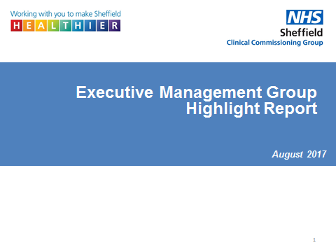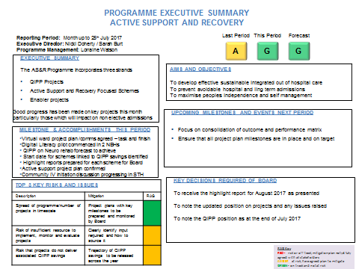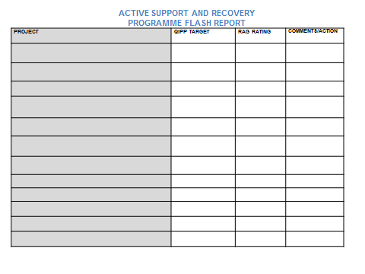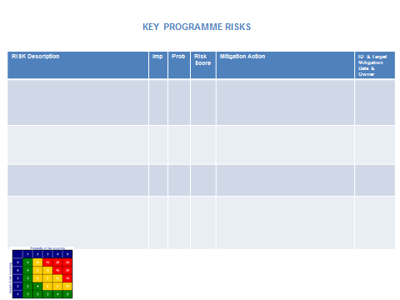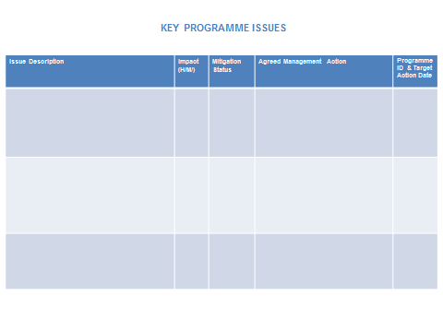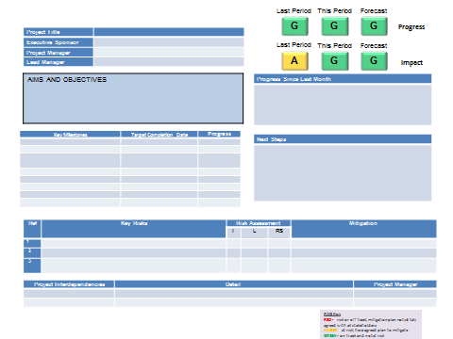

### Appendix 2

BECOMING A HEALTH CHAMPION BY HAZEL BLACKBOURN

I became a Diabetic in 2005, as a result I became very interested in Diabetes health. In 2008, I started my own Diabetes Group, which I ran until earlier this year. I became a Health Champion in 2012 during the Living Well campaign. This set me on the road for being involved in all aspects of health. I got involve with different projects, and really enjoyed what I was doing. I also did Health Courses during this time, and along with the projects, it empowered me and made me believe I was making a difference.

One of the projects I was involved in, was Healthwatch and was involved in helping to set it up. Whilst on the Board, In the summer of 2015, I was asked if I would like to be a Lay Member on the Area Prescribing Group (which is a Panel of Clinicians) who assess the medicines, which NHS England and NICE ask us to look at. I enjoy this and have learned quite a lot from being on the panel.

From that, I was approached by another colleague, who asked if I would also be interested in being on her panel (which Jo was in the process of setting up) to look at medicine wastage, as this is costing the NHS millions of pounds in unused drugs.

I also heard about a project through the CCG, which was MSK, (which means Musculoskeletal) I have been on the Patient Committee ever since.

From another organisation, I was given the opportunity to be involved with a plan to help patients stay at home, instead of unnecessarily being taken into hospital. I agreed. The Okay to Stay Plan was born, and is enabling patients to do just that!

I met Eileen on this Committee and she asked me if I would be interested in becoming a Lay Member Volunteer on her team the Locality Support Team. Once again, I said yes. I was then asked to become a CCG Volunteer, to enable me to continue my work with the CCG. I know quite a few people who work at the CCG and I am now one of the colleagues. This make me feel proud and good about myself.

The work I do for Locality Support Team, is giving my thoughts and ideas on how we go forward into the future. How GP’s and Surgeries will have to adapt and change to enable the NHS to go forward. During my time with Eileen I have been on courses to learn about PAM and Person-Centred Care Plan. This has enabled me to understand what the team is working on.

You may think, that’s all very well, but what do I get out of it? May I tell you?

You have a feeling of I am an expert patient in my condition, and from that you can help others to become an expert. Nobody knows their condition better than the person themselves. This is what set me on the road to where I am now. I am in total control of my condition, and this makes me feel I have accomplished a lot, by being in control.

With that very good feeling, you then feel you can become a Health Champion. From this, you get a sense of purpose. I find that my mind mentally is 21 (lots of laughs) even though I am 72 this year I don’t feel it. This stops retired people from becoming Isolated and lonely. It gives someone a purpose in life. I hope to continue to be able to do my bit, and I am very sorry that I am unable to be here today.

### CPMC_mastheadAppendix 3

15 Peaks Mount · Sheffield · S20 7HZ · tel: 0114 2510040 · fax: 0114 251 0954

Dr A R M Andrzejowski · Dr G S Davison· Dr S Costen · Dr K Gillgrass · Dr M A Fisher · Dr E J Terry

GMC No. 2914811 GMC No. 4299174 GMC No. 4728423 GMC No. 61051090 GMC No. 7045315 GMC No. 3056066

Crystal Peaks - Person Centred Care: Case Study March 2017

Putting Joan first – a story about person-centred care in Sheffield

Joining up health, care and community services, to support the most vulnerable people in our communities stay well and out of hospital, isn’t new. It’s happening across the country and has been for some time. Here in Sheffield, it’s simply part of the day job for many of us.

Those working in the field call it many terms from ‘integrated care’ to ‘person-centred care’. Simply put, it’s about putting 82-year old Fred and his wife, Betty at the heart of any decision-making when it comes to his health and wellbeing. It’s about giving Suraj the practical support he needs so he can pop to Sainsbury’s when he wants. It’s about planning and joining up all the ways we can help Clint and his family to stay upbeat and manage his early onset of dementia on their terms, not anyone else’s.

Here in Sheffield, Neighbourhoods are all working hard towards improving their approach to person-centred care so that it’s consistent across the city. It’s a big job and it can’t be solved by a GP practice alone which is why Neighbourhood working is perfect in tackling this effectively.

Person-centred care ‘clear as crystal’ in the south east of Sheffield

Primary care and community services in and around the Crystal Peaks area of the city are making tremendous progress when it comes to person-centred care. Here’s just one story of many on how they’re making it work there and comes from the team at Crystal Peaks Surgery:

IN A BOX First up, what’s a care plan?

Most of us working in the sector know what a care plan is but if you don’t, it’s a simple document which draws up how a person’s care and support needs will be met, including their personal wishes and preferences which are essential for person-centred care to succeed.

From the start – what we had in mind

We’ve known Joan\* for years at the practice. She’s one of those that wouldn’t ask for help unless it was urgent and we’d all spotted signs she was struggling a bit. Confusion with her repeat prescriptions, missing some of her appointments and even Joan’s neighbour raised concerns about her ability to drive.

Joan was an ideal candidate for a care plan and a more person-centred approach.

At our practice, we hold a monthly meeting where we look at unplanned admission data together. The team includes a lead GP, community matron, district nurse and a community support worker.

We could see she’d had two unplanned admissions to hospital over the last 12 months and used the out of hours service a number of times. By teaming up and coordinating our services, we felt we could make a difference to Joan. By developing a care plan with her, we knew we could understand her immediate health and care needs better as well as understand what her concerns were, what her understanding of her own health was and how we could best go about safeguarding her so she could remain in her own home living as independently as possible. She’d told us these were her wishes a number of times over the years.

We hoped the care planning process would enable Joan to access the best community services, maintain her social independence and reduce her DNAs and use of OOH services.

What we did, when we did it and why?

Our admin lead contacted Joan to discuss our new approach and whether she’d like to be involved. She was happy to of course.

She completed a PAM questionnaire (score 1) and the healthcare assistant visited Joan at home to take blood tests.

Our lead GP reviewed all the blood tests and made some adjustments to her repeat prescriptions - mainly to the times she was taking the medication so there was less chance for her to forget.

Our nurse practitioner did a home visit to conduct the care plan in view of everyone’s concerns.

Through us spending some time chatting with Joan at this visit, it was clear her memory had deteriorated from when it was tested 12 months earlier. She openly admitted to getting lost in the car on previously familiar routes and also spoke about her wishes for end of life care and her relationship with her family.

Things seemed to be getting on top of Joan around her home too. Unopened post, unkempt garden and windows, possible urinary incontinence and poor Joan admitting she was going to McDonald’s each day for a hot meal through losing her confidence to cook. It gave the nurse practitioner plenty of information to feedback at the next monthly meeting to set things in motion.

What happened next?

Our local community support worker organised for gardening, upgrades to the house alarm and regular window cleaning for Joan’s house through the council.

The GP did a home visit and referred Joan to hospital as an outpatient for investigation of the recurrent UTIs and incontinence. The community nurse now organises a pad delivery service for Joan as previously she was spending a lot of money on them.

Joan and the GP discussed her memory. Following referral to the memory clinic, Joan was diagnosed with vascular dementia. The GP chatted with Joan and her daughter about driving too. It was agreed that on balance it was best to stop driving and the community support worker arranged for community transport for when Joan fancied a trip to her local lunch club.

The local pharmacist organised pre-packed prescription service for Joan and following a referral to social services, she now has carers attending for one call a day to help with her washing and dressing.

Putting Joan first – what have we learned?

Local community services and primary care coming together in a united way absolutely benefits the patient.

Joan maintained her autonomy throughout. A person centred approach meant she ultimately decided to stop driving herself.

Though now officially housebound, Joan is more socially engaged than ever. She’s less vulnerable and has not had any out of hours attendances or unplanned hospital admissions in the last six months.

Using our community support worker to “touch base” with Joan on a monthly basis is something we hear they both enjoy.

A care plan allows us to be proactive rather than responding to problems after they’ve happened.

Above all, adopting a person centred care and care planning approach provides us with time to really engage with the Fred’s and Bettys in our communities who might be struggling quietly at home. A simple co-ordinated care approach that allows us to help more people to feel better, attend hospital less and build confidence in self-care more than ever before.

If you’d like to find out more about Crystal Peak’s person-centred care approach, contact Miss Hannah Smith, Assistant Practice Manager on 0114 2510040.

### Appendix 4

|  |  |  |  |  |  |  |
| --- | --- | --- | --- | --- | --- | --- |
| Active Support and Recovery | **Deliverable Theme** | **Description of Risk** | **Mitigation** | | **Organisation Owner** | **Lead** |
| Sheffield Place Based plan and STP Dependencies | There is a risk of duplication of effort or absence of synchronisation of activity due to the areas of overlapping with other work streams within the wider Sheffield Transformation Board and STP, and this may lead to undermining maximisation of the scale of opportunity. | | Development of the Sheffield Transformation Board governance with regular reporting within and across work streams will minimise impact. AS&R work stream lead director and programme manager linked into pan-initiatives to share progress, developments and learning. | Sheffield Clinical Commissioning ng Group and Sheffield City Council | Nicki Doherty Sheffield CCG/Phil Holmes Sheffield City Council |
| Internal programme dependencies | There is a risk to programme delivery activity due to activity in the AS&R work stream cutting across change programmes which are internal to CCG and LA e.g. consistency with QIPP agenda, Primary Care and Cases, and this can lead to loss of direction in the internal programmes. | | Dependencies are mapped to identify cross over and key leads become stakeholders in AS&R with regular communication. |
| Communications & Engagement | There is a risk of ineffective engagement at multiple levels across Sheffield including within organisations for staff as well as within the programme of AS&R, Neighbourhoods, and including citizens and patients, due to lack of engagement and lack of clarity of vision and lack of key communications with key stakeholders, thus resulting in failing to ensure the programme is not able to achieve the objectives. | | Robust stakeholder identification and a clear programme of structured two-way communications is implemented. Clear messages are appropriately directed to key audiences ensuring stakeholders maintain necessary levels of influence and knowledge. Programme to utilise the best and most appropriate channels to communicate with stakeholders. |
| Blueprint of AS&R programme | There is a risk of significant change in external environment as a result of national, regional and PAN Sheffield policies and commissioners development which could lead to ongoing need for scope change of the programme resulting in lack of clarity of vision and lack of delivery of programme. | | Clear vision and support with continued engagement with commissioners and providers and Neighbourhoods and one- to- one engagement with providers. |
| Work stream groups | There is a risk of lack of available capacity to meet the needs of the work stream plan of proposed work stream with the governance of AS&R programme and associated work plans, which would mean that insufficient progress is made on delivery objectives | | Regular reviews at JT ASR PCB. Engagement with leads to identify gaps in capacity and alternative |
| Ongoing constraints | There is a risk that the design and integrated commissioning model could not operate effectively due to being affected by a number of external constraints including demand, flow, seasonal variations and external policies changes that may affect patient demand, resulting in ineffective model design and delivery. | | Effective engagement within the programme board, making the most of resources. |
| Finances & QIPP | Pressure on finance sustainability requiring achievement of QIPP targets and redistribution of resources from acute environment to community based model of delivery. | | Effective engagement within the programme board. Use of BCF opportunities to ensure Sheffield pound is spent effectively to meet needs of the city. Monitoring of QIPP schemes, wider involvement of city wide services to enable delivery of savings. |
| Overall programme team | There is risk of lack of continuation of key members of the programme team including BI support, Comms & engagement and lack of resilience of PMO team, and lack of support to Neighbourhoods due to lack of resources which can lead to affect the delivery of the programme and lack of progress with having outcomes in place to monitor the performance across the Neighbourhoods and across city wide services. | | Planned changes in personnel are anticipated and managed effectively with a robust handover. Unanticipated changes are managed at a senior level to ensure as much continuity as possible. Effective engagement with providers, commissioners and locality managers working with Neighbourhoods and Citizens to identify key priorities and actions for city wide services. |
| Outcome of programme | There is a risk that the programme will not reflect the purpose of the outcomes of AS&R and will not remain sensitive to the STP Sheffield based plan due to a number of factors e.g. lack of resources, lack of metrics in place, governance arrangements which can lead to lack of progress of the programme. | | Governance arrangements are being revisited, ToR to be in place, MoU is in place. Metrics are being developed to monitor the outcome and progress of the programme. |
| Neighbourhoods | There is a risk of lack of engagement and lack of resources at Neighbourhoods with the stakeholders to support the Neighbourhood model, this can create variation in speed of Neighbourhoods moving forward and could lead to inequality and impact on patients. | | Neighbourhoods are supported by Locality managers, providers, commissioners to help develop each Neighbourhood. Effective engagement with providers and commissioners. Neighbourhoods to roll out their successes and problems to aid development. Neighbourhood learning development forum to aid sharing good practices etc. |
| Wider OD Agenda | There is a risk of insufficient alignment of approaches of the organisations with the wider system change to support new skills/new training/new behaviours and new culture, new technology, this also links into the programme risk of lack of resources; which can affect the delivery of the programme | | Key messages through communication with providers, localities, practices to champion Neighbourhoods development and involvement. Development of shared learning, resources, developing skills and technology. |
| Savings | There is a risk that the savings targets will not be met due to external constraints - demand/flow/seasonal variations that may affect patient demand. | | Monitoring of savings and the wider involvement of city wide services to enable delivery of savings. |
| Impact of changes | There is a risk of any service changes or processes that are proposed to alter may have an impact on a satellite surgery in any one Neighbourhood due to the practices having branch sites that sit in other Neighbourhoods resulting in delays to the delivery of the neighbourhoods. | | Key messages that the practices involved are communicated about the changes and allowed to comment on them. Sharing the learning and lessons through the development of the Neighbourhoods. |
| IM&T | It was noted that there is a risk of Neighbourhoods progressing inappropriately in the absence of sufficient IG/IT involvement & support. This would be higher in the interim until the new Head of IT was in post. | | The IMT workstream is being closely monitored with the departure of MW, until the new Head of IT in post. |
| MW to flag concern with Sam Merridale / Nicki Doherty. | |
| Performance | Service redesign may be delayed due to lack of expert resource in the performance / information team, and the inability to obtain timely PM data. | | Options for additional resource being explored. Risk has been escalated to Nicki Doherty. |
| Service change | Community Support Worker contracts are on a rolling 6 monthly renewal. Current period ends 30th Sept (notice given to workers by 30th June). Risk is loss of workforce due to short term nature of contracts. | | To be discussed at Delivery Group on 26th April. |
| Ongoing Care | Finance | Release savings from redesign to other parts of the system | | Joint working with Clinical Commissioning Group (CCG) and Sheffield City Council (SCC) and all parts of the system. Working with finance and business intelligence to develop a financial model to enable smart data and costing to inform decisions to support other parts of the system. | Sheffield Clinical Commissioning Group and Sheffield City Council | Penny Brooks Sheffield CCG/Phil Holmes Sheffield City Council |
| Need to invest in shared information systems but limited resource | | Phase 1 scoping of shared information exercise has been completed, phase 2 of exploring options for shared solution to be developed with proposed costing. CCG and SCC working together to reduce duplication streamline processes and align paperwork. |
| Time frames | Meeting assurance frameworks and timeframe | | The Continuing Health Care (CHC) process and pathways are being jointly reviewed with colleagues from CCG and SCC to ensure that we are compliant with the framework. Legal training has been completed for all CCG nurses and SCC social workers to ensure staff are update with current legislation. |
| Resource | Capacity and demand on resources and growth internally and across the system | | Regular Ongoing Care Integration meetings discuss any capacity and demand issues. Capacity and demand modelling has been carried out in CCG to identify any issues and to develop ways to support the service. |
| Urgent Care | Decreasing A&E Waits | Winter Pressures | | System wide winter resiliency plan | Sheffield Clinical Commissioning Group and Sheffield City Council | Brian Hughes Sheffield CCG/Phil Holmes Sheffield City Council |
| Implementation of ARP | | Close partnership working across the region via Lead Commissioner networks (999/111 CMBs) |
| Increase number of same day discharges from assessment units | Winter Pressures will overwhelm supporting services both within the hospital and wider health and social care system. A lack of responsiveness could have a significant impact on the ability of these pathways to function effectively | | System wide winter resiliency plan |
| Supporting initiatives to support system resiliency as a whole e.g. Weekly Flow Group meetings and Newton Europe work |
| Reducing LOS on spells less than 4 days in 5 identified specialities | Winter Pressures will overwhelm supporting services both within the hospital and wider health and social care system. A lack of responsiveness could have a significant impact on the ability of these pathways to function effectively | | System wide winter resiliency plan. Supporting initiatives to support system resiliency as a whole e.g. Weekly Flow Group meetings and Newton Europe work |
| Reducing the number of Delayed Transfers of Care (DTOCs) | Independent Sector capacity during winter | | Additional funding from Local Authority during winter |
| Mental Health | Collabrative Working | Delivery of the transformational programme is reliant of all parties working collaboratively and jointly. There is not a statutory requirement for them to do this. | | A governance arrangement has now been agreed by respective CEOs, which ensures cross organisational  involvement at every stage of the decision making process. This is supported by a delivery structure which is overseen and monitored by the Transformation Steering Group, consisting of an Executive Director sponsor from each organisation. In addition, the Mental Health, Learning Disability and Dementia Delivery Board, which is chaired by Kevan Taylor (SHSC CEO), has now been constituted as being the main forum at which major decisions will be taken. The membership of this group includes senior staff from each of the partners, plus other interested parties, including service user and carer representation. The Delivery Board reports to the Accountable Care Partnership Board. | Sheffield Clinical commissioning Group and Sheffield City Council | Brian HughesSheffield CCG/Dawn Walton Sheffield City Council |
| Significant work has also been undertaken in terms of engagement, ensuring that the aims and objectives of the transformation programme are well known and importantly well understood. This has included targeted one-to-one engagement as well as presenting to various forums across the city. The key message has however been consistent; this is a jointly owned programme of work aimed at improving the quality of services and the experience of those who use them. |
| Efficiencies | Transformation programme does not deliver efficiencies within required timescales; this may therefore generate financial instability. | | A series of additional schemes are currently being developed to mitigate against potential underachievement. This includes exploratory work around reducing the number of ‘loss making’ services in Sheffield, considering options for further joint working (including, but not limited to, sharing back-room functions), expediting and agreeing stretch targets for existing projects such as the CHC review process and the development of new ‘stand-alone’ projects. |
|
| Resource | The Transformation programme is very ambitious and will require dedicated resource to ensure full delivery. Although a joint post has been created and has been filled, working across all three organisations, the delivery of each respective programme area is being undertaken on top of a number of individual’s current roles.  This will need to be reviewed regularly. | | Resourcing continues to be an issue, and has therefore been raised via the Executive Management Group. A number of solutions are being considered and explored, including an invest-to-save approach, whereas additional resource is secured against an increased target which ensures the investment is, as a minimum, cost neutral. Options for developing a joint delivery team are also being considered. As noted, this will continue to be reviewed regularly. |
|
| Childrens | Engagement | Lack of engagement from clinical staff | | Planned PLI Events and full staff consultation to engage clinicians particularly in relation to Community Health Redesign. | Sheffield Clinical Commissioning Group and Sheffield City Council | Penny Brook Sheffield CCG/Dawn Walton Sheffield City Council |
| Methodology | Diversion in approach and methodology with providers/ SCC/CCG | | Through the Children’s JCG align and agree joint methodology and delivery processes |
| Resource | Other agendas and initiatives such as in adult services with competing priorities on resource and direction of travel | | Through the governance structures of the Children’s Transformation Board and the Children’s JCG and agreement reached on priorities, activities and timescale to avoid distraction and competing priorities. |
| Demand on resources and growth in need could delay implementation of early help and early intervention and prevention models | | Joint partnership commitment to the delivery of a new Early Help Model. |
| Public health resources being challenged which could impact on need | | Thorough assessment of C&YP’s needs so as to ensure evidence base to manage and challenge PH grant budget reductions |
| Resources to deliver the changes needed within timescales needed. | |  |
| IG/Assurance | Statutory duties still being met through changes in pathways and shared governance and accountability framework | | Robust service specifications which maintain delivery and performance and strong provider/commissioner relationships which flag any potential issues. |
| Meeting assurance frameworks and timeframe for mobilising new models of care | | Comprehensive review of our Children’s Transformation Board priorities and capacity with identified project delivery capacity agreed via each partner: SCC, SCCG and SC NHS FT |

1. There are currently 85,000 people across Sheffield City Region unemployed due to low level mental health or Musculo skeletal conditions. The health and employment system do not work together and those 85,000 people are all witnesses to this poor ‘system connectivity’. We have recently had approved an operating model for a trial study to overcome/ reduce poor connectivity.  The basis of the study is a pilot delivering Individual Placement and Support-based employment support. It will be a randomised control trial, receiving 7,500 referrals from  the health system across  the region (mainly primary care) over the course of the next 18months- 2 years.  It will be integrated into an increased number of employment advisors within IAPT service across the region. [↑](#footnote-ref-1)