scc_logo

**Sheffield Suicide Prevention Action Plan**

2019 - 2021

Date:

Draft Version 0.1

**Prepared by**

**Joanna Rutter**

**Health Improvement Principal**

**On behalf of the Sheffield Suicide Prevention Steering Group**

**Joanna.rutter1@nhs.net**

**Version History**

|  |  |
| --- | --- |
| Title | Sheffield Suicide Prevention Action Plan |
| Reference |  |
| Status (Draft / Issued) | Draft v1 |
| Version |  |
| Date Created | November 2018 |
| Approved By | Greg Fell, Director of Public Health |
| Audience |  |
| Distribution |  |
| FOI Category |  |
| Author | Joanna Rutter, Health Improvement Principal |
| Owner (if different) |  |
| Amendment History |  |
| Review date | November 2019 |
| Comments |  |

**Table of Contents**

Foreword 4

1. Introduction 6

2. Suicide – Key Facts 6

2.1 Mortality 6

2.2 Gender 7

2.3 Summary of mortality in men 9

2.4 Risk factors and prevention 10

3. Sheffield vision and objectives 11

3.1 Local delivery and governance 11

3.2 Funding 12

3.3 Suicide audit 12

4. Local Action Plan 13

Appendix A 17

**Foreword**

Nationally there is a call for a new conversation to reduce suicide death. We fully support that call in Sheffield and have developed a fresh plan to reduce suicide in both adults and children. For a long time the numbers of people taking their own life has been relatively stable over the years. However this has started to increase in recent years. This is a significant trend.

One death from suicide is too many, it is a deeply personal tragedy and has a ripple effect a long way beyond the family affected. Every suicide is a tragedy that has a far reaching impact on individuals, family, friends and the community long after a person has died.

This strategy aims to make suicide prevention everyone’s business in order to reduce the incidence of suicide locally. It enables all to see what we are doing together to prevent death by suicide and to understand what support is available for those individuals, families and communities affected by suicide.

In line with the UK National Strategy on Suicide Prevention there are 6 key areas for action to reduce suicide. These are;

• Reduce the risk of suicide in key high-risk groups

• Tailor approaches to improve mental health in specific groups

• Reduce access to the means of suicide

• Provide better information and support to those bereaved or affected by suicide

• Support the media in delivering sensitive approaches to suicide and suicidal behaviour

• Support research, data collection and monitoring.

We know these are the right actions and we have challenged all our organisations in the city to implement interventions with urgency and fully. Initial areas of focus in Sheffield include the development of real time surveillance and early bereavement support for those affected by suspected suicide, increased support for people who self-harm, the development of a local suicide prevention awareness training offer and support for middle aged men.

For many years suicide prevention has not been a mainstream issue, sometimes because of stigma, sometimes because of fear of making things worse, sometimes for other reasons. Our strategy aims to correct this and we aim to be fearless in our implementation

The actions in this strategy are derived from evidence-based practices & user experience.

Many of us have narrowly focused on ‘identifying persons at risk and getting them into treatment.’ Conversely, many mental health consumer advocates either avoid or react negatively to suicide prevention discussions, at times due to traumas associated with historically coercive practices and policies. We aim to take an approach that is focused on those at high risk AND helping shift population norms.

This work is owned by the Sheffield Suicide Prevention Group. This is a multi-agency and multi-disciplinary group with members drawn from a wide range of places. We continually try to increase the service user input into this group, and are open to new members

I would welcome any comments on this plan in the hope of improving it in the future.

****

**Greg Fell**

**Director of Public Health**

****

1. **Introduction**

Suicide is a major concern for society and a tragedy for the bereaved. Suicide and undetermined injury are a leading cause of years of life lost and one of the main causes of death in men under the age of 45.

Suicide is often the end point of a complex history of risk factors, distressing events and adverse experiences, but there are many ways in which services, communities, individuals and society as a whole can help to prevent it.

One death from suicide is too many. It is a deeply personal tragedy and has a ripple effect a long way beyond the family affected. Every suicide is a tragedy that has a far reaching impact on individuals, family, friends and the community long after a person has died. Work to reduce and prevent suicide in England is informed by the national strategy for England [Preventing Suicide in England – A cross governmental outcomes strategy](https://www.gov.uk/government/publications/suicide-prevention-strategy-for-england)

1. **Suicide – Key Facts**

**2.1 Mortality**

The headline indicator of age-standardised mortality rate from suicide and injury of undetermined intent per 100,000 population (aged 15+) is recorded as part of the national Public Health Outcomes Framework. The Sheffield trend compared to England is shown in the graph.

The actual number of suicides that occur each year is relatively low, so we combine figures over three year periods to provide a reliable statistic. Even taking account of three year pooled data, variation can remain wide; this should be taken into account when scrutinising trends over time or comparing different groups or areas.

For men and women in Sheffield, the suicide rate has fallen slightly in the last period (2014-16 combined) compared with a steady rise between 2010-12 and 2013-15. A peak in 2013-15 saw the Sheffield rate rise above the national average for the first time since 2006-08 although the difference is not statistically significant. The fall in the rate in 2014-16 places Sheffield back below the England rate, although as before, this difference is not statistically significant [[1]](https://sheffieldcc.maps.arcgis.com/sharing/rest/content/items/91f9b7ca56234a599c4ba69c8c3fc921/data).

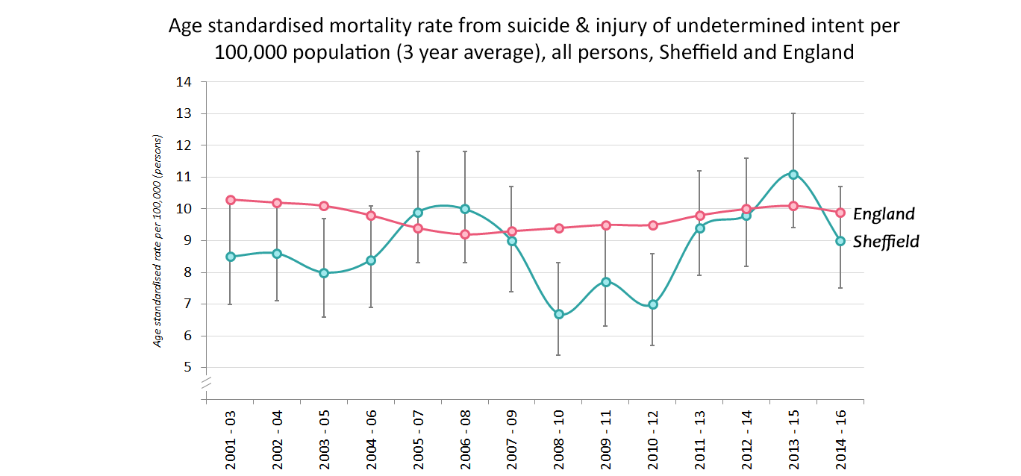

**2.2 Gender**

Men are more at risk of suicide than women. In the most recent period (2014-16) the rate of suicides for men was 14.1 per 100,000 population compared with 4 per 100,000 for women. Men were 3.5 times more likely to die by suicide than were women. This figure (subject to some variation) has remained consistent since 2001-03 [[2]](https://sheffieldcc.maps.arcgis.com/sharing/rest/content/items/a97e02645d6c402da9202d0caefb74f4/data).

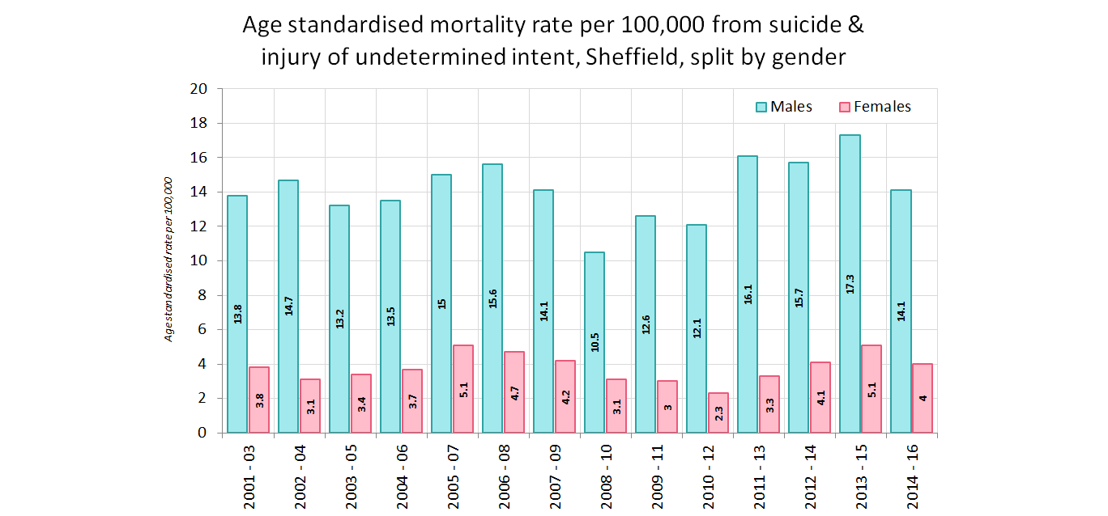

As the majority of deaths from suicide are in men, the trend chart for males closely matches the overall figures [[3]](https://sheffieldcc.maps.arcgis.com/sharing/rest/content/items/b7e98e3042124394a431b205a94bb818/data).

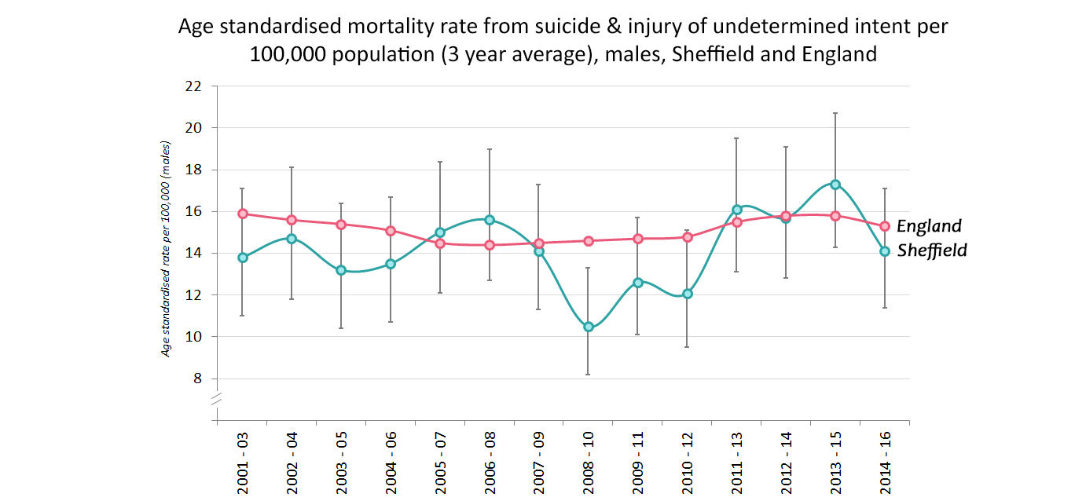

For women there was a sharp increase from 2010-12 (2.3 per 100,000) to 2013-15 (5.1) but because overall numbers of deaths from suicide are so much smaller in women, this leads to much bigger variations [[4]](https://sheffieldcc.maps.arcgis.com/sharing/rest/content/items/9c2543868fe344669a48656918c2f8a4/data).

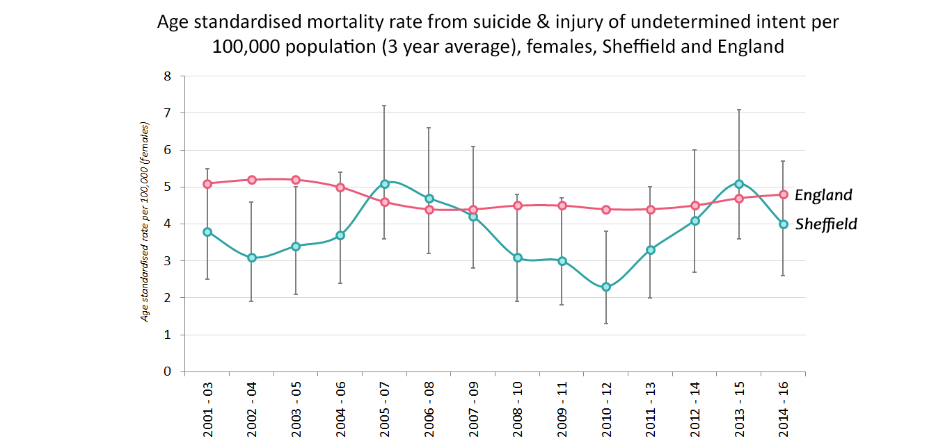

For all ages, 79.5% of all deaths from suicide and undetermined injury recorded between 2012 and 2016 were in men, with similar proportions in each of the age groups. For those under the age of thirty, 87% were in men (13% female). The chart below details this [[5]](https://sheffieldcc.maps.arcgis.com/sharing/rest/content/items/23bce38b56c34ff78ab5ceb6516276ed/data).

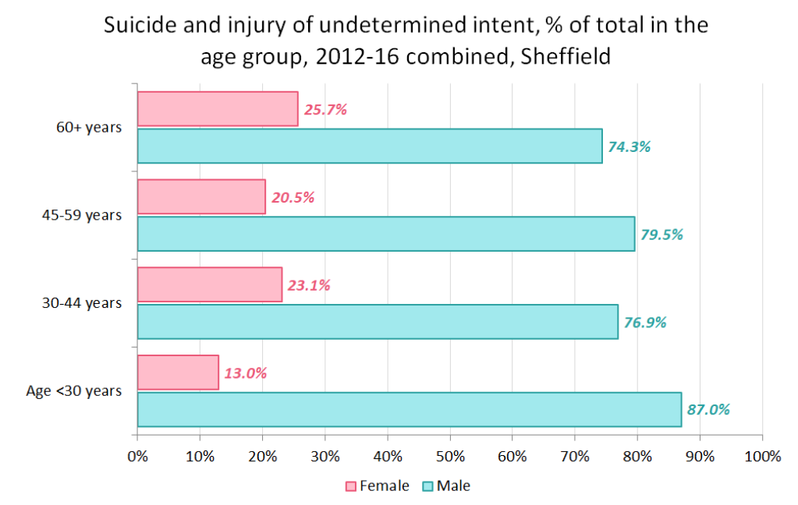

**2.3 Summary of mortality in men**

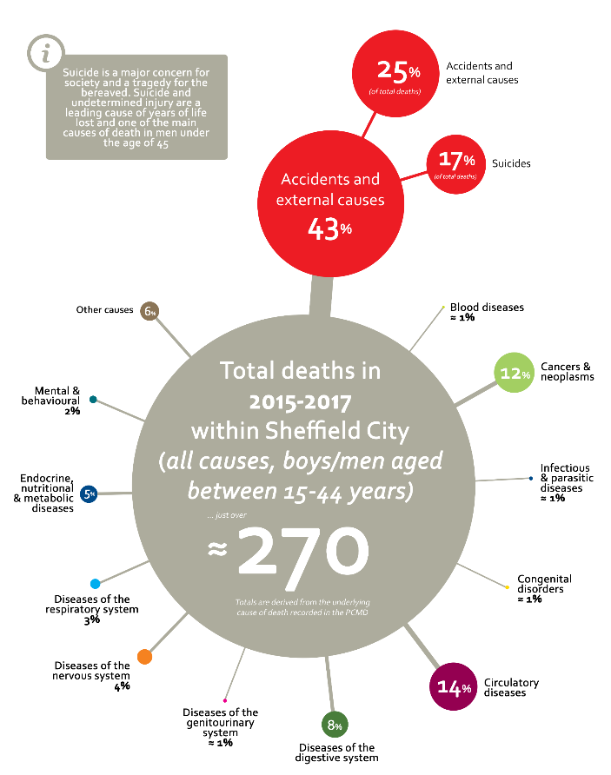



**2.4 Risk factors and prevention**

Every suicide should be seen as preventable. Gaining an understanding of vulnerability in local populations can aid development of an effective suicide prevention plan. As already noted, suicide is usually the end point of a history of multiple risk factors, distressing events and adverse experiences.

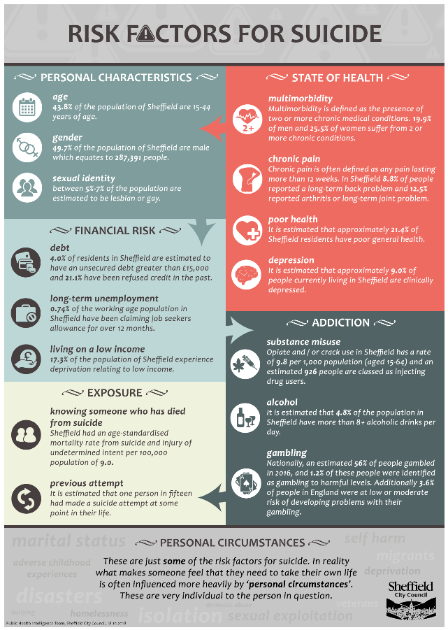

**3 Sheffield Vision & Objectives**

We want Sheffield to be a place where no one takes their life

Sheffield City Council, alongside our partners and local communities will work to make Sheffield a city that -

* Supports people through the difficulties they face and at times of personal crisis
* Builds individual and community resilience
* Creates the opportunity for conversations in our communities, schools, workplaces, social spaces and more that help break the silence and dispel stigma
* Increases training and awareness about suicide

**3.1 Local delivery and Governance**

Suicide prevention is a priority for Sheffield. Locally this work is coordinated by a multi-sector steering group led by Sheffield City Council’s Director of Public Health. Our steering group has representation from;

• SCC Mental Health commissioning, CYP Commissioning, Learning and Development, DACT and Public Health

• NHS Sheffield

• Sheffield Teaching Hospitals Trust

• Sheffield Health and Social Care Trust

• Sheffield Samaritans

• SOBS – Survivors of Bereavement by Suicide

• STORMS

• Experts by Experience

• Sheffield Universities

A short summary of suicide prevention work overseen by this group in 2017-18 can be found in Appendix A

Local responsibility for leading work to reduce suicide is the responsibility of Local Government and is supported by Public Health England through the Yorkshire and Humber Mental Health and Suicide Prevention Community of Interest Group attended by Public Health suicide prevention leads.

The group has developed a local action plan to support our work. Our local plan focusses on adults as Communities (formerly CYP) Portfolio in SCC had already developed a suicide prevention pathway for Children and Young People, which was a key reference point in developing the Sheffield plan. Carol Fordham (CYP Commissioning Manager) is an active member of our steering group and any suicide prevention work that impacts on children and young people would be planned in partnership and aligned to existing work especially Future in Mind and the Healthy Minds Framework. The group, and its planned work, will link to the work of the Sheffield Child Death Overview Panel, in terms of addressing learning and actions agreed following relevant deaths in children, and to the Emotional Wellbeing and Mental Health programme for Children and Young People (Future in Mind).

Our plan is built around the six priorities of the key national strategy. These are to;

* Reduce the risk of suicide in high risk groups
* Tailor approaches to mental health in specific groups
* Reduce access to the means of suicide
* Provide better information and support to those bereaved or affected by suicide
* Support the media in delivering sensitive approaches to suicide and suicidal behaviour
* Support research, data collection and monitoring

**3.2 Funding**

Historically, suicide prevention work in Sheffield has not been specifically funded and has relied on good will and commitment from local partners. Earlier this year, South Yorkshire and Bassetlaw Integrated Care System (ICS) secured £555,622 of central government funding for suicide prevention work for 2018/19. Year two funding has also now been confirmed a third is possible.

The funding comes with a target of a 10% reduction in suicides across the SY&B patch. The money follows on from the Five Year Forward View for Mental Health and some of the allocation will go directly to local areas. This has been agreed but the areas for spend have been prescribed by NHSE, in other words, we can only fund activity that relates to the priorities set by NHSE (described below) Our local allocation is £96,000 this year. Sheffield will further benefit from initiatives developed across the whole area.

The intention of the ICS level work is to build on local suicide prevention plans where it makes more sense to work at a larger footprint on key areas of work. There is a SY&B steering group developing this programme with representation from all 5 local areas and priorities for delivery include

* The development of consistent real time surveillance (RTS) across the ICS footprint between coroners, police and local authorities
* Improvement in self-harm services and pathways in acute settings and in the prevention of self-harm in community settings especially for children and young people
* Suicide prevention awareness training in primary care
* Support to middle aged men as a particular high risk group
* Improved bereavement support following the development of RTS as described above

This updated plan for Sheffield reflects this new allocation of funding and takes into account the priorities set by NHSE.

**3.3 Suicide Audit**

The most recent formal suicide audit was conducted in Sheffield in 2012. During the development of our last local plan, the steering group felt that we did not have the capacity and resources for an in depth analysis of Sheffield records and they committed to conducting an audit in 2018.

The ICS Mental Health and Learning Disability Executive Steering Group have recently allocated some resource to the production of an audit across the South Yorkshire and Bassetlaw footprint which will be commence in January 2019. As this local plan is refreshed annually, any learning form this audit will be incorporated as appropriate.

1. **Local Action Plan**

During 2019-2021 the Sheffield Suicide Prevention Steering group will oversee the following local actions across the 6 domains of the national strategy.

Progress towards the actions outlines below will be monitored by the Sheffield Suicide Prevention Steering Group and an updated action plan produced following the ICS SYB wide suicide audit

|  |  |  |  |  |  |
| --- | --- | --- | --- | --- | --- |
|  | Completed |  | Not started |  | In progress |

**Domain 1: Reduce the risk of suicide in high risk groups**

|  |  |  |  |  |  |
| --- | --- | --- | --- | --- | --- |
| **Outline Deliverable** | **Identify who will deliver it** | **Explain how it will be delivered** | **Describe your desired outcomes form the deliverable and how you will measure these** | **Provide an indicative timescale for delivery** | **Provide an indicative costing** |
| ***Reducing suicide and self-harm in men*** | | | | | |
| 16 community partnerships commissioned to engage men with suicide prevention messages | SCC - People Keeping Well Commissioner  Community anchor organisations leading each partnership | 1. We will utilise the existing PKW commissioning framework arrangements to include suicide prevention work | Engagement outputs will vary by neighbourhood but will include;   * Mapping of local opportunities to engage with men * Distribution of suicide prevention campaign materials targeting men * 800 people completing ZSA training (VCF staff, volunteers, residents - 50 completions per community partnership) * 100 front line VCF completing Sheffield ‘Let’s Talk’ suicide prevention training * Scope of present back future opportunities to engage in a more in depth way in Year 2 | 1. January 2019   By September 2019  By September 2019  By September 2019  By September 2019  By December 2019 | 1. £48,000 |
| Pilot a workplace suicide prevention programme that targets male dominated employers especially those in high risk occupations and scope out opportunities to extend this to other workplaces in Year 2 | Sheffield MIND | We will commission Sheffield MIND to pilot a workplace suicide prevention programme that builds on their existing ‘tooled up’ MH awareness campaign and links with the Chamber of Commerce. Initial workplaces and settings will include Sheffield Forgemasters and the football clubs | Specification for pilot agreed  Pilot commences  Interim evaluation completed and new workplaces proposed for year 2 of project | March 2019  April 2019  March 2020 | £5000 |
| Scope the potential for suicide prevention interventions targeting serving personal about to leave the forces, veterans and their families living in Sheffield by March 2019 | Sheffield MIND | Sheffield MIND have already been commissioned by MOD to deliver a programme of support to the families of serving personnel in South Yorkshire. We will commission them to scope the potential for including suicide prevention within this work and to extend their reach to include veterans and those about to leave the forces and pilot a proposed programme of suicide prevention with this target group | Proposal completed  Pilot commences  Evaluation report produced  Measured through  numbers engaging with suicide prevention activity (tba) | March 2019  April 2019  March 2020 | £3000 |
| ***Reducing suicide and self-harm in students*** | | | | | |
| We will work with colleagues from Sheffield Universities and Sheffield College to explore ways to support student mental health. | SCC Public Health Lead | In particular we will;   * Support the Universities and College to roll out our ‘Let’s Talk’ face to face suicide prevention awareness training to identified staff, SU groups and students as agreed * Provide a representative on the Sheffield Student Health and Wellbeing Board and contribute to their MH&WB plan |  |  |  |
| ***Reducing suicide and self-harm in children and young people*** | | | | | |
| Develop early intervention and support for children and young people who self-harm | SCC CYP Commissioner | An online counselling service will be commissioned to support CYP with a range of mental health risk factors including self harm and bereavement.  We will bring together a range of stakeholders to develop a peer support model for schools and community settings that builds resilience and early intervention support for self harm  We will refresh the CYP suicide prevention pathway as part of the development of our local plan into an all age action plan for suicide prevention | CYP will have an increased accessibility to support for a range of mental health and wellbeing issues including self harm and bereavement  Measured through   * Interim reports produced by the provider * Numbers of CYP supported with issues connected to self-harm and bereavement in particular   Stakeholder Group established  Plan developed  Pilot launched  Stakeholder group established  Pathway update completed | Online counselling service launched March 2019  December 2018  January – March 2019  April 2019  December 2018  March 2019 | £30,000  £30,000 |
| ***Reducing suicide and self harm in mental health services*** | | | | | |
| Complete rebuild/modernisation of all SHSCT properties that meet all guidelines relating to physical risks of suicide e.g. ligature points | SHSCT Executive Board  SSPG - SHCT lead | SHSCT is currently undergoing a programme of modernisation for all its estate properties. This process will reflect all guidance in relation to suicide risk i.e. ligature points | Removal of all historical ligature points  Modern/fit for purpose therapeutic buildings that meet all guidance for the removal of ligature points and any other physical risks for suicide | By December 2022 | Within mainstream budget |
| SHSCT will have a graduated suicide prevention and self-harm training plan in place | SCHCT lead  SCC L&D Consultant | A locally developed, one day, coproduced training course will be delivered weekly from January 2019 to all the identified staff teams. The course is delivered by 1 x expert by experience and 1 x clinician. The course is mandatory for those identified staff.  The SHSCT lead will also scope out the potential for extending the delivery of this course to other staff teams based on need and course evaluation e.g. primary care staff, VCS colleagues  A locally developed 2 hour training session will be delivered to non clinical SHSCT staff teams including   * Housekeepers * Administration and secretarial staff * Support workers | 95% (approx. 600 staff) of the following staff teams will have received the full day suicide prevention and self harm training   * Crisis/Home Treatment Teams * Community MH teams * Liaison Psychiatry teams * Older People’s Community teams * In patient Psychiatric ward staff * Substance misuse staff   Learning outcomes will be met as described below:   * Be more suicide aware, * Be confident in recognising someone who may be having suicidal thoughts, * Feel confident about responding in a helpful way, * Know the Trusts recommended process for intervention including completion of a collaborative Suicide Prevention Safety Plan   A learning resource pack will be developed for staff undertaking the one day training course  Measured through;   * Session evaluation forms | March 2020 with qurtly delivery updates to SSPG from March 2019  Learning resource pack developed by March 2019  Scoping document produced by September 2019 | £2000 |
| 20 SHSCT staff will be trained in postvention support | PABBS trainers | PABBS commissioned to deliver 1 training session | Improvements in postvention support through SHSCT  Measured through   * Course evaluation forms | Scoping by September 2019 | £5000 |
| 95% of individuals with a history of suicide attempts and self-harm will receive a follow up within 48 hours of discharge from secondary mental health services | SHSCT lead | We will have an initial focus on the pathway for patients through the following   * Home Treatment and in patient wards being discharged to Community MH teams/other * People discharged from a Section 136 place of safety having been assessed as not requiring detention/admission * People discharged from Liaison Psychiatry in ED to whatever service is thought most appropriate.   The initial aim will be for these services to follow up with the individual, against an agreed set of criteria, in the proceeding 48hrs. The aim of this will be to assess the current level of suicidal ideation/intent with a view to possible further assessment via signposting where required. | 95% of individuals with a known history of suicide attempts and self-harm will receive a follow up within 48 hours of discharge from mental health service  Measured through performance mgt, quality assurance processes, sampling cases, patient feedback and audit. | By March 2020 | Within mainstream budget? |
| ***Reducing suicide and self harm in acute services*** | | | | | |
| Complete a review of liaison psych pathways for patients who self-harm by September 2019 | STH lead  with support from SCC PH lead | A task and finish group will be established of the key stakeholders to oversee the review | The review will be produced and an action plan will follow to implement the findings | Review completion by September 2019  Improvement plan completed by December 2019 |  |
| Core 24 and relevant ward staff receive specialist suicide prevention and self-harm training | STH lead  STH L&D/HR | This action will be incorporated into the service improvement plan that follows the review of liaison psych pathways | 95% of the identified staff will have received training  Training evaluation forms | By March 2020 |  |

**Domain 2: Tailor approaches to mental health in specific groups**

|  |  |  |  |  |  |
| --- | --- | --- | --- | --- | --- |
| **Outline Deliverable** | **Identify who will deliver it** | **Explain how it will be delivered** | **Describe your desired outcomes from the deliverable and how you will measure these** | **Provide an indicative timescale for delivery** | **Provide an indicative costing** |
| ***Reducing suicide and self-harm across the wider community*** | | | | | |
| Increase community awareness of and reduce stigma associated with suicide | Sheffield Flourish | Sheffield Flourish ran a public engagement event as part of WSPD18, and feedback from attendees raised a number of priorities for action. These included;   * Reducing stigma * Training * Digital signpost * Info sharing * MH education in schools   In relation to digital signposting, we will   * Coproduce a web based signpost resource that will feature consistent messaging, presented in a simple and highly usable way, and be easily printable.   In relation to reducing stigma, we will   * Work with all partners, especially experts by experience to plan future engagement events in the community that increase awareness of suicide with a particular focus on an event to coincide with WSPD19   In relation to training we will   * Develop a local campaign to increase take up in Sheffield of ZSA training | Stakeholder group brought together to plan web resource Plan for engagement events developed, including WSPD19  Campaign for ZSA take up developed  Measured through; numbers attending events, feedback form resources, event feedback forms, social media reach | February 2019 March 2019  WSPD19 event Sept 2019  March 2019 | £7000 |
| Increase community awareness of suicide and the organisations available to support | Sheffield Samaritans | 6 community awareness/outreach events that support work with high risk groups will be delivered. These events aim to raise awareness of suicide, of how Samaritans can help, and how to contact them  Sheffield Samaritans will develop and pilot a 'Building Emotional Resilience' session for inclusion in transition programmes for 17/18 year olds leaving school. The target is to deliver in 2 schools in 2019.  Sheffield Samaritans will deliver an event at Sheffield Midland Station to support the National 'Brew Monday' campaign each January. | 6 community events delivered Session developed and delivered in two schools  Events delivered  Numbers of people engaged | March 2020 March 2020  January 2019 and January 2020 |  |
| Increase access and take up of suicide prevention training for front line workers in both the public and voluntary sectors | SCC L&D Consultant  SCC Public health Lead  SCC MH Commissioning officer | We will develop a targeted approach for the delivery of suicide prevention awareness and training to key front line workers in both the public and voluntary sectors that   * Understands what is currently being delivered across the city and builds on it * Works within existing resources and capacity * Actively explores opportunities to collaborate both locally and regionally where appropriate and best value   Understands what is currently being delivered across the city and builds on it Works within existing resources and capaci Actively explores opportunities to collaborate both locally and regionally where appropriate and best value |  |  |  |
| *Suicide prevention work with primary care* | | | | | |
| NHS Sheffield and Primary Care Sheffield will have a graduated suicide prevention and self-harm training plan in place by January 2019 | CCG MH Clin lead  CCG MH Commissioner  SCC PH lead | The identified stakeholders will develop the plan | Suicide prevention and self-harm training plan in place | March 2019 |  |
| 95% of NHS Sheffield and Primary Care Sheffield members will complete appropriate suicide prevention and self-harm training | CCG MH Clin lead  CCG MH Commissioner  CCG HR/L&D  PCS  SCC PH lead | Identified stakeholders will develop a graduated plan for suicide and self-harm training that reflects the training needs of varied staff groups and roles | 95% of NHS Sheffield and Primary Care Sheffield members will complete appropriate suicide prevention and self-harm training Measured through:   * Numbers attending courses * Course evaluation forms | March 2020 | £15,000 |
| At least one trainer trained to deliver suicide prevention awareness training in NHS Sheffield |  |  | At least one trainer trained | September 2019 |  |
| 20 GP champions (5 from each NHS Sheffield locality) trained in postvention support by September 2019 | PABBS trainers | PABBS to deliver one training session  <https://suicidebereavementuk.com/sbuk-training> | Improvements in postvention support provided through primary careMeasured byNumbers attending the course.Evaluations from the training | September 2019 | £5000 |
| All GP practices to have a named suicide prevention lead |  |  |  | September 2019 |  |
| To complete a review of the prescribing of medicines commonly associated with fatal overdose |  |  |  | December2019 | Within mainstream budget |

**Domain 3: Reduce access to the means of suicide**

|  |  |  |  |  |  |
| --- | --- | --- | --- | --- | --- |
| **Outline Deliverable** | **Identify who will deliver it** | **Explain how it will be delivered** | **Describe your desired outcomes from the deliverable and how you will measure these** | **Provide an indicative timescale for delivery** | **Provide an indicative costing** |
| We will continue to engage with Network Rail and receive updates on their ongoing work to reduce deaths by suicide on the rail network | Network Rail  Samaritans  SCC Public Health lead | Network Rail will;   * promote the use of the Learning Tool as another option for staff training to increase opportunity and capacity for interventions. * To ensure regular Samaritans Managing Suicidal Contacts (MSC) courses are run for Network Rail, BTP and Train Operator Staff * Network Rail will inform local authorities where three or more suicides/attempts have taken place in a rolling 12 month period on its infrastructure. It will then seek to work with them to make the community in and around the area less vulnerable to suicide. * The Rail Industry in conjunction with BTP will provide information on numbers of incidents at stations within Sheffield Council * Increase the opportunities for help seeking by suicidal individuals – Samaritans material such as signs and posters can be fitted at identified stations * In identified risk areas stations will be assessed and physical barriers can be considered |  | Ongoing |  |

**Domain 4: Provide better information and support to those bereaved or affected by suicide**

|  |  |  |  |  |  |
| --- | --- | --- | --- | --- | --- |
| **Outline Deliverable** | **Identify who will deliver it** | **Explain how it will be delivered** | **Describe your desired outcomes from the deliverable and how you will measure these** | **Provide an indicative timescale for delivery** | **Provide an indicative costing** |
| Improve the support available for people bereaved through suicide | ICS Suicide Prevention Steering Group  Local area stakeholders | We will collaborate with stakeholders both local and across the ICS to develop/pilot a consistent, timely and compassionate bereavement support offer for those affected by a death by suicide in Sheffield. This is likely to involve;   * The development of a pathway to refer bereaved family members to support services in the period immediately following a suspected suicide as part of a real time surveillance pathway * The development of a community based bereavement support offer accessed either by referral from services or through self-referral | We will have developed a consistent, timely and compassionate bereavement support offer for those affected by a death by suicide in Sheffield. | March 2020 | ICS will fund facilitated workshops to co-produce and design the bereavement support offer.  Any local service offer will need to be agreed by SSPG. |

**Domain 5: Support the media in delivering sensitive approaches to suicide and suicidal behaviour**

|  |  |  |  |  |  |
| --- | --- | --- | --- | --- | --- |
| **Outline Deliverable** | **Identify who will deliver it** | **Explain how it will be delivered** | **Describe your desired outcomes from the deliverable and how you will measure these** | **Provide an indicative timescale for delivery** | **Provide an indicative costing** |
| Media outlets across Yorkshire and Humber are supported to report suicide and suicidal behaviour sensitively, in line with guidance from the Samaritans | ICS Steering Group nominated lead | Collaborate with ICS suicide prevention leads to deliver an update for local media outlets, especially local newspapers on the suicide reporting guidelines. |  | By Summer 2019 | ICS Budget |

**Domain 6: Support research, data collection and monitoring**

|  |  |  |  |  |  |
| --- | --- | --- | --- | --- | --- |
| **Outline Deliverable** | **Identify who will deliver it** | **Explain how it will be delivered** | **Describe your desired outcomes form the deliverable and how you will measure these** | **Provide an indicative timescale for delivery** | **Provide an indicative costing** |
| Develop a system/protocol for real time surveillance of deaths for which suicide is suspected | ICS Suicide Prevention Steering Group  Local area stakeholders | Alongside colleagues in SY&B, develop a system/protocol between Coroners, South Yorkshire Police, SCC and key partners for real time surveillance that provides rapid information following a sudden or unexplained death to enable consideration of interventions required after a death has occurred where the circumstances suggest suicide in advance of the coroner’s conclusion. |  | July 2019 | ICS Budget |
| Sheffield has an active partnership group overseeing a local suicide prevention action plan | Sheffield Suicide Prevention Group  SCC Public Health Lead | The Sheffield suicide prevention steering group is well established and a local suicide prevention plan is developed in line with national guidance | Terms of Reference for SSPG agreed  Local suicide prevention action plan produced, agreed by SSPG and shared with Sheffield MH&LD Transformational Group and Health and Wellbeing Board | February 2019  Plan agreed February 2019  Plan shared March 2019 |  |
| The SSPG provides appropriate suicide surveillance and conducts suicide audit as appropriate | ICS SP Steering Group | The ICS MH&LD Executive Group has funded an audit of Coroners records across the 5 areas | Audit produced | Audit completed July 2019 | ICS budget |

**Appendix A**

**Summary of suicide prevention work in 2017-2018**

• Developing an awareness raising campaign targeting men and encouraging them to recognise mental health need in themselves and friends and encouraging help seeking behaviour delivered as part of World Suicide Prevention Day in September 2017 and 2018

• Developed local suicide prevention awareness training that is currently being piloted with front line SCC staff including housing officers, community support workers and health trainers. We have also piloted it with University faculty support staff.

• Working alongside NHS Sheffield to deliver a protected learning initiative (PLI) for frontline primary care staff that included the production of an interactive learning pack.

• Delivery of a ‘We Listen’ event in August 2018 in response to Sheffield stations being identified by Network Rail as being of higher risk for railway suicides. The event brought together organisations that provide a broad range of support for well-being and mental health, including our local branches of Samaritans, to provide information, guidance and support to local residents.

• The development of a web page to host our local plan and provide links for Sheffield links to local and national sources of support, including the Sheffield Mental Health Guide

• A self-harm themed steering group meeting to inform the development of local action to reduce self as a risk factor for suicide