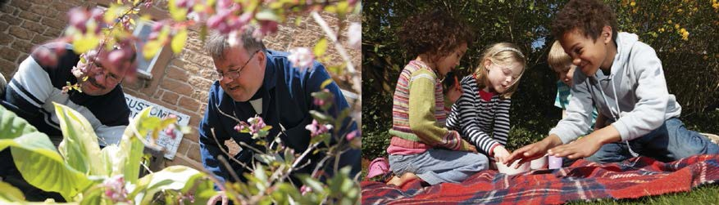
Safeguarding Strategy

Sheffield Clinical Commissioning Group will work to ensure that services are in place to recognise and respond to children and adults who are at risk of abuse or neglect and ensure their views are taken into account to influence service provision, this also includes looked after children and young people.

‘Working together to Safeguard'

The Children Acts 1989 & 2004 and the Children and Social Work Act 2017 outline the statutory duties relating to safeguarding and promoting the welfare of children across the partnership. These summarised in the Working Together to Safeguard Children Department of Health (DoH) 2018 and Statutory Guidance on making arrangements to safeguard and promote the welfare of children

The Care Act of 2014 for the first time puts adult safeguarding on the same legal footing as children and outlines our role to ensure the commissioning of services that promote core principles to safeguard adults with care and support needs from neglect and abuse

Demonstrating commitment to quality & safety in everything we do

- Seek the views of children, young people including those looked after and adults with care and support needs and their carers to influence the commissioning and provision of local services
What we will do
- Ensure health and social care organisations comply with statutory safeguarding requirements
- Identify clear lines of governance and accountability relating to safeguarding
- Ensure effective arrangements for information sharing across the partnership which comply with the Data Protection Act 2018 and the General Data Protection Regulations

How we will do it

- Have executive level representation on Sheffield Adult and Children Safeguarding Partnerships Executive Meetings
- Representation at the Corporate Parenting Board for children and young people who are looked after
- Collaborate across the partnership to achieve the best outcomes and to keep people safe
- Work in partnership with the Local Authority and agencies
- Increase awareness and recognition of all categories of abuse and their impact
- Support the commissioning of services which support victims and survivors of abuse
- Quality assure that safe practice is embedded in Provider organisations including services for looked after children and young people
- Aim to ensure that the statutory principles of the Mental Capacity Act are consistently applied for all people over the age of 16.
- Have safeguarding policies and procedures in place which are accessible
- Check and make sure that local health services are safe through KPI’s and assurance processes
- Listen and learn from the views and experiences of our population
- Learn lessons and implement change from practice and learning reviews
- Commission specialist roles and services to lead and promote the safeguarding agenda across all services
- Reduce the risk of exploitation by promoting the PREVENT anti-terrorist strategy and human trafficking and modern slavery legislation

For more information, please contact SCCG Safeguarding Team on 0114 3051239 (July 2020)
Thanks to Bassetlaw CCG

