

**NHS Sheffield Clinical Commissioning Group**

**Urgent Care Engagement**

**Key Findings Report**

**June 2019**

**Contents**

|  |  |  |  |  |
| --- | --- | --- | --- | --- |
|  | | | | Page |
| 1 | Executive Summary |  |  | 3 |
| 2 | Background |  |  | 5 |
| 3 | Oversight |  |  | 5 |
| 4 | Report Structure |  |  | 6 |
| 5 | Methodology |  |  | 6 |
| 6 | Responses |  |  | 6 |
| 7 | Overview of the Engagement | 7.1 | Qualitative community outreach engagement | 7 |
|  |  | 7.2 | Patient journeys | 8 |
|  |  | 7.3 | Public online survey | 8 |
|  |  | 7.4 | Staff survey | 9 |
|  |  | 7.5 | Design Group | 9 |
|  |  | 7.6 | Public and Partner Reference Group | 10 |
| 8 | Key findings | 8.1 | Definition of urgent care | 11 |
|  |  | 8.2 | Services people accessed and why | 12 |
|  |  | 8.3 | Timings of people accessing services | 16 |
|  |  | 8.4 | How people travelled to services | 17 |
|  |  | 8.5 | Referrals to other services | 18 |
|  |  | 8.6 | Patient experiences of using services | 19 |
|  |  | 8.7 | Public and staff urgent care priorities | 20 |
|  |  | 8.8 | Need for change | 25 |
| 9 | Similarities and differences from views gained previously in relation to urgent care |  |  | 26 |

**Appendices**

|  |  |  |
| --- | --- | --- |
|  | | Page |
| Appendix A | Infographic | 29 |
| Appendix B | Lowedges community | 30 |
| Appendix C | Darnall community | 32 |
| Appendix D | Roma Slovak community | 34 |
| Appendix E | Walk-in Centre | 39 |
| Appendix F | A&E | 37 |
| Appendix G | Journey Maps Summary | 39 |
| Appendix H | Public Survey – Summary of Responses | 42 |
| Appendix I | Staff Survey | 52 |
| Appendix J | Public and Partner Reference Group Workshops Summary | 58 |

|  |
| --- |
| **NHS Sheffield Clinical Commissioning Group would like to thank everyone who contributed to this report particularly members of the public, staff and those working in voluntary and community organisations such as Darnall Wellbeing, The Terminus Initiative and Mencap.** |

**1. Executive Summary**

Between December 2018 and May 2019, NHS Sheffield CCG engaged the public, partners and staff on urgent care services in the city. The engagement included an online questionnaire to gain views from the local population of Sheffield and staff in front line services, interviews and group discussions involving targeted groups (including harder to reach communities) and patients at the Walk-in Centre, A&E and in GP surgeries.

The themes in this report were developed with input from public and partner representatives via a Public and Partner Reference Group and a Design Group.

**Key themes from the information gathered during this phase of the engagement**

**Overall**

* There was praise for the quality of services, especially the quality of care in local GP practices in all the engagement methods we used.
* Transport remains an issue for communities in the areas of highest deprivation, particularly the cost of travel. Other broader transport concerns included the cost of parking, travelling whilst ill and travelling with sick children.
* When asked if respondents agreed or disagreed that urgent care services in Sheffield needed to improve, the majority of staff and patients stated they strongly or slightly agreed.

**Confusing and inconsistent pathways**

* People who live with mental health conditions and learning disabilities rely on services that they know and trust – their local GP or 999. There was very limited awareness of 111, the walk in centre or minor injuries unit. Staff who support people living with mental health conditions and learning disabilities are cautious when making decisions in relation to care navigation.
* Themes from staff in providers related to better pathways between services and access to diagnostics, alongside staff and patient education to raise awareness of services. Improving mental health services was also a big theme.
* Staff were significantly less confident that they knew the right service to refer onto when a patient had a mental health rather than physical health need.
* Access to GP or practice nurse appointments remains an issue, which was highlighted in the previous engagement. During the outreach engagement, the Walk-in Centre provides a highly valued alternative for people requiring quick access, out of hours or at a weekend.
* Other access issues such as waiting times and availability were also raised. When asked about one thing respondents would do, if they were the boss of the NHS in Sheffield, the most common theme from the public and staff was to improve access, including increased appointments and availability at GP practices and reduce waiting times. Staff also responded with increasing staff and workforce numbers, improving patient education and improving communications and engagement.

**Inconsistent knowledge and lack of knowledge**

* There is limited awareness about the availability of urgent care services and other supporting services which staff can refer too.
* There was a general lack of awareness of the Minor Injuries Unit and what could be treated there amongst all communities interviewed during the outreach work. In the patient journeys work, no one’s first point of contact was the Minor Injuries Unit. However, in the survey, minor injuries unit was the third service which patients went to first. The majority of respondents to the survey were from the lesser deprived areas.
* There was a lack of knowledge by staff of appropriate places to refer onto for people living with mental health urgent care needs.

**Culture and behaviour differences**

* The biggest driver of people’s behaviour for why they chose the urgent care services they did, was previous experience of using the service, they knew they’d be seen and knew the service would be open. This could be either a positive or negative experience which could impact on how they accessed services.
* Circumstances such as transport and cost of parking remained an issue in the more deprived communities.

**Lack of and inefficient use of resource**

* There is a shortage of time to care. If one service is unable to manage the demand, it bounces into another part of the system – day or night or between primary, community and secondary care.
* It means patients have difficulty accessing the right services for physical and mental health or care at the right time and staff don’t get the time they want to care for their patients appropriately.
* Staff responded in the survey that increasing staff and workforce numbers would help improve urgent care services.

**Definition of Urgent Care**

* The vast majority of respondents agreed with the following definition of urgent care:

“Urgent care means advice and treatment for illness* and injuries for all ages thought to be urgent (care needed within 24 hours) - but not life threatening.

*Illness includes mental and physical health.”

An infographic (see Appendix A) has been developed to illustrate the key findings of the Urgent Care Review 2019.

1. **Background**

Between 2015 and 2018, the CCG undertook engagement with the public of Sheffield about urgent care. The engagement identified a number of problems and issues with urgent care services. This included access to GP appointments, confusion about what services to use, the system not working cohesively, and barriers for some people that influenced the services they chose to use.

The engagement helped inform an urgent care strategy and a public consultation, which took place between September 2017 and January 2018. At the time, the Government introduced Urgent Treatment Centres as a policy to nationally address the same problems.

The aims of the proposals made in the public consultation were to improve urgent care services in Sheffield, by:

* Simplifying services, reducing duplication and confusion,
* Improving access to GP appointments to guarantee that everyone who needs an urgent appointment can get one within 24 hours, and mostly on the same day.

During and after the formal public consultation, concerns were raised about the proposals contained in the consultation as well as how the consultation had been undertaken. As a result, in September 2018, the CCG took the decision to explore further and refresh what the problems and issues are with urgent care with stakeholders and the public of Sheffield.

Consequently, between December 2018 and May 2019, Sheffield CCG engaged with the public and staff on urgent care services in the city.

The objectives were:

* To understand why people use services, their experiences and what is important to them and what needs most improvement
* Work in partnership with the public and stakeholders to identify the key problems and issues
* Be open and transparent with the public
* Meet our legal duties to involve including the Gunning principles.

1. **Oversight**

Learning from feedback during the urgent care consultation, it was important during this engagement that we were transparent, open and that wider stakeholder involvement helped us design the process. We therefore had oversight from three key groups:

1. Design Group – Co-designed the proposals and reference group workshops, analysed outputs and highlighted areas for further consideration, tested and challenged the products and processes developed by the Programme Team.
2. Reference Group – Members of the public and representatives from partner organisations locally and regionally offered their experiences of the urgent care system, offered oversight of the process, and analysed themes and trends as they emerged from the outreach engagement with communities.
3. Strategic Patient Engagement, Equalities and Experience Committee (SPEEEC) - A subcommittee of the CCG governing body who offered strategic oversight of the engagement process on behalf of governing body, ensuring that our statutory duties and moral obligations to the people of Sheffield were being met.
4. **Report Structure**

Included in the report are all the findings from the quantitative and qualitative engagement. The main thread of the report is a set of top line findings from the online survey which provides quick reference to all the questions asked. Any significant differences in opinion across the demographic groups are also illustrated and commented on throughout the report.

The views of people from community outreach (qualitative work) are after the survey question analysis, to complement, compare, contrast and enhance the analysis.

It should be noted that when the survey results are discussed within the report, often percentages will be rounded up or down to the nearest one per cent. Therefore occasionally figures may add up to 101% or 99%.

When considering how people have answered the questions, it is clear that words have different meanings for different individuals and communities, and therefore perception of terms will influence the answers given. This has been highlighted in the free text where appropriate.

1. **Methodology**

This engagement used a mixed method approach with an online questionnaire to gain views from the local population of Sheffield, interviews and group discussions involving targeted groups (including harder to reach communities and patients at the Walk-in Centre, A&E and in GP surgeries), and an online survey for staff.

1. **Responses**

Overall, 2,587 people have contributed to this stage of the urgent care review (including 317 staff from provider organisations.

|  |  |  |
| --- | --- | --- |
| Method | Month/Year | Number of respondents |
| Online surveys (public) | Feb – Mar 2019 | 1,783 |
| Online survey (staff) | Mar 2019 | 317 |
| Outreach engagement work in communities | Feb – Mar 2019 | 309 |
| Discussions with patients in A&E and the Walk-in Centre | Mar 2019 | 20 |
| Public and Partner Reference Group | Dec 2018 – Jun 2019 | 63 |
| Patient journeys (including targeted general practices) | Jan – Mar 2019 | 95 |
| Total |  | **2,587** |

In terms of how reliable the results are, the quantitative data is accurate to +/-2.32% margin of error at a 95% confidence level. This means that, for example, if 70% of respondents agreed with the statement that urgent care needs to change, we could be 95% confident that if all the public in Sheffield had answered the question then between 67.68% and 72.23% would have agreed.

1. **Overview Of The Engagement**
   1. **Qualitative community outreach engagement**

Feedback from these communities builds on previous engagement and consultation[1] from 2015 onwards.

Time-intensive qualitative research techniques were used, including in-depth semi-structured interviews, individual discussions and group interactions, to gain a richness of data to inform this review. This involved people sharing deeply personal stories and experiences as well as the impact the urgent care system had had on them. Where appropriate, examples have been matched to feedback from the online survey and additional information is highlighted in appendices.

Overall, 309 people were engaged in the outreach engagement (see Appendices B-D). 273 people lived in the Lowedges and Darnall areas of the city as these were under-represented in the previous engagement activity and are specific areas of high deprivation. Individuals with specific protected characteristics or life experience were encouraged to be involved:

* 8 people living with learning disabilities / difficulties
* 25 people living with mental health conditions
* 8 people with experience of substance misuse
* 100 people from the Pakistani community
* 20 members of the Roma Slovak community
* 8 people living with respiratory conditions

The activities included conversations with people from 12 different countries (UK, Iraq, Ireland, Hungary, Senegal, Nigeria, Bulgaria, Romania, China, Pakistan, India and Yemen).

In addition, 9 people who live with a learning disability or difficulty who access services at Mencap contributed as did 19 students at the University of Sheffield who were playing sports and therefore at risk of injury.

Qualitative feedback from these communities is included throughout the analysis alongside demographic data to illustrate how different geographical communities and those with protected characteristics are experiencing urgent care services.

In addition, 20 users of services at the Walk-in centre and adult A&E were interviewed (see Appendix E – F). This builds on previous engagement at children’s A&E and in the Minor Injuries Unit in 2016.

* 1. **Patient Journeys**

In addition to the outreach work and in order to understand what the patient journey looks like from patient perspectives, a journey map was developed for people to complete that provided information on the journey through the urgent care services in Sheffield, not about the problems and issues faced (see appendix G). The maps were tested and completed by participants at the workshop held on the 17 January 2019, and amended before being used to collect information from the places listed below. 95 journey maps were completed in total from:

* Participants at 3 x targeted engagement sessions at The Terminus Initiative
* Patients at Manor Clinic and Firth Park Clinic (community nursing services)
* Patients at The Healthcare Surgery (waiting room)
* Patients at Page Hall Medical Centre (waiting room)
* Patients at Porter Brook Medical Centre (waiting room)
* Patients at Pitsmoor Surgery (waiting room)
* Patients at University Health Service (waiting room)
* Participants at Chilypep.
  1. **Public online survey**

The public online survey ran from 8February 2019 to 29March 2019. The following numbers of the public completed the online survey and shared demographic information in comparison to the Sheffield population. A summary table of the responses to all questions can be found in Appendix H.

To help promote the survey, over 50 emails were sent to various organisations for wider dissemination to partners, councillors, community groups, voluntary, charity and faith organisations, and the media. In addition, the CCG shared and posted various posts on Facebook and Twitter with groups identified as seldom heard in the previous engagement.

|  |  |  |
| --- | --- | --- |
| Demographic | Online survey feedback | Sheffield population |
| Sex | 949 (72%) were female and 360 (28%) were male | This compares to 50/50 for the Sheffield population |
| Carers | 334 (26%) were carers | 10% are unpaid carers |
| Disability | 196 (15%) lived with a disability. Asked subsequently about the type of disability: 116 (50%) live with a long-standing illness or health condition, 84 (36%) live with a physical or mobility disability, 58 (25%) live with a mental health condition and 10 (5%) live with a learning disability or difficulty | 19% of the population lives with a disability or long-term condition |
| Race | 1,201 (94%) were white British and 67 (6%) were Black, Asian, Minority Ethnic and Refugee (BAMER) | White British people 84%  BAMER 16% of Sheffield’s population. |
| Age | 218 (18%) under 40 years old,  216 (18%) were between 40-50,  235 (19%) were between 50-60,  277 (23%) were between 60-70,  219 (18%) were between 70-80,  53 (4%) were 80+. | 55% under 40,  13% 40-50,  12% 50-60,  9% 60-70,  6% 70 – 80 and  5% 80+ |
| Religion or belief | 36 (49%) said they were Christian,  40% had no religion,  nearly 1% were Muslim and  0.5% Buddhist | 53% of are Christian,  39.7% No religion  6% Muslim, 0.6% Hindu  0.4% Buddhist, 0.2% Sikh and  0.1%.Jewish |
| Parents | 328 (25%) were parents of a child under 16 | 36% of households include children. |
| Access to technology | 148 (11%) did not have access to a smart phone, 1,285 (99%) have access to the internet at home and 17(1%) do not |  |

* 1. **Staff Survey**

The staff survey was launched on the 1 March and closed on the 29 March 2019. We promoted the survey via GP practices, care homes, partners and around 25 community organisations. It was completed by the following staff:

|  |  |
| --- | --- |
| Provider | Responses |
| GP practices | 130 |
| Sheffield Teaching Hospitals (inc GP Out of Hours) | 67 |
| Other | 55 |
| Sheffield Children’s Hospital | 24 |
| Primary Care Sheffield | 19 |
| Walk-in Centre | 13 |
| Sheffield Health and Care Trust | 6 |
| Pharmacy | 3 |

‘Other’ consisted of respondents from Sheffield City Council, Care Homes and Voluntary, Community and Faith organisations. Please refer to Appendix I for further detail about the responses.

**7.5 Design Group**

The Design Group was established with the following aims:

* To design the proposals
* To design workshops
* Test and challenge products developed by Programme Team.
* Review outputs from the workshops and highlight any areas for further consideration
* To review the feedback of the engagement

Membership of the Design Group was by invitation for stakeholders identified including the following:

* Patients (volunteers from the public reference group)
* Sheffield CCG
* Sheffield Teaching Hospitals NHS Foundation Trust
* Sheffield Children’s Hospital NHS Foundation Trust
* Sheffield Health & Social Care NHS Foundation Trust
* Primary Care Sheffield
* One Medicare
* Sheffield City Council
* Yorkshire Ambulance Service
* Healthwatch
* GP Practices
* ScHARR (School of Health and Related Research)
* Public Health
* Local Pharmaceutical Committee
* Local Medical Committee

The group has met monthly from December 2018 to June 2019 and will continue to meet to have oversight of the process.

**7.6 Public and Partner Reference Group**

The Public Reference Group was established with the following aims:

* To share members’ experiences of the urgent care system
* To oversee the process followed
* To analyse the outputs from public engagement and consider themes and trends

Membership of the Public Reference Group was by invitation for:

* Organisations from the Voluntary, Community and Faith sector
* Members of Patient Participation Groups representing GP surgeries across the City
* The University of Sheffield and Sheffield Hallam University
* Healthwatch Sheffield
* Save our NHS

In December 2018 we held an initial workshop with representatives from the Public Reference Group and a separate workshop with representatives from our Partner Organisations across the system, including:

* Sheffield Teaching Hospitals NHS Foundation Trust
* Sheffield Children’s Hospital NHS Foundation Trust
* Sheffield Health and Social Care NHS Foundation Trust
* Yorkshire Ambulance Service
* Sheffield City Council
* NHS111
* Primary Care Sheffield

In January 2019 we held a joint workshop with members from the Public Reference Group and our Partner Organisations. Feedback from attendees led us to combine the groups to form a Public and Partner Reference Group.

This group met a further four times between February 2019 and June 2019, including a specific workshop to consider children’s urgent care services. Please refer to Appendix J for a summary of the Public and Partner Reference Group Workshops.

1. **Key findings**

The public survey consisted of 22 questions – closed and free text. The results are summarised in the following sections alongside additional insight from the outreach engagement work, where appropriate. A summary table for each response can be found in Appendix H.

The staff survey consisted of 16 questions.

* 1. **Definition of urgent care**

As part of reference groups and stakeholder engagement, a draft definition of urgent care. was developed:

“Urgent care means advice and treatment for illness* and injuries for all ages thought to be urgent (care needed within 24 hours) - but not life threatening.

*Illness includes mental and physical health.”

In the survey, we asked people if they agreed with the definition. The vast majority (94%) of people agreed. Of the 6% who did not agree, respondents offered alternative suggestions summarised in the quotes below:

*“Urgent may not be doctors definition but patient may feel it is”*

*“I think urgent could be interpreted or understood by some as emergency.”*

*“Urgent care = life threatening.”*

*“I would change this to "urgent care means advice and treatment for illness* and injuries for all ages thought to be urgent (care needed within 24 hours) - including illnesses that need to be treated within 24h so they don’t become life threatening”*

*“If it is urgent surely 24 hours is too long.”*

*“Within a few hours - up to 6.”*

*“Instead of urgent care it should be renamed urgent treatment. Care is confusing for a lot of people due to care is used in care homes, care which is used for personal care and finances.”*

*“If it were called "non-emergency urgent care" I think people would understand the distinction better. Most members of the lay public will not naturally draw a distinction between "urgent" and "emergency."*

* 1. **Services people accessed and why**

94% of respondents to the public survey had used urgent care services. Thinking about the last time, 54% used the service for themselves, 16% for a child, 9% for an adult they cared for, and 21% for an adult.

**Thinking about the last time you had an urgent healthcare need for you or someone you care for, what did you do first?**

* Overall, the majority of people (57%) contacted or went straight to an NHS service initially for their urgent care need.
* Males were proportionately more likely to go straight to an NHS service rather than look online or self-care in comparison to females.
* It would appear that people in the most affluent areas of the city are more likely to go to NHS services initially than those in the most deprived areas.
* Parents of children under 16 are more likely than average to look online than go straight to an NHS service.
* People from Black, Asian, Minority Ethnic and Refugee groups are no more or less likely than average to go straight to an NHS service.
* People who live with a disability are more likely to go straight to an NHS service.

**Which NHS service did you contact first for advice?**

* The biggest proportion of respondents’ first contact with an NHS service was NHS 111 (23%), with 22% phoning and a further 2% going online. This is followed by 22% of people who visited or phoned their GP practice. 2 in 5 people went to the Walk-in Centre (20%) and 13% of people visited the Minor Injuries Unit (MIU) and 13% A&E – 7% Adults and 5% Children’s.
* Carers are more likely than average to contact the GP or Walk-in Centre first
* Parents of a child under 16 were more likely to contact Children’s A&E first, followed by NHS 111.
* When seeking advice for themselves, females are more likely to contact their GP first and males are more likely visit the Walk-in Centre initially.
* People living in the most deprived areas of the city are least likely to visit the Minor Injuries Unit.

**Community engagement findings (see Appendices D-G)**

Based on the outreach engagement with the learning disabilities community at Mencap, it emerged that 999 was the automatic response to minor injury and non-emergency conditions or for carers who often have intellectual disabilities themselves – a direct quote was:

*“I need help. I’m not well. I need an ambulance.”*

Based on the outreach work in Darnall, young Pakistani males (under 40) who identified themselves as suffering from anxiety and depression spoke about ongoing difficulties obtaining appointments and this has resulted in frequent use of the Walk-in Centre.

*“I was told that I had to wait a week and I knew that I would get worse if I waited that long”*

In both the Lowedges and Darnall communities, the majority of feedback indicated that most people are unaware of the existence of the Minor Injuries Unit and there were suggestions that publicising this service could be helpful. When asked if they would consider using the Minor Injuries Unit in future, for example sprains or burns, there was confusion about which service to use

*“How do I know where to go – Walk-in Centre or Minor Injuries Unit?”*

This is in contrast to the survey findings, most people said their driver for choosing a service was whichever service was nearer to where they lived.

The majority of people in the Lowedges community who live with learning disabilities and enduring mental health needs either did not know about 111, the Walk-in Centre or Minor Injuries Unit for out-of-hours non-urgent care, or knew and did not wish to use the services, preferring to see their GP at the next available opportunity or use the emergency 999 service.

A common theme from the Roma Slovak families was the common clinical practice in their home countries to prescribe antibiotics much more frequently than would be considered appropriate in the UK. This seems to result in patients choosing to attend A&E where there is the expectation of seeing a doctor on the same day as the presenting need, and an expectation that certain medications are more likely to be prescribed.

*“UK doctors are not as good as they are (back home), they don’t care, and they don’t give me and my son the medicines we know we need.”*

There was confusion regarding where patients should be signposted for urgent dental care, with several patients being told by staff at Walk-in Centre that Charles Clifford does not carry out urgent dental care and being referred back to their GP.

In the engagement carried out in 2015, a key theme was that people said they would go to a pharmacy first, particularly those from the Traveller community. In the most recent engagement activity, only a few people mentioned using their pharmacy.

Based on the information from the patient journey maps, no-one mentioned using the Minor Injuries Unit as the first point of access. A few patients mentioned using the GP hubs. Similarly to the survey, few people mentioned self-care and only one person mentioned using their pharmacy.

**Why did you choose this service?**

* Asked why they chose that service, the biggest driver of people’s behaviour was due to a previous experience (34%), followed by they knew they’d be seen there (27%) and said they knew it would be open (25%).
* The fourth most popular answer was “other”. Here people said that they had been referred by another professional, it was the easiest service to get too or it was at the weekend.
* In the qualitative responses within the online survey from people who had used A&E, key themes from respondents were that they felt it was the most appropriate service for their need or that they were told to attend by another professional.
* The themes relating to why 999 were called included being encouraged to do so by another professional and feeling that the situation was serious enough to warrant an ambulance.
* In relation to Children’s A&E, parents chose that service because they trusted the competence, skill and service available at that site.
* Reasons given for utilising the Minor Injuries Unit included ease of access on foot, that it is the nearest service and that it was the most appropriate service based on the urgent care need. People stated they knew they would get the advice they needed as the primary reason for contacting their GP or NHS111. Other reasons given for contacting NHS111 included previous personal experience of the service, they knew it would be available or they could access it from home.

**Community engagement findings**

The majority of people in the Lowedges community were concerned about transport costs to the Walk-in Centre and this concern had stopped patients attending. Other comments included concerns regarding the difficulties of travelling whilst ill, travelling with sick children, and the cost of nearby parking.

Students who were aware of the Minor Injuries Unit preferred to attend this service rather than the walk in centre due to its geographical location and the experience of shorter wait times. Students said that at freshers’ induction sessions the Minor Injuries Unit is not referenced and this seems to be reflected in the low levels of awareness of this service.

As mentioned previously, the Roma Slovak population shared that they were more likely to attend A&E rather than their GP due to the expectations of the service they would receive.

Feedback from the focus group at Mencap of people with learning disabilities and their carers was that none of the members had heard of NHS111 but all members present had heard of the walk in centre and 8 members had heard of Minor Injuries Unit.

Based on the outreach work in Lowedges, the majority of usage of Walk-in Centre was prompted by local surgeries being closed at weekends and bank holidays. In the Pakistani community, most of the visits to the Walk-in Centre and A&E were prompted because the patient could not obtain an appointment with a GP during opening hours.

Although the sample size from the waiting room at the walk in centre was small, everyone shared that they weren’t able to get an appointment with their GP.

* 1. **Timings of people accessing services**
* Nearly two-thirds of people (64%) used the services on a weekday: 26% in the morning, 21% afternoon and 17% in the evening.
* 32% of people used services at the weekend or bank holiday, with the biggest proportion of this group having used a service between 8am and 12pm (12%).
* People using their GP first is highest in the morning, declining sharply over the day
* Use of NHS111 and the walk in centre increases in the afternoon and evening
* Minor Injuries Unit use declines in the evening as it closes at 8pm.

**Proportion of people using services by time of day**

* The proportion of people responding that they first used 999, A&E and Minor Injuries Unit is consistent at around 35-40% throughout the day.
* The focus of activity mainly switches between GP, NHS111 and the Walk-in Centre
* 50% of respondents using a service in the morning used their GP first. This drops to 32% in the afternoon and 4% in the evening.
* Only 7% of those using a service in the morning used NHS111 first, rising to 34% in the evening and 55% at night.
* 11% reported using the Walk-in Centre first on a weekday morning
  1. **How people travelled to services**

**How did you get to this service?**

* The majority of people (56%) travelled to the service by car. 17% of people didn’t travel as it was a telephone or online service. Just 1 in 10 people (9%) walked and 6% got public transport.
* People living in the more affluent areas were most likely to travel by car (55%). Those people living in areas of high deprivation were more likely than average to travel by bus (7%) and least commonly by ambulance (4%).
* When asked if respondents experienced any difficulties getting to services, 87% of respondents answered no. Respondents comments included:

*“Had to get a taxi to other side of Sheffield NGH and then a taxi back to children’s hospital”*

*“Car parking at NGH horrendous. Unable to catch bus due to long walk up path to get to hospital”*

*Actually as no problem with parking given a Sunday morning. However, any other time the car parking would be a nightmare. A multi-storey car park is badly needed at NGH. Also a better bus service, or better still a tram out to NGH!*

*“Chose Chesterfield hospital as much quicker and easier to access from where I live in the south west of Sheffield”*

* 1. **Referrals to other services**

**Which service were you referred to?**

* Of those who were referred elsewhere, 30% were referred to A&E - 24% A&E at NGH and 6% to children’s A&E. 29% were referred to primary care - 16% to their GP practice, 8% GP out of hours, 3% pharmacy, and 2% primary care hubs.
* A small number were referred to Walk-in Centre (4%) and Minor Injuries Unit (2%).
* Of the 13% who said ‘other’, they were referred for further diagnostics tests, or for specialist treatments.
* After using or contacting their first service the majority of people who filled in the survey (55%) were referred to another service by a healthcare professional or service.
* 31% of those referred had initially made contact with NHS111. This would be expected, however it is interesting to note that a high proportion 53% of those referred to a second service were from services such as Minor Injuries, Walk-in Centre, both A&Es, 999 and GP practices. The reasons behind this need exploring further but could be indicative of problems in pathways and signposting and behaviours which have been highlighted in the patient journeys, workshops and survey results.
* Over a quarter were referred to hospital, 14% as an outpatient, 10% as an inpatient, and 3% to emergency assessment unit.
* The vast majority (96%) went to the service they were referred to.
* Of the patients who were referred to A&E (children and adult) said they were referred by NHS111 (41%), GP (22%) and the Walk-in Centre (16%). GP surgery referrals were via the Walk-in centre (30%) and NHS111 (29%).
  1. **Patient experiences of using services**

**Thinking about the last time you needed an urgent care appointment with your GP or another healthcare professional in your practice, were you able to get one within 24 hours?**

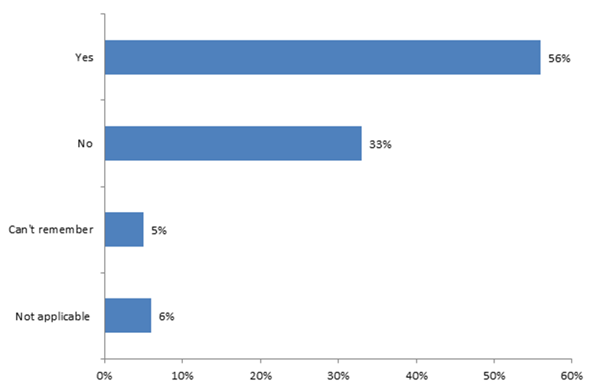

* More than 50% of respondents were able to access an urgent appointment (within 24 hours) at their GP surgery, or with another healthcare professional, last time they requested one. 11% of people couldn’t remember or it wasn’t applicable in their situation and 33% of respondents were not able to access an appointment when they perceived they needed one.

Based on the respondents’ experience of using the services, and referral from one service to another, comments included:

*“It was helpful to get advice and signposted to see medical attention.”*

*“The ambulance people were ok but I didn't see them again. And the information I communicated to them was not read up by subsequent doctors and nurses whom I came into contact with so I had to go through the story several times. This was frustrating, confusing and tiresome because I am autistic therefore communication is very difficult for me.”*

*“They were very good but working through the required script ended up saying I needed an ambulance. I refused as I was able to get there myself and was quite local. I was trying to save the NHS money. Now I know what I know I should have accepted as I then needed further NHS "drains" by me utilising 4 GPs, 1 radiographer, 3 hospital visits, a nurse, 2 pharmacists, 2 GP collaborative visits etc. I feel had I have started in the "system" I would have been far less time, trouble and cost to the NHS.”*

*“Absolutely wonderful as always, NHS at its best.”*

*“They were unable to help me - agreed with my diagnosis but could not provide the cream my daughter needed without a GP confirming it so I called the GP and couldn't get an appointment so I then call 111 who then told me to go to the walk in centre who confirmed the diagnosis which myself and the pharmacist had agreed 3 hours previously and prescribed the cream that the pharmacist had recommended and I went back the pharmacy to collect it. All of this for a 4 year old with impetigo!”*

* 1. **Public and staff urgent care priorities**

**Public’s urgent care priorities**

We asked the public to pick up to five areas of urgent care (from a list of 20) that were most important and up to five that were most in need of improvement.

The most important were:

1. Being seen by a healthcare professional best able to treat them (53%).
2. Being seen on the same day (51%)
3. Being seen at my own GP practice (44%)
4. Being able to walk in for an appointment (31%)
5. Being able to book in for an appointment (30%).

The most need of improvement included a slightly different list to those most important:

1. Being seen at my own GP practice (40%)
2. Being seen on the same day (37%)
3. Being able to book in for an appointment (30%)
4. Being able to see my own GP on the same day (30%)
5. Being seen by a healthcare professional best able to treat me (27%)

The graph overleaf shows the correlation between most important against most in need of improvement.

Those in the top right-hand box are those that are classified as the most important and most need improving. These are:

1. Being seen at my own GP practice
2. Being seen on the same day
3. Being seen by a healthcare professional best able to treat me
4. Being able to walk in for an appointment
5. Being able to book in for an appointment

**Public’s urgent care priorities**

**Important and needs improving**

**Less important but needs improvement**

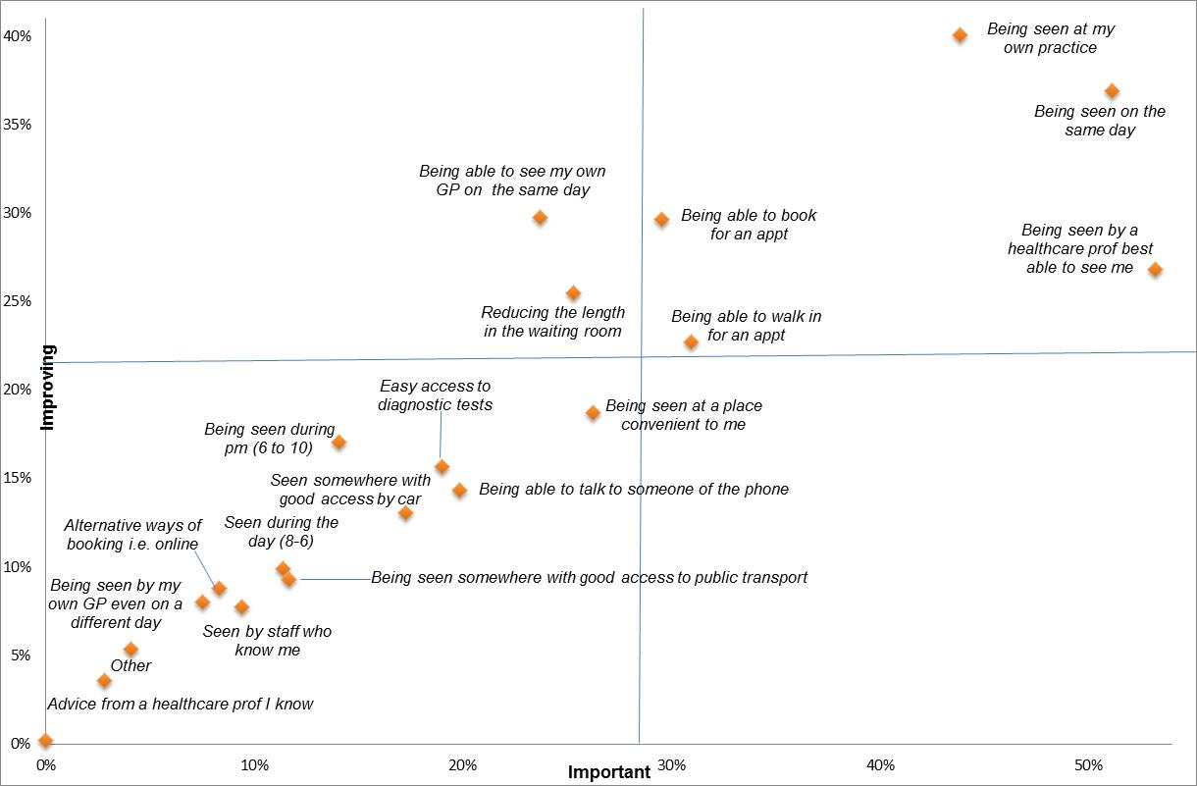

**Important and less in need of improvement**

**Less important and less in need of improvement**

Although numbers were small and not statistically significant, responses from different demographic groups were as follows:

* Disabled respondents selected ‘seeing own GP/someone who knows me’ slightly more frequently than the average (20% compared to average of 19%)
* People from Black, Asian, Minority Ethnic and Refugee groups are more likely than average to select ‘seeing own GP/someone who knows me’ (24% compared to average of 22%) and less likely to select ‘being seen on the same day’ (19% compared to 21%)
* Respondents from postcodes S10/S11 were more likely than average to select convenience to get to (16% of responses compared to average of 14%) and slightly less likely to select ‘seeing own GP/someone who knows me’ (18% compared to 19%)

**Staff’s urgent care priorities**

We asked staff to pick up to five areas of urgent care (from a list of 20 that were slightly different to the public list) that were most important and up to five that were most in need of improvement:

The most important were:

1. Being able to provide enough same day appointments (50%).
2. Having an up to date list of all the services I can signpost/refer to (47%)
3. Gaining the trust of the patient, I am providing advice or treatment to (41%)
4. Putting clinical triage in place (41%)
5. Being able to electronically talk to other computer systems across services and organisations (37%).

The most need of improvement was a slightly different list to those most important:

1. Being able to provide enough same day appointments (48%)
2. Access to services that can deal with urgent non-health problems such as benefit advice, social care (46%)
3. Having an up to date list of all services I can signpost/refer to (39%)
4. Being able to electronically talk to other computer systems across services and organisations (32%)
5. Having a range of services offered in our organisation which we can refer patients to (31%)

The graph overleaf shows the correlation between most important against most in need of improvement.

Those in the top right-hand box are those that are classified as most important and need most improving. These are:

1. Being able to provide enough same day appointments
2. Having an up to date list of all services I can signpost/refer to
3. Access to services which can deal with urgent non health problems such as benefit advice, social care
4. Being able to electronically talk to other computer systems across services and organisations.

**Staff’s urgent care priorities**.

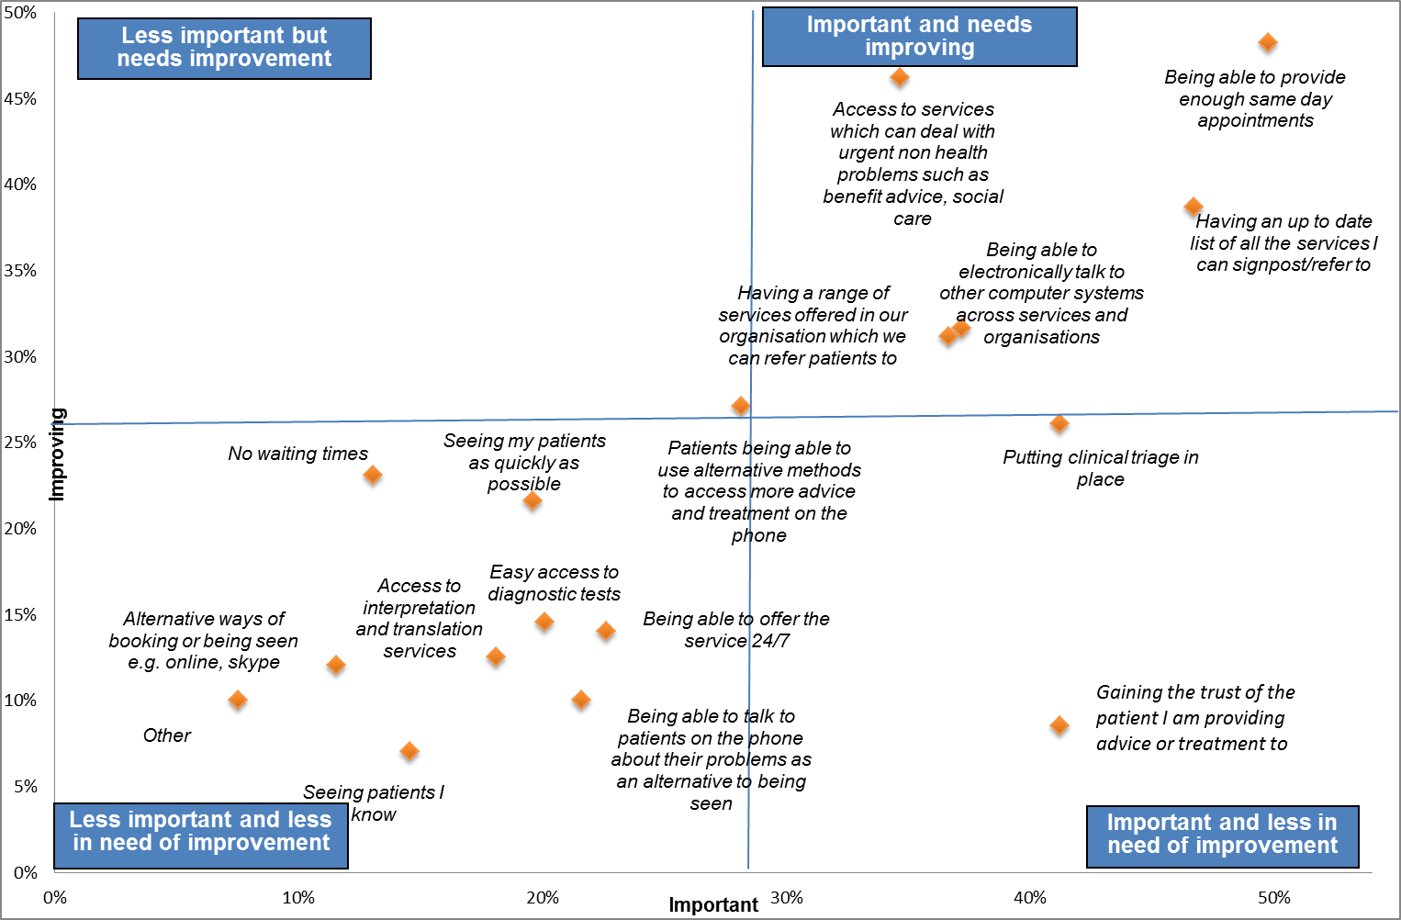

**One thing people would improve**

We asked people if they were the boss of the NHS in Sheffield, what one thing they would do to improve their experience of urgent care services in the city

There was a diverse range of responses from patients to this question, but the top six themes were:

1. Improve access (18%);
2. Don’t close services / retain services (13%);
3. Increase number of locations / services (13%);
4. More staff / workforce (11%);
5. Improve patient education (6%);
6. Better triage (5%).

The public shared the following comments:

*“Make it less confusing to access, and easier to navigate (or be navigated) round the system to get seen by the right person quickly. I drove past the children's hospital to get to GP Collab at NGH (as told by NHS 111), only to be told by the GP to go back to SCH.”*

*“Employ more staff. Do not shut down Walk-in Centres. Make access easy for all.”*

*“Increase awareness that you can get an out of hours GP appointment from 111. Maybe increase the number of locations that run it.”*

*“Easier access to urgent healthcare in the outskirts of Sheffield, especially where public transport is lacking.”*

Based on all the feedback received in response to this question, the following words were used (the more prominent the word, the greater the frequency of use):

**Public**  **Staff**

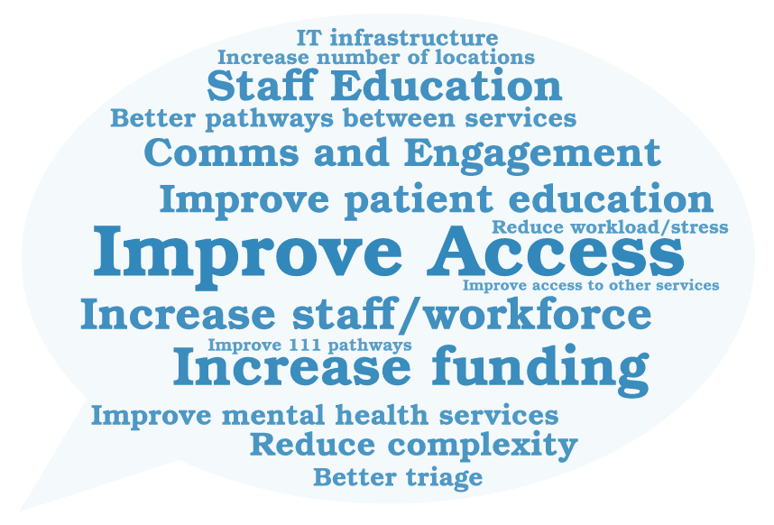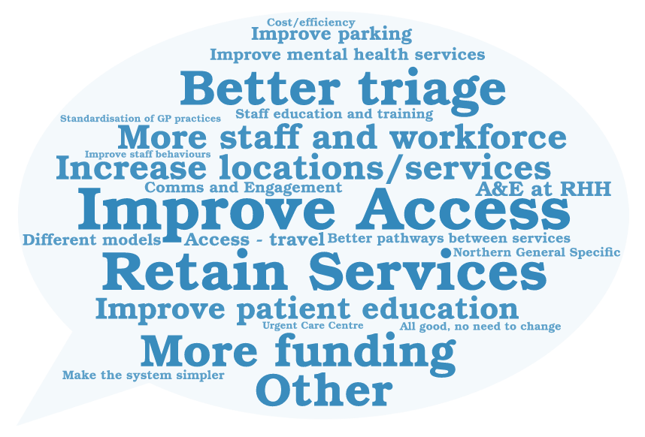

The top four themes from a staff perspective were:

|  |  |
| --- | --- |
| **Theme** | **Instances** |
| Better pathways between services/ access to diagnostics | 77 |
| Improve Patient Education | 69 |
| Improve Staff Education | 69 |
| Improve Mental Health Services | 68 |

* 1. **Need for change**

**How much do you agree or disagree that urgent care services in Sheffield need to improve?**

* Overall, 72% of people who completed the question, strongly (38%) or slightly (34%) agreed that urgent care services in Sheffield needed to improve, 1 in 10 (10%) of people disagreed. This is a net agreement of +62%.
* Older people are more likely than younger people to perceive that urgent care services require improvement
* People who live with a disability are more likely to think that services need to change - 49% strongly agreed that urgent care services need to be improved and 27% slightly agreed.
* From carers who contributed to the survey, 77% strongly or slightly agreed that urgent care services need to be improved and 67% for parents of a child.
* Of those working in urgent care services, 69% of respondents strongly or slightly agreed that services need to change.

**9. Overview of similarities and differences from views gained previously in relation to urgent care**

Engagement on urgent care started in 2015. A table showing the key themes from all the engagement and consultation undertaken is below.

From May to August 20151, the CCG talked to patients and the public using a variety of methods, estimating over 14,000 contacts with individuals and groups specifically relating to the urgent care services review.

Healthwatch Sheffield then carried out surveys in late 2015 and early 2016 at A&E, Children’s A&E, Minor Injuries Unit and the Walk-in Centre. The information gathered provided a snapshot of the behaviours of people using these services at a particular date and time.

Pre-consultation engagement activity was undertaken in March 20172, with 289 community members from the following six groups, some of whom were considered ‘seldom heard’:

* Homeless people
* Substance misuse community
* Communities with greatest deprivation
* City workers
* Students
* Vulnerable people

Sheffield CCG then ran a formal public consultation between 26 September 2017 and 31 January 2018 on proposals to redesign urgent primary care within Sheffield. The consultation was then extended by a further 6 weeks. This engagement was in relation to the specific proposals in the consultation document. Then in September 2018, the CCG took the decision to explore further and refresh what the problems and issues are with urgent care with stakeholders and the public of Sheffield. This resulted in the urgent care review from December 2018 to May 2019.

In summary, over the last 4 years, NHS Sheffield CCG has used a variety of methodologies and a range of questions and has approached diverse range of communities. The analyses in the table below shows that themes that have emerged from all the engagement work conducted over this time have been very similar, which allows us to be assured that the views we have collected are a representative sample of the views of the people of Sheffield. There have been consistent themes across all engagement reports, particularly around access to the right service, first time, concerns about public transport and the cost and patients passed from pillar to post.

1 Urgent Care Survey, Healthwatch Sheffield, NHS Sheffield CCG, March 2016

2 PublicEngagement with Specific Groups, Summary Report, NHS Sheffield CCG, March 2017

Themes identified from all the engagement activity mentioned above can be seen in the table below:

| Summer 2015 | Surveys 2015/16 | Pre-consultation March 17 | Consultation Activity 2017/18 | Urgent Care Review 2019 |
| --- | --- | --- | --- | --- |
| * Access to GP appointments * Confusion about what services to use * System not working cohesively * Mixed view of staff attitude and communication * Differing experiences and knowledge of services – electronic access * Alternative services available closer to home * Discharge failures * Lacking a holistic approach for physical and mental health needs * People use the services they are familiar with and close to home | * Most people had chosen to access the Walk-in Centre because they were unable to make an appointment with the GP * Shorter waiting times and more information about how long they will have to wait * Most people had chosen to access A&E and Children’s A&E because they felt that was the service that they needed. * People were mostly looking for medical advice * Most people who had tried to access another service before A&E had called NHS111 and been told to go there * If the service people were accessing wasn’t there: * A&E said they would go to WIC * Children’s A&E said they would go to the WIC * MIU said they would wait to see own GP * WIC said they would go to A&E   + Only 4.6% of respondents stated they were not registered with a GP | * + Recognising that phones give lots of people access but the cost and access to phones can be a barrier   + Issues around support and after care for vulnerable patients   + For homeless, substance misuse and communities of greatest deprivation, visits are higher in A&E than the Walk-in Centre, with some very high frequent attenders   + 9 people = 164 attendances at A&E   + Lack of specialist support to people with experience of substance misuse and revolving door   + Temporary registration creates barriers and impacts on health inequalities   + People with low literacy or English as second language find it difficult navigating the system   + Service they had used most was pharmacy   + People use services that they know and trust rather than unfamiliar environments   + Choice of using a service is based on previous experience and trust | CONSULTATION REPORT   * + Current access to GP appointments meant that urgent care access was not seen as a viable alternative.   + Concerns about the proposals around achievability of neighbourhoods/primary care   + Local care in the community close to home   + Concerns around widening health inequalities and accessibility of NGH site, including transport, and after care for vulnerable patients.(contrary to high use of A&E)   + Need for services to remain in the city centre   + Lack of knowledge about where and when to access urgent primary care.   TELEPHONE SURVEY Feb 2018   * Care in local community * Speed of being seen important – particularly for younger people * Convenient appointments important – but different for times of day depending on age * NGH site a concern as less accessible (e.g. distance, poor transport links, parking) * Public transport a concern * Loss of city centre services and concern (both MIU & WIC * Need more awareness of what services to use – improve working conditions and capacity of the NHS   TELEPHONE SURVEY – Selected Postcodes   * Care local to home preferred * Speed of getting an appointment important, particularly to males and younger people * Older people and those living with a disability are more likely to want appointments closer to home in the daytime * Accessibility of NGH site, (distance, poor transport links, parking) * Concern about closure of WIC and MIU * Need more awareness of what services to use | The findings of this review have been described in detail throughout this report. The overall themes that have been identified are:   * Confusing and Inconsistent Pathways   + Parity between referral and services available for people with mental health rather than physical health conditions   + Speed of access important for some communities * Inconsistent knowledge and lack of knowledge   + Confidence level of staff in support roles to refer   + Staff – training, numbers, signposting etc * Culture and Behaviour Issues, including:   + Travel using public transport – particularly cost and travelling whilst poorly   + Reliance on services people know and trust * Lack of and inefficient use of resource   + Access to GPs including waiting times and availability   There was a strong sense that “something needs to change” |
| Common themes across all engagement   * Confusion about what services to use, the recent review suggested this included patients and staff not knowing where to refer to * Public transport a concern * Care local to home preferred * Access and speed of getting an appointment important * People who are older and those who live with a disability are more likely to want appointments closer to home in the daytime * Accessibility of NGH site, with concerns about distance, poor transport links and issues with parking. There was also feedback about lack of accessibility around the site, particularly for vulnerable, infirm and older people. * Concern about closure of WIC and MIU (consultation onwards) | | | | |

**Appendices**

**Appendix A – Infographic**

This infographic has been developed to illustrate the key findings of the Urgent Care Review 2019.

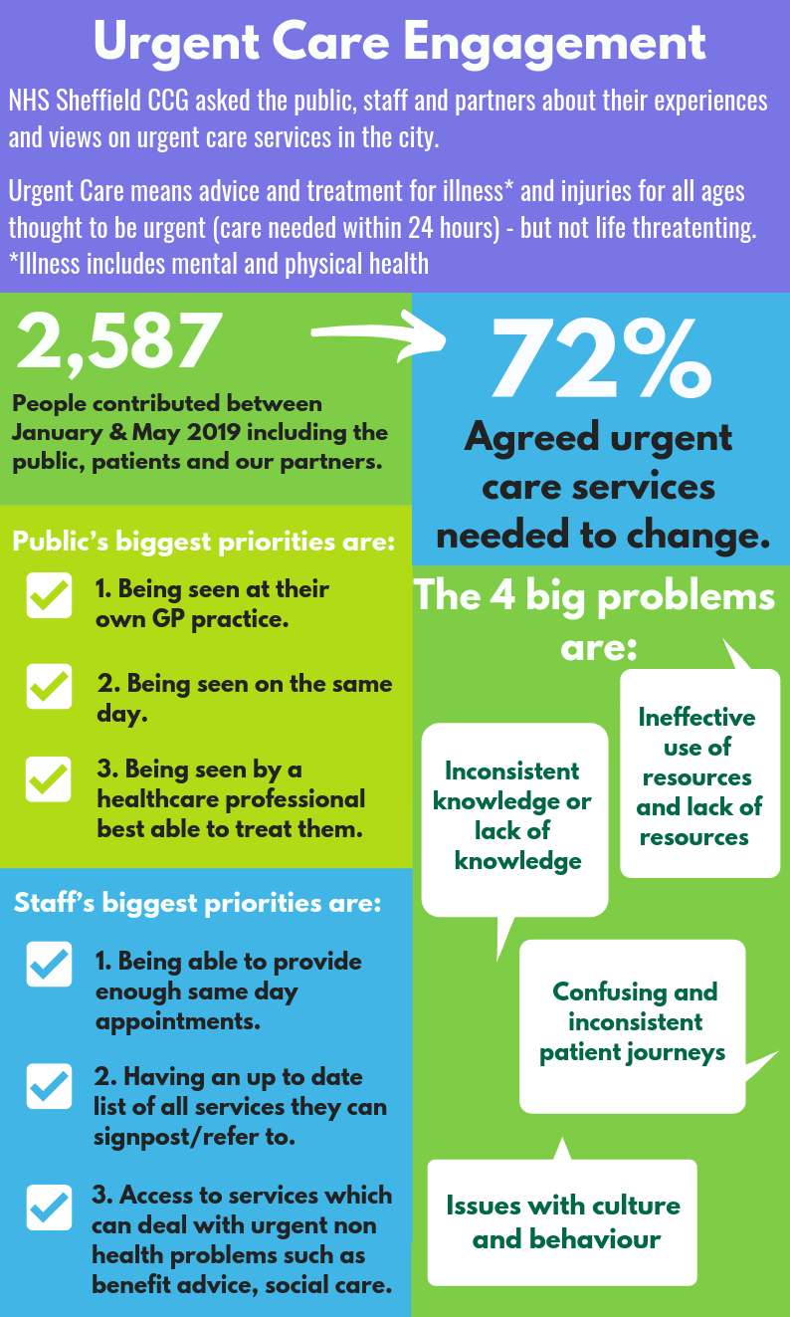

**Appendix B – Lowedges community**

|  |  |
| --- | --- |
| Session: | Urgent Care Community Engagement with people living in Lowedges, Batemoor and Jordanthorpe |
| Date: | 13 – 27 February 2019 |
| Partner organisation: | Terminus Initiative |
| Facilitators: | Pam Daniel (Terminus Initiative) & Paula Mackintosh (CCG) |

**Summary of interactions:**

* 100 people contributed via semi-structured interviews, group interactions and brief conversations
* Community members shared that their country of origin included: UK, Iraq, Ireland, Hungary, Senegal, Nigeria, Bulgaria, Romania, Bulgaria & Yemen
* 25 people disclosed that they live with long-term health conditions including respiratory conditions, learning disabilities and mental health conditions
* Settings for discussions included a Dementia Café, Carers Group, food growing project, MIND support group

**Emerging themes from engagement activities in Lowedges:**

* The vast majority of conversations took place with patients who had attended the Walk in Centre because the health need arose out of hours and were signposted to WIC via GP answer phone. Only 2 people said they could not access their GP and were signposted to the Walk in Centre.
* Cost of transport to the Walk In Centre prohibitive for many, although family groups help each other with this
* Attendees are generally happy with the Walk in Centre and NHS111 service, despite complaints about waiting times, the feedback was positive in terms of clinical care and outcomes. There were very few suggestions for service improvement or extending the range of choices, although interviewees were all asked this question. Walk In Centre described as a “Godsend” by a several attendees
* Attendees with Learning Difficulties and Complex mental health needs did not know about the NHS111 service, the Walk In Centre, Minor Injuries Unit and said they would either wait until the surgery opened or use emergency 999 service
* Several attendees are also Care Workers and their respective Employers (Private Care Homes) use the Walk In Centre when emergency doctors aren’t available
* Concerns relating to the relocation of the local surgeries to Jordanthorpe dominated many conversations and remained a recurring theme in all of the Lowedges sessions. The implications for people living on the Lowedges estates is far reaching as for many people travelling to their local surgery will require two buses. “ I will need to take 2 buses to the surgery and it is an £8.00 taxi trip to the WIC so I don’t feel I have any choices at all” This has since been resolved by interventions from Louise Haigh, and revised bus routes are now operating.
* General observation by attendees ; a significant number of attendees felt that the local community infrastructure had been decimated, with post offices and facilities closing down, and the Terminus Initiative acting as the main hub for the Lowedges Estate. There were concerns expressed re accessing primary care services given the mobility issues of many older residents.
* All but 2 attendees said they had used the NHS111 service and the Walk in Centre because it was either a weekend or out of hours during the week. The majority said they were able to obtain appointments at their local surgeries.
* There was praise for the quality of services, especially the quality of care in local GP practices, and praise for the doctors at Walk In Centre and the care with which older people were treated

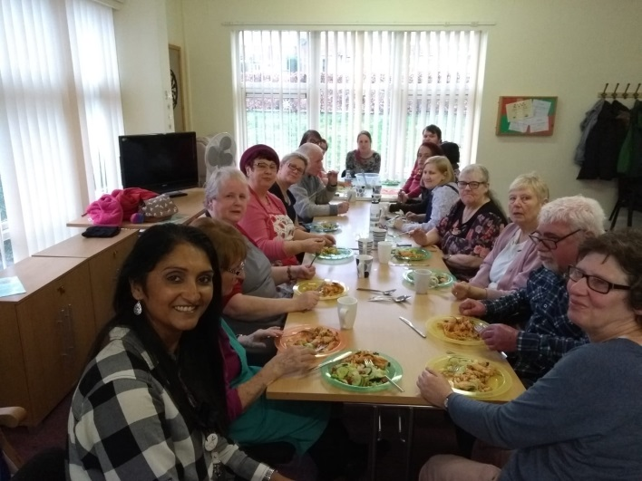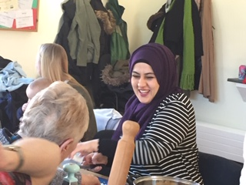

**Appendix C – Darnall Community**

|  |  |
| --- | --- |
| Session: | Urgent Care Community Engagement with people living in Darnall |
| Date: | 13 February - 15 March 2019 |
| Partner organisation: | Darnall Wellbeing |
| Facilitators: | Joanne Van Leavsey (Darnall Wellbeing) & Paula Mackintosh (CCG) |

**Summary of interactions:**

* 153 people contributed via semi-structured interviews, completion of journey maps, community group interactions
* 60% of people were female and 40% female
* Regarding ethnic background, 90% of people who contributed were Asian or Asian British
* Ages ranged from 21-78

**Emerging themes from interaction in Darnall**

* There is confusion regarding where patients should be signposted for urgent dental care, with several patients being told by staff at WIC that Charles Clifford does not carry out urgent dental care and being referred back to their GP
* A significant number of younger Asian males (under 40) identified themselves as suffering from anxiety and depression. Ongoing difficulties obtaining appointments often results in regular use of the WIC. “I was told that I had to wait a week and I knew that I would get worse if I waited that long” The common issues of cost and inconvenience transporting younger children does not feature as prominently as most are working and several did not have children
* Feedback from patients in the Darnall Primary Care Centre waiting area said they have no issues with the quality of the clinical care they receive, but indicated difficulties accessing GP and Practice nurse appointments. This has led to an increased use of the Walk in Centre as an overspill for demand. During interviews, patients asked if the centre could become “like the Walk-in Centre” and several patients said an Urgent Treatment Centre could work on a neighbourhood level. However, additional comments included “What is this large building for if it is not to provide Urgent Care? But they would need to recruit more staff”.
* Transport costs to WIC were cited as being a concern and have stopped patients attending the WIC. Other comments include concerns regarding the difficulties of travelling whilst ill, travelling with sick children, and the cost of nearby parking.
* One patient (lives in Firth Park but attending the CAB at DPCC)) described how he went to the MIU following a burn, and waited for over 2 hours. He said if he hadn’t had a car he would have gone to A&E as it was the nearest facility. He said he overheard one of the nurses say that the waiting time at A&E was unusually short at 20 minutes. G’s suggestion: He said he thought it would be a good idea to have a live dashboard that directs people to the facility with the greatest capacity. He said if choices were improved on a neighbourhood level it would relieve the spikes in demand in other facilities “ you only make better choices if you make an informed choice, I can say with confidence that I know the care will be good, but I am concerned about access”
* Observations by a patient and echoed by other patients: “you need to bear in mind the cultural (norms) that exist in people’s minds about (urgent care). People bring with them the expectation that the access will be immediate, especially for things like blood tests” WT suggested that an information campaign would be helpful.

 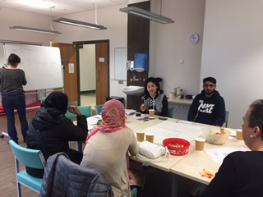

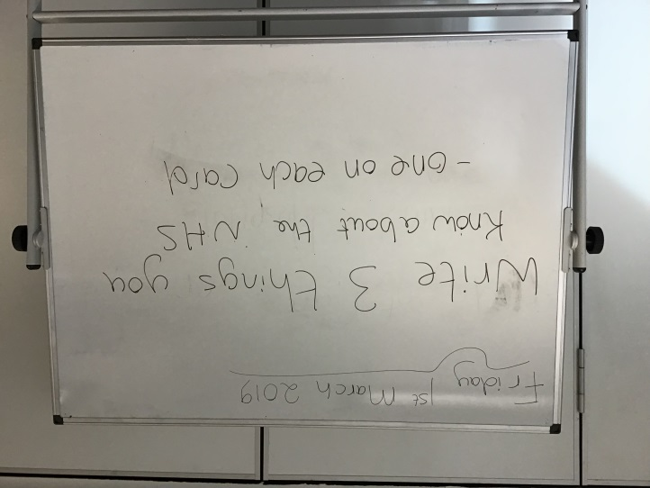 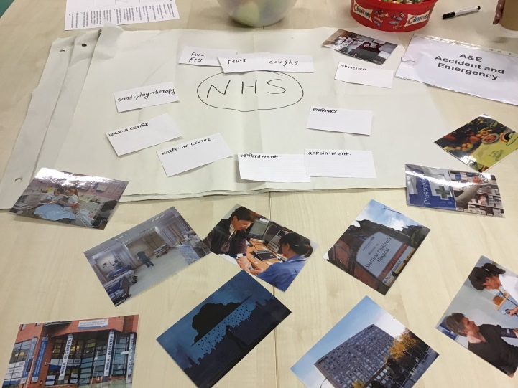

**Appendix D – Roma Slovak community**

|  |  |
| --- | --- |
| Session: | Urgent Care Community Engagement with Roma Slovak families |
| Date: | 4 March - 15 March 2019 |
| Partner organisation: | Darnall Wellbeing |
| Facilitators: | Joanne Van Leavsey (Darnall Wellbeing) & Paula Mackintosh (CCG) |

**Summary of interactions:**

* 5 families (20 people), S9 postcode, women, family members attend Clover Practice
* 7 patient journey maps have been completed.
* Age range 24-70
* The majority of conversations took place in family homes. Roma Slovak families at the Diabetes Support group and Sheffield Children’s Centre also contributed.
* Individuals describe similar experiences to those at Darnall Wellbeing, especially regarding obtaining GP appointments and being signposted to walk in centre

**Emerging themes:**

* **Roma Slovak experiences of the Walk-in Centre were generally negative**

Patients felt that their health concerns were not perceived to be taken seriously by doctors. One patient said that a Walk-in Centre visit resulted in advice only, with no treatment or medication being assessed as being necessary. “I didn’t see a doctor, no real advice, I was told it wasn’t serious and made to feel I have wasted everyone’s time”

* **Managing expectations re accessing primary care services**

It is the cultural norm in Slovakia for Roma patients to see a GP on the same day as the presenting health need. Face to face conversations confirm that this remains the case, with patients adhering to this expectation when accessing primary care services.

* **Expectation of a script for Antibiotics following a GP appointment**

We know from historical engagement over the last 10 years with Roma in Darnall that it is common for doctors within Slovakia to prescribe antibiotics much more liberally than would be considered to be safe levels within the UK. This practice has been compared to prescribing norms in UK 30-40 years ago. This background intelligence has been supported by recent face to face discussions with individuals. During a home visit, one woman explained that if a meeting with the GP does not result in a prescription for antibiotics, this will result in a sense of being let down, and not being looked after properly.

*“UK doctors are not as good as they are (back home), they don’t care, and they don’t give me and my son the medicines we know we need”*

* **Attendance at A&E – “a better option** **than GP”**

The combination of unrealistic expectations re access to GP and prescriptions for antibiotics results in a belief that A&E is a better option for the patient, as they will be seen on the same day as the presenting need and the likelihood of treatment is perceived to be higher.

**Appendix E – Patient and staff interviews at the Walk-in Centre**

|  |  |
| --- | --- |
| Detailed notes from sessions: | Discussions with staff and patients at the Walk-in Centre |
| Date: | 19 March 2019 between 8am and 11am |
| Partner organisation: | Walk-in Centre, Broad Lane, Sheffield |
| Facilitators: | Paula Mackintosh |

**Summary of interactions with patients:**

Visit took place during a quiet period. Snap shot at 8.36 am:

* 12 patients in waiting room, 7 men, 5 women**.**
* 7 White UK, 1 Black UK, 3 Asian (not possible to be specific) 1 child under 5
* All under 65, there were no older people present at the time. Ages of patients stated on 4 patient flow maps

**Outputs from this visit**: 4 incomplete patient journey maps

**Emerging themes:**

* All patients spoken to were attending because they could not get an appointment with their local GP surgery
* Interviews were cut short as patients were called to be seen, or discussion halted because the patient was visibly unwell. Basic details were obtained on maps but this represented only the start of a particular journey.
* 3 Patients were unwell with throat infections and could not speak clearly
* Patients generally have more on their minds: some patients had anxieties re the implications of symptoms (e.g. chest pains). Two people were very anxious re letting their employers know when they could return to work.
* All patients said they had not heard of Minor Injuries Unit
* 2 patients (male) said that when they were asked by the receptionist “is it urgent or is it routine?” they were confused as to how they should respond. When they answered “routine “(reasoning that they had persistent but none life threatening common illnesses) they were each given appointments 1-2 weeks away. This led to their attendance at the Walk-in Centre “I’m not dying of tonsillitis, I don’t think it is urgent, but I’ve had it for 3 weeks and it isn’t going away”
* Patient’s responses indicate a high level of satisfaction with Walk-in Centre and the NHS111 service, with feedback positive in terms of clinical care and outcomes. There were very few suggestions for how urgent care could work better, although interviewees were all asked this question. The Walk-in Centre was described as a “Godsend” by several attendees.

**Interviews with 3 staff at the Walk-in Centre**

* **Variation in usage**

The Walk-in Centre is generally busier at weekends and Monday morning can be as busy, if not busier than a Saturday. On Saturday 16March, a large number of children were signposted to the Walk-in Centre from Sheffield Children Hospital, were patient’s families were told there was a 4.5 hours waiting time.

* **Increase in usage**

Staff said there is no single explanation for the doubling of the daily usage of the Walk-in Centre, when a comparison is made daily, year on year (other than for students where numbers are steady). Possible explanations were suggested, all well-known; the workforce pressures faced by primary care (estimated that 80% of weekday usage is due to patients not being able to access GP appointments), recruitment difficulties in General Practice, Brexit and examples of medics such as Cardiologists returning to Warsaw, Spain and Germany as logistics regarding contracts and future security is uncertain.

* **Improving urgent care**

Walk-in sessions at GP surgeries and publicity relating to the diagnostics and treatments available at the Minor Injuries Unit were suggested to improve the current system.

**Appendix F – Patients in the A&E department at the Northern General Hospital**

|  |  |
| --- | --- |
| Detailed notes from sessions: | Discussions with staff and patients at A&E |
| Date: | 25 March 2019 between 9:30am and 2pm |
| Partner organisation: | Sheffield Teaching Hospitals |
| Facilitators: | Paula Mackintosh |

**Summary of interactions with patients:**

* 9 patients were approached and interviewed - their feedback included:
  + Severe dog bite to hand, female aged 71, White British, lives in S36, Deepcar GP surgery. Patient had attended Minor Injuries Unit two days earlier, but wound had become very swollen and infected
  + Unconscious following a fall in city centre, ambulance to A&E, female aged 68, White British, Upperthorpe GP surgery
  + Partial severance of finger, male aged72, S17, White British, Totley Rise GP Surgery. Not heard of Minor Injuries Unit but was aware of the Walk-in Centre. He said that the Minor Injures Unit was near to the scene of accident and he would have attended had he known about it.
  + Female aged 25, accompanying grandmother who had broken her thumb. Female aged 70, lives in S20 and patient at Owlthorpe GP surgery, White British. Relative was not aware of Walk-in Centre or Minor Injuries Unit. Relative said they would still have brought patient to A&E as grandmother was in severe pain, the injury had occurred 3 days earlier and she had not informed her family.
  + Pain due to severe arthritis, previously undiagnosed, male aged 69, White British, Meersbrook GP surgery S8. Patient could not obtain appointment with GP; patient said had they known about the Minor Injuries Unit they would have attended there first.
  + Fall and heard crack in foot & waiting for the results of X-rays. Female aged 25, S6, Dykes Hall Medical Centre, White British. Patient said they had not contacted GP as she knew there would be no appointments. Patient regularly uses the Walk-in Centre as has young children. Patient had not heard of Minor Injuries Unit.
  + Severe back pain following a gardening accident. Female aged 71, S35, White British, Ecclesfield GP Surgery. Patient had not heard of Minor Injuries Unit. Patient said she knew that it would not be possible to obtain a GP appointment.
  + Mental health crisis. Female aged 23, S10, White British, Ruslings Road GP surgery. Patient said she would have preferred to go to her GP but could not obtain an appointment.
  + Pains in chest, female aged 71, White British, Meersbrook GP surgery, came to ED as felt it was an emergency.

**Themes from A&E session:**

* Eight of the 9 patients had not heard of Minor Injuries Unit. Three patients said they would travel there in the first instance if they had known.
* Concerns expressed regarding the prevalence of DNAs at their local surgery, and viewed this as one of the reasons for not being able to obtain an appointment. Two patients said people who DNA should be fined, and two patients expressed their anger at the high rate of DNA for MRI scans. Four patients said the Minor Injuries Unit should be advertised and promoted to take pressure of A&E.

**Appendix G – Journey Maps Summary**

**Patient Journey Flowcharts – 95 completed**

In order to understand what the patient journey looks like, a journey map was developed for people to complete that provided information on the journey through the urgent care services in Sheffield, not about the problems and issues faced. The maps were tested and completed by participants at the workshop held on the 17 January 2019, and amended before being used to collect information from additional sources.

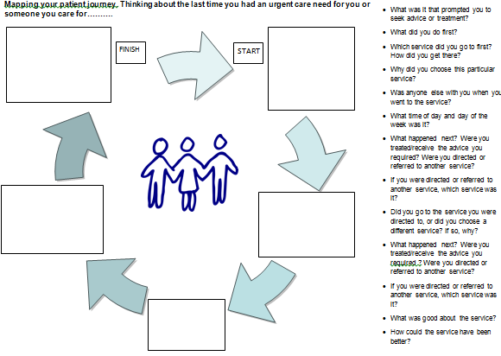

As well as being used as a tool to aid discussion during the engagement activity in Lowedges and Darnall, completed flowcharts were collected from:

Participants at the Urgent Care Workshop held on 17 January 2019

Participants at 3 x targeted engagement sessions at the Terminus

Patients at Manor Clinic and Firth Park Clinic (Community Nursing Services)

Patients at The Healthcare Surgery, S5 (Waiting Room)

Patients at Page Hall Surgery (Waiting Room)

Patients at Porter Brook Medical Centre (Waiting Room)

Patients at Pitsmoor Surgery (Waiting Room)

Patients at University Health Service (Waiting Room)

Young People at Chilypep

**Analysed at workshops**

The completed flowcharts were analysed at the workshops held on the 14 February 2019 and at the Children’s workshop held on the 26 March 2019.

Key reflections from the analysis at the February workshop are:

|  |  |
| --- | --- |
| **Key Reflections from the maps of patient journeys** | **Other comments on the journeys** |
| * Not many using Hubs * Lots of NHS111 to A&E * No MIU as 1st point of call * Generally not too many steps * Lots of points of entry * Lack of Self Care * Need somewhere before crisis, e.g. like self-harm/suicidal * Need a specific service for Urgent Care MH Support * Mental Health – nothing online about MH Urgent Care, people don’t know where to go * Out of hours NHS111 should be first contact for signposting * MIU never first and no one used hubs * Only 1 pharmacy * Main issue is where people go first * NHS111 and GP is frequently first point of call * Children services – GP or NHS111 first | * Ability of pharmacist to prescribe medicines would reduce journey length (avoid GP appointment) * Sickness in staff * If you plan a service, will there be staffing problems? * Small sample size - experience of all services. * WIC isn’t captured * Relative Complexity although should expect some complexity. * People don’t know what it can be used for. * High volume of unresolved cases – particularly Mental Health. |

We also shared the children’s patient journey maps with participants at the children’s workshop held in March 2019:

|  |  |
| --- | --- |
| **Key observations** | **General observations** |
| * Impossible to get through to GP on phone * Repeating information 3 times * Difficult to access urgent mental health for children and 16-18 * No appropriate safe place for children with MH problems – try and prioritise * Second contact - large numbers from NHS111 to children’s A&E and OOH * Quarter go straight to A&E * Confusing pathways, patients bouncing around services, but the children’s pathway doesn’t seem as complicated as the Adult pathways | * Should have a ‘grandma’ room at A&E * Staff not aware what is on offer * Consistency of message * Describe what urgent mental health services look like over 24 hour period. * Seen big increase in schools sending patients to ED, also seeking sick note request from schools, Lots of patients attend ED having vomited once. * Lack of support networks. |

**Appendix H – Public Survey – Summary of Responses**

**Thinking about the last time you accessed urgent health care services:**

1. **Who needed the advice?**

|  |  |  |
| --- | --- | --- |
| Who needed advice | Number of respondents | % |
| I did | 926 | 52.0% |
| Another adult | 361 | 20.3% |
| A child under 16 | 268 | 15.0% |
| An adult who I care for | 163 | 9.1% |
| No Response | 64 | 3.6% |
| Grand Total | **1783** | **100%** |

1. **What did you do first?**

|  |  |  |
| --- | --- | --- |
| What did you do first | Number of respondents | % |
| Straight to NHS Service | 1017 | 57% |
| Self Care | 268 | 15% |
| Online | 207 | 11% |
| I haven't had a need for urgent care treatment | 111 | 6% |
| Other | 92 | 5% |
| Talked to a friend or relative for advice | 87 | 5% |
| Grand Total | **1783** | **100%** |

1. **After taking this action, did you require NHS treatment?**

|  |  |  |
| --- | --- | --- |
| Did you require NHS treatment? | Number of respondents | % |
| No Response | 1130 | 63% |
| Yes | 556 | 31% |
| No | 96 | 5% |
| Grand Total | **1783** | **100%** |

1. **Which NHS service did you contact first for advice?**

|  |  |  |
| --- | --- | --- |
| Which NHS service did you contact? | Number of respondents | % |
| NHS111 | 354 | 20% |
| GP (Visited/Phoned) | 344 | 19% |
| Walk in Centre on Broad Lane | 302 | 17% |
| NULL Response/No service used | 270 | 15% |
| Minor Injuries Unit at the Hallamshire Hospital | 204 | 11% |
| A&E (NGH/Children's) | 177 | 10% |
| Other | 73 | 4% |
| Called 999 | 58 | 3% |
| Grand Total | **1783** | **100%** |

1. **Why did you choose this service? (Please choose all that apply)**

|  |  |  |
| --- | --- | --- |
| Why did you choose this service? | Number of respondents | % |
| Previous experience of the service | 499 | 20% |
| I knew I would be seen there | 400 | 16% |
| I knew it would be open | 370 | 15% |
| Other (please specify) | 313 | 12% |
| Easiest to get to by car | 165 | 7% |
| Advice from friends or family | 110 | 4% |
| Advice from looking online | 103 | 4% |
| I knew I could park my car there | 102 | 4% |
| Easiest to get to by public transport | 73 | 3% |
| I wasn't aware of other options | 68 | 3% |
| Not answered | 309 | 12% |
| Grand Total | **2512** | **100%** |

1. **What time of day and day of the week did you use this service?**

|  |  |  |
| --- | --- | --- |
| What time of day and day of week? | Number of respondents | % |
| Weekday morning between 08:00 - 12:00 | 366 | 21% |
| Weekday afternoon between 12:00 - 18:30 | 298 | 17% |
| Weekday evening between 18:30 - 22:00 | 245 | 14% |
| Weekday night between 22:00 - 08:00 | 73 | 4% |
| Weekend/bank holiday morning between 08:00 - 12:00 | 171 | 10% |
| Weekend/bank holiday afternoon between 12:00 - 18:30 | 126 | 7% |
| Weekend/bank holiday evening between 18:30 - 22:00 | 62 | 3% |
| Weekend/bank holiday night between 22:00 - 08:00 | 23 | 1% |
| I'm not sure | 60 | 3% |
| Null | 358 | 20% |
| Grand Total | **2512** | **100%** |

1. **How did you get to this service? (Please tick all that apply)**

|  |  |  |
| --- | --- | --- |
| How did you get to this service? | Number of respondents | % |
| Car | 829 | 45% |
| No Response | 365 | 20% |
| N/A - Phone or Online Service | 261 | 14% |
| Walked | 133 | 7% |
| Bus/Tram/Train | 85 | 5% |
| Ambulance | 74 | 4% |
| Taxi | 46 | 2% |
| Other | 44 | 2% |
| Cycle/Motobike | 5 | 0% |
| Grand Total | **1842** |  |

1. **Is there anything you would like to tell us about your experience of using this service? – open-ended responses**
2. **After using this service were you then referred elsewhere by a**

**healthcare professional or service?**

|  |  |  |  |  |
| --- | --- | --- | --- | --- |
| Service First Contacted/Referred elsewhere | YES | NO | No Response | % Referred Elsewhere |
| NHS111 | 243 | 80 | 31 | 69% |
| GP (Phone/Visit) | 198 | 124 | 22 | 58% |
| Walk in Centre | 121 | 174 | 7 | 40% |
| Minor Injuries Unit | 84 | 115 | 5 | 41% |
| A&E | 66 | 104 | 7 | 37% |
| Called 999 | 38 | 11 | 9 | 66% |
| Other | 33 | 33 | 7 | 45% |
| NULL |  |  | 271 |  |
| Grand Total | **783** | **641** | **359** |  |

1. **Which service were you referred to? (Please choose all that apply)**

|  |  |  |
| --- | --- | --- |
| Which service where you referred to | Referred elsewhere | % |
| A&E or 999 | 235 | 31% |
| Other Hospital Follow-up | 126 | 16% |
| Own GP | 121 | 16% |
| Other GP Service | 106 | 14% |
| Hospital Admission | 104 | 14% |
| Minor Injuries/Fracture Clinic/Eye Clinic | 40 | 5% |
| Community or MH Service | 36 | 5% |
| Grand Total | **783** |  |

1. **Did you go to/use the service you were referred to?**

|  |  |  |
| --- | --- | --- |
| Did you use the service referred to? | Number of respondents | % |
| Yes | 743 | 42% |
| No | 28 | 1% |
| Null | 1012 | 57% |
| Grand Total | **1783** | **100%** |

1. **Did you experience any difficulties or issues with getting to any of the services you used?**

|  |  |  |
| --- | --- | --- |
| Did you use experience any difficulties? | Number of respondents | % |
| Yes | 113 | 6% |
| No | 111 | 6% |
| No Response | 1559 | 88% |
| Grand Total | **1783** | **100%** |

1. **Did you choose to use any more services for this illness or injury**

|  |  |  |
| --- | --- | --- |
| Did you use use any more services? | Number of respondents | % |
| Yes | 117 | 7% |
| No | 119 | 7% |
| No Response | 1559 | 86% |
| Grand Total | **1783** | **100%** |

1. **Did you experience any difficulties or issues with getting to other services you used?**

|  |  |  |
| --- | --- | --- |
| Did you use experience any difficulties? | Number of respondents | % |
| Yes | 124 | 7% |
| No | 123 | 7% |
| No Response | 1559 | 86% |
| Grand Total | **1783** | **100%** |

1. **How much do you agree or disagree that urgent care services in Sheffield need to improve?**

|  |  |  |
| --- | --- | --- |
| Agree or disagree that urgent care services need to improve | Referred elsewhere | % |
| Strongly agree | 525 | 29% |
| Slightly agree | 480 | 27% |
| Neither agree nor disagree | 253 | 14% |
| Slightly disagree | 95 | 5% |
| Strongly disagree | 43 | 2% |
| Null | 386 | 22% |
| Grand Total | **783** |  |

1. **Thinking about when you have an urgent health need, which of the following options is most important to you? (Pick up to five answers)**

|  |  |  |
| --- | --- | --- |
| Which options are most important to you? | Number of respondents | % |
| Being seen by a healthcare professional best able to treat me | 743 | 42% |
| Being seen on the same day | 714 | 40% |
| Being seen at my own GP practice | 612 | 34% |
| Being able to walk in for an appointment | 432 | 24% |
| Being able to book in for an appointment | 412 | 23% |
| Being seen at a place convenient to me | 366 | 21% |
| Reducing the length of time spent in the waiting room before seeing a healthcare professional | 353 | 20% |
| Being able to see my own GP on the same day | 331 | 19% |
| Being able to talk to someone on the phone about my problem as an alternative to being seen in person | 277 | 16% |
| Having easy access to diagnostic tests | 265 | 15% |
| Being seen somewhere with good access by car | 241 | 14% |
| Being seen during the evening (18:00- 22:00) | 196 | 11% |
| Being seen somewhere with good access by public transport | 163 | 9% |
| Being seen during the day (08:00 - 18:00) | 159 | 9% |
| Being seen by healthcare staff who know me | 131 | 7% |
| The option of alternative ways of booking or being seen e.g. booking online | 116 | 7% |
| Being able to see my own GP even if it means being seen on a different day | 105 | 6% |
| Other | 56 | 3% |
| Receiving advice from a healthcare professional I know | 39 | 2% |
| Access to interpretation and translation services | 0 | 0% |
| Grand Total | **2512** | **100%** |

1. **Thinking about when you have an urgent health need, which of the following options is most in need of improvement? (Pick up to five answers)**

|  |  |  |
| --- | --- | --- |
| Which option is most in need of improvement? | Number of respondents | % |
| Being seen at my own GP practice | 559 | 31% |
| Being seen on the same day | 515 | 29% |
| Being able to see my own GP on the same day | 415 | 23% |
| Being able to book in for an appointment | 414 | 23% |
| Being seen by a healthcare professional best able to treat me | 374 | 21% |
| Reducing the length of time spent in the waiting room before seeing a healthcare professional | 356 | 20% |
| Being able to walk in for an appointment | 317 | 18% |
| Being seen at a place convenient to me | 261 | 15% |
| Being seen during the evening (18:00 - 22:00) | 238 | 13% |
| Having easy access to diagnostic tests | 219 | 12% |
| Being able to talk to someone on the phone about my problem as an alternative to being seen in person | 200 | 11% |
| Being seen somewhere with good access by car | 182 | 10% |
| Being seen during the day (08:00 - 18:00) | 138 | 8% |
| Being seen somewhere with good access by public transport | 130 | 7% |
| The option of alternative ways of booking or being seen e.g. booking online | 123 | 7% |
| Being able to see my own GP even if it means being seen on a different day | 112 | 6% |
| Being seen by healthcare staff who know me | 108 | 6% |
| Other | 75 | 4% |
| Receiving advice from a healthcare professional I know | 50 | 3% |
| Access to interpretation and translation services | 3 | 0% |
| Grand Total | **2512** | **100%** |

**18) Thinking about the last time you needed an urgent care appointment with your GP or another healthcare professional in your practice, were you able to get one within 24 hours?**

|  |  |  |
| --- | --- | --- |
| Able to get GP appointment within 24 hours | Referred elsewhere | % |
| Yes | 786 | 44% |
| No | 456 | 26% |
| No Response | 386 | 22% |
| Not applicable | 85 | 5% |
| Can't remember | 69 | 4% |
| Grand Total | **1783** | **100** |

**19) Do you agree with the definition of urgent care?**

Urgent Care means advice and treatment for illness* and injuries for all ages thought to be urgent (care needed within 24 hours) - but not life threatening.*Illness includes mental and physical health

|  |  |  |
| --- | --- | --- |
| Do you agree with the definition of urgent care? | Referred elsewhere | % |
| Yes | 1307 | 73% |
| No Response | 386 | 22% |
| Other (please specify) | 88 | 5% |
| No | 1 | 0% |
| Grand Total | **1783** | **100** |

**Public Survey - Demographic profile of respondents**

**What is your gender?**

|  |  |  |
| --- | --- | --- |
| Gender | Number of respondents | % |
| Female | 949 | 53% |
| Male | 360 | 20% |
| No Response | 446 | 25% |
| Prefer not to say | 28 | 2% |
| Grand Total | **1783** | **100%** |

**What is your age?**

|  |  |  |
| --- | --- | --- |
| Age Group | Number of respondents | % |
| Under 40 | 222 | 12% |
| 40-50 | 216 | 12% |
| 50-60 | 235 | 13% |
| 60-70 | 277 | 16% |
| 70-80 | 219 | 12% |
| Over 80 | 53 | 3% |
| No Resonse | 561 | 31% |
| Grand Total | **1783** | **100%** |

**Please tell us your postcode**

|  |  |  |
| --- | --- | --- |
| Postcode | Number of respondents | % |
| S10 | 298 | 17% |
| S11 | 198 | 11% |
| S6 | 139 | 8% |
| S8 | 130 | 7% |
| S17 | 115 | 6% |
| S35 | 75 | 4% |
| S7 | 44 | 3% |
| S13 | 31 | 2% |
| S36 | 29 | 2% |
| S12 | 27 | 2% |
| S20 | 26 | 1% |
| S5 | 22 | 1% |
| Other – with less than 20 responses | 81 | 5% |
| No Response | 568 | 32% |
| Grand Total | **1783** | **100%** |

**What is your sexual orientation?**

|  |  |  |
| --- | --- | --- |
| Sexual Orientation | Number of respondents | % |
| Heterosexual/Straight (opposite sex) | 1130 | 63% |
| No Response | 471 | 26% |
| Prefer not to say | 128 | 7% |
| Bisexual (both sexes) | 19 | 1% |
| Other | 18 | 1% |
| Homosexual (Same Sex) | 17 | 1% |
| Grand Total | **1783** | **100%** |

**Ethnicity**

|  |  |  |
| --- | --- | --- |
| Ethnic Category | Number of respondents | % |
| White - UK | 1194 | 67% |
| No Response | 450 | 25% |
| BME | 87 | 5% |
| Prefer not to say | 52 | 3% |
| Grand Total | **1783** | **100%** |

**Do you consider yourself to belong to any religion?**

|  |  |  |
| --- | --- | --- |
| Religion | Number of respondents | % |
| Christianity | 632 | 35% |
| No religion | 520 | 29% |
| No Response | 483 | 27% |
| Prefer not to say | 94 | 5% |
| Other | 30 | 2% |
| Islam | 11 | <1% |
| Buddhism | 7 | <1% |
| Judaism | 3 | <1% |
| Hinduism | 2 | <1% |
| Sikhism | 1 | <1% |
| Grand Total | **1783** | **100%** |

**Do you consider yourself to be disabled?**

|  |  |  |
| --- | --- | --- |
| Disability | Number of respondents | % |
| NO | 1096 | 61% |
| No Response | 452 | 25% |
| Prefer not to say | 39 | 2% |
| YES | 196 | 11% |
| Grand Total | **1783** | **100%** |

**If yes to the above question, what type of disability do you have?**

|  |  |  |
| --- | --- | --- |
| Type of Disability | Number of respondents | % |
| Long-standing illness or health condition | 116 | 36% |
| Physical or mobility | 84 | 26% |
| Mental health condition | 58 | 18% |
| Hearing | 37 | 11% |
| Other | 12 | 4% |
| Learning disability/difficulty | 10 | 3% |
| Visual | 7 | 2% |
| Grand Total | **324** | **100%** |

**Do you provide care for someone?**

|  |  |  |
| --- | --- | --- |
| Carer | Number of respondents | % |
| NO | 945 | 53% |
| No Response | 467 | 26% |
| YES | 334 | 19% |
| Prefer not to say | 37 | 2% |
| Grand Total | **1783** | **100%** |

**Are you a Parent of Child under 16**

|  |  |  |
| --- | --- | --- |
| Parent of Child under 16 | Number of respondents | % |
| NO | 967 | 54% |
| No Response | 464 | 26% |
| YES | 328 | 18% |
| Prefer not to say | 24 | 1% |
| Grand Total | **1783** | **100%** |

**Is English your first language?**

|  |  |  |
| --- | --- | --- |
| English First Language | Number of respondents | % |
| YES | 1287 | 72% |
| No Response | 453 | 25% |
| Prefer not to say | 25 | 1% |
| NO | 18 | 1% |
| Grand Total | **1783** | **100%** |

**Are you a student in further or higher education?**

|  |  |  |
| --- | --- | --- |
| Student | Number of respondents | % |
| NO | 1239 | 70% |
| NO RESPONSE | 455 | 26% |
| YES | 60 | 3% |
| Prefer not to say | 28 | 2% |
| Grand Total | **1783** | **100%** |

**Do you have access to a smart phone?**

|  |  |  |
| --- | --- | --- |
| Smart Phone | Number of respondents | % |
| YES | 1143 | 64% |
| No Response | 453 | 25% |
| NO | 147 | 8% |
| Prefer not to say | 40 | 2% |
| Grand Total | **1783** | **100%** |

**Do you have access to the internet at home?**

|  |  |  |
| --- | --- | --- |
| Internet at home | Number of respondents | % |
| YES | 1285 | 72% |
| No Response | 449 | 25% |
| Prefer not to say | 32 | 2% |
| NO | 17 | 1% |
| Grand Total | **1783** | **100%** |

**Appendix I – Staff Survey**

A significant number of staff feel less confident about being able to confidently and clearly signpost for 16-18 year olds.

A significant number of staff feel less confident about having the right services to refer into for mental health than physical health.

**Staff Survey – Free Text Analysis**

The free text responses to the following questions were analysed by the Urgent Care in Primary Care Design Group:

* Are there any other problems that you faced that are not mentioned above?
* If you have indicated that you are not confident with any of the areas above, please provide a reason why.
* If the problems you highlighted were addressed, or things were improved, what would most allow you to provide optimal care?
* If you were the boss of the NHS in Sheffield, what one thing would you do to improve urgent care services in the city?

The Design Group identified themes that emerged in the responses and allocated each response to one or more themes.

Staff’s responses were divided into the following groups for the purposes of this analysis:

* Care homes and charities
* GP practices
* GP collaborative and PCS
* Sheffield City Council
* SCH, WIC and A&E

**The key themes were:**

**GP Practices (**clinical and clerical)

130 responses.

* *Improving mental health,*
* *Improving patient education,*
* *Better pathways between services/ access to diagnostics*.

**GP Collaborative/ PCS**

76 responses.

* *Better pathways between services*
* *access to diagnostics*
* *Improving patient education*
* *staff education*

**SCH, WIC, A&E**

47 respondents

* *Staff education*.
* *Improving patient education*
* *Better pathways between services/ access to diagnostics*.

**Care Homes and Charities**

16 responses.

* *Increasing staff/workforce,*
* *Increasing funding,*
* *Improving waiting times,*
* *Improving mental health services* and
* *Better pathways between services/ access to diagnostics*

**Sheffield City Council**

35 responses

* *Staff education*
* *Increasing staff/workforce*,
* *Improving availability (open longer)* and
* *Better pathways between services/ access to diagnostics*

The top 4 themes across all questions are:

|  |  |
| --- | --- |
| **Theme** | **Instances** |
| Better pathways between services/ access to diagnostics | 77 |
| Improve Patient Education | 69 |
| Staff Education | 69 |
| Improve Mental Health Services | 68 |

**Top 3 Themes by Question**

This looks across the groups of organisations (GP Practices, Care Homes & Charities, GP Collaborative & PCS, Sheffield City Council and SCH, WIC & A&E), and identifies the top 3 or 4 themes for each question.

* **Are there any other problems that you faced that are not mentioned above?**

This refers to the previous question “Please indicate on a scale of 0 – 5 how you feel about the following”, which included a list of statements about working within Urgent Care. It asked people to score their confidence levels for those statements.

In total, 156 people across the organisation groups submitted a response to this question. 69 of those answered to say that they have not faced any other problems. Of the 87 responses that contained text:

1. 29 answers indicated that additional problems faced are around *Pathways Between Services/ Access to Diagnostics*.
2. 16 answers suggested that *Staff Education*is a problem.
3. *Patient Education* was the third most common theme, with 10 answers suggesting this was a problem.

* **If you have indicated that you are not confident with any of the areas above, please provide a reason why.**

142 responders answered this question. 27 of those answered “No” or “N/A”. Of the remaining 115:

1. 31 responses to this question identified *Mental Health Services*.
2. *Staff Education* contributed to 25 responses.
3. *Patient Education* and *Lists of Services* had 19 and 18 responses respectively.

* **If the problems you highlighted were addressed, or things were improved, what would most allow you to provide optimal care?**

137 responses were received to this question, 21 stated “No” or “N/A”, and the themes identified were spread relatively evenly across the remaining 116 responses:

1. The theme of *Staff Education* was highlighted in 15 responses to this question.
2. *Increasing staff/workforce* was mentioned by 14
3. Both *Increasing funding* and *Better pathways between services/ access to diagnostics* were highlighted in 13 responses
4. *Improving Mental Health Services* appeared in 12

* **If you were the boss of the NHS in Sheffield, what one thing would you do to improve urgent care services in the city?**

Of the set of free text questions in the staff survey, this question about being the boss of the NHS in Sheffield received the most responses, with 192 responders providing an answer. 4 of those were null answers. There were common themes (see below) through many of the questions, but there were also suggestions to abandon NHS111, charge patients if they are under the influence of drinks/drugs, improving IT infrastructure and many more.

1. The theme of *Improving Patient Education* was the most commonly mentioned for this response, with 33 of respondents stating that they would address this.
2. *Increasing staff/workforce* also featured regularly in the answers, with 26 respondents.
3. *Improving GP Appointments* and *Comms and Engagement* were also highlighted in the responses to this question, with 21 and 20 of answers including these themes.

**Note:** When analysing the public survey response to the question “If you were the boss of the NHS in Sheffield, what one thing would you do to improve urgent care services in the city?” the most common theme identified was “*Improving Access”*. It is important to note that this theme was separated into “*Improve GP Appointments”, “Improve Waiting Times”* and “*Improve availability (open longer)”* when the analysis of the staff survey was undertaken. If these three themes were taken together, then “*Improving Access”* would also be the most common theme in the staff survey.

**Top Themes by Organisation**

The organisations were divided into the following groups for the purposes of this analysis:

* Care Homes and Charities
* GP Practices
* GP Collaborative and PCS
* Sheffield City Council
* SCH, WIC and A&E

**Care Homes and Charities**

16 respondents were in this group. The top themes across all questions mentioned by staff are:

1. *Staff Education* (10 respondents)
2. *Increasing staff/workforce, Increasing funding, Improving waiting times, Improving Mental Health services* and *Better Pathways between services/ access to diagnostics* all featured in 4 responses (25%)

**GP Practices**

There were 130 responses from GP Practice Staff (clinical and clerical).

1. 40 of the responses across all questions from people who work at a GP practice focussed on *Improving Mental Health*
2. *Improving patient education* received 31 responses
3. *Better pathways between services/ access to diagnostics* received 30 (23.1%)

**GP Collaborative/ PCS**

76 people completed the survey from the GP Collaborative and Primary Care Sheffield.

1. Both *Better pathways between services/ access to diagnostics* and *Improving Patient Education* featured highly in the responses from GP Collaborative and PCS staff, with 24 and 23 responses collectively mentioning these themes.
2. *Staff Education* was also a common theme amongst these respondents, with 18 of the responses highlighting this.

**Sheffield City Council**

35 responses were from members of staff at Sheffield City Council.

1. *Staff education* featured in the comments from Sheffield City Council, with 11 responses falling within this theme.
2. *Increasing staff/workforce*, *improving availability (open longer)* and *Better pathways between services/ access to diagnostics* were mentioned in 7 responses each.

**SCH, WIC, A&E**

47 respondents stated that they were employed by Sheffield Children’s Hospital, Sheffield Teaching Hospitals or the Walk in Centre.

1. The most common theme from the SCH, WIC and A&E responses was around *Staff Education*. 14 responses included this.
2. *Improving patient education* was mentioned in 13 (27.7%) of the responses.
3. 12 (25.5%) of the responses were linked to the theme of *Better Pathways between services/ access to diagnostics*.

**Staff Survey Questions:**

|  |  |
| --- | --- |
| **Q1** | Which organisation do you work for? |
| **Q2** | How long have you worked for this organisation? |
| **Q3** | Please indication which type of patient that you mostly see: |
| **Q4** | What is your role? |
| **Q5** | On an average day, do you see more than 30 patients per day? |
| **Q6** | Are you a prescriber? |
| **Q7** | Please indicate on a scale of 0-5 how you feel about the following, where 0 is least confident and 5 is most confident. Please mark each statement individually. |
| **Q8** | Are there any other problems that you faced that are not mentioned above? |
| **Q9** | If you have indicated that you are not confident with any of the areas above, please provide a reason why. |
| **Q10** | If you have indicated that you are very confident with any of the areas above, please provide a reason why. |
| **Q11** | If the problems you highlighted were addressed or things were improved, what would most allow you to provide optimal care? |
| **Q12** | Do you agree with the definition of urgent care described above? |
| **Q13** | How much do you agree or disagree that urgent care services in Sheffield need to improve? |
| **Q14** | If you were the boss of the NHS is Sheffield, what one thing would you do to improve urgent care services in the city? |
| **Q15** | Thinking about providing urgent care which of the following options are most important to you? (Pick up to FIVE boxes) |
| **Q16** | Thinking about providing urgent care, which of the following options is most in need of improvement? (Pick up to five answers) |
| **Q17** | What is your gender? |
| **Q18** | Is your gender identity different to the sex you were assumed to be at birth? |
| **Q19** | What is your age? |
| **Q20** | What is your sexual orientation? |
| **Q21** | What is your ethnicity? |
| **Q22** | Do you consider yourself to belong to any religion? |
| **Q23** | Do you consider yourself to be disabled? |
| **Q24** | If you answered yes to the above question, what type of disability do you have? |
| **Q25** | Is English your first language? |
| **Q26** | Are you a student in further or higher education? |
|  |  |

**Appendix J – Public and Partner Reference Group Workshops Summary**

Following the lessons learnt from the first round of consultation and engagement, the CCG hosted six workshops from December 2018 to March 2019, inviting members of the Public Reference Group[2] and representatives from partners across Sheffield and Yorkshire and Humber to gain a collective understanding of urgent care services in Sheffield, to share their experiences of urgent care and to co-produce outputs arising from the workshops and more generally form the review. A workshop was also held to solely focus on children’s urgent care and to share and review problems with children’s urgent care services in Sheffield.

The workshops were intended to complement the specific engagement in communities and both the public and staff surveys. Information gathered by these methods was also reviewed by workshop attendees so that they had access to all sources of information to help shape the key themes of problems in urgent care.

Presentations and notes from the workshops were shared with workshop attendees and posted on the CCG website.

Two separate workshops were held in December 2018 – one for partners and one for the public. The responses relating to what problems faced the urgent care system are detailed below:

**Partner Workshop December 2018**

|  |
| --- |
| **Organisational Issues** |
| Targets - Short length of appointments - Support to professionals - Inconsistency in systems – lack of access (can’t direct book) – 7 day working – don’t turn away people when in ‘wrong’ place |
| **System wide Issues** |
| Lack of joined up working – lack of co-ordination - Problems have impact on other parts of the system – Interdependency with and provision of proactive primary care – lack of defined pathways - Too complicated an offer – Different perceptions of services available 24 hours – gaps in service – services across system are not clear |
| **Common reasons for change** |
| Lack of resource (workforce, estate, funding) workforce - Lack of capacity –staff retention – skills mix – recruitment – wider determinants of health – issues of inequalities |
| **Need** |
| Distressed people with severe health problems isolated and anxious - increase in social problems – increase in behavioural problems |
| **Cultural Issues** |
| Patient expectations – Patterns of behaviour – Perception of place of safety and trust - Risk assessment |

The Public Reference Group was set up in 2018 as part of the Urgent Care consultation. The group comprises members of the public who reflect the diverse communities across Sheffield, both in terms of location and those with protected characteristics under the Equality Act or who are from vulnerable groups. Members of the group were recruited from GP patient participation group’s networks, the equality hubs and representatives from community and partner organisations, plus the student unions, Healthwatch and Sheffield Save Our NHS.

|  |  |
| --- | --- |
| **What’s good and not so good about urgent care – Responses from the Public Reference Group workshop December 2018** | |
| * Seen /responded really quickly | * Not open all the time |
| * X-ray quickly | * Long time to answer phones |
| * friendly and caring staff | * Judgemental reception |
| * they have all information about you | * Long waits - Difficult or can’t get an appointment |
| * Gateway/triage to other services medical and signposting | * Sent somewhere else instead |
| * Can see a range of clinicians | * Short appointments |
| * Booked appointments | * No links or working with other services |
| * Know your community | * Lack of local information/response |
| * Easy to get prescriptions | * Confusion of where to go |
| * Good appointment system | * Lack of clinical staff |
| * Good treatment | * Lack of social care |
| * Open longer | * First point of contact missing |

Key issues common to both public and partners workshops in December were poor pathways, resource (especially around workforce and time available) and knowledge about the services available.

In January and February’s workshops, partners and the public came together and participants assessed urgent care activity and demand (based on usage data from A&E, the Minor Injuries Unit, Walk-in Centre and hubs as a proxy for demand and deprivation, not owning a car and living with two or more long term conditions as a proxy for need), reviewed key themes from the outreach engagement and started to bring together a range of key problems, sense checking at every workshop to ensure that any new problems and issues identified from communities and groups were captured and truly reflected in the key themes.

In addition to reviewing information and sharing experiences, workshop participants also developed a definition of urgent care. One of the key lessons learnt from the original consultation was that language was not consistent and not easy to understand and there was a view that the definition of urgent care was being misunderstood. The workshop developed the following definition which was tested in the staff and public surveys. The vast majority of respondents to the survey agreed that this below was the right definition.

**Definition of Urgent Care**

|  |
| --- |
| **Urgent Care means**  **•Advice and treatment for illness and injuries for all ages thought to be urgent (within 24 hours) - but not life threatening.**  **This does NOT mean**  **Emergency care**  **•Which is for people with serious illness or injury or life threatening conditions that need immediate medical attention.**  ***Illness includes mental and physical health*** |

We held a specific children’s workshop in March. People shared their experiences, reviewed patient stories and identified the following gaps and issues in children’s urgent care services.

|  |  |
| --- | --- |
| **What’s good?**   * Children’s A&E is too good. * Children’s is one stop. Adult’s has split minor injuries. * A duty Dr system works well * GP streaming – non judgemental * Patients not turned away | **What’s not so good**   * Impossible to get through to GP on phone * Repeating information 3 times * Difficult to access urgent mental health for children and 16-18 * Confusing pathways, patients bouncing around services, but the children’s pathway doesn’t seem as complicated as the Adult pathways * Lack of information about late night pharmacies and pharmacies providing additional services * Language and culture * Is there more to do on prevention/public health in children’s health * More additional follow up than adults probably due to higher risk aversion in staff. |

A final workshop for this stage of the urgent care review was held on 6 June 2019. The Public and Partner Reference Group and Partner were invited to assess all of the outcomes from all of the engagement, ensure that the key problems and issues were truly reflective of the engagement work, and assessed how the problems and issues can be addressed.

It is intended that in the next phase of the urgent care review, we will continue to engage with the Public as we have done through this engagement.

The following two pages include a Venn diagram and a slide with the key problem themes. The Venn diagram on the page 63 shows the analysis performed by the Design Group on the outputs from the first workshops on the key problems and issues identified. The key problem themes (page 64) were drawn from this to give a summary of the messages that we were hearing. These two diagrams were reviewed and amended by the Public and Partner Reference Group as new engagement information was received and analysed.

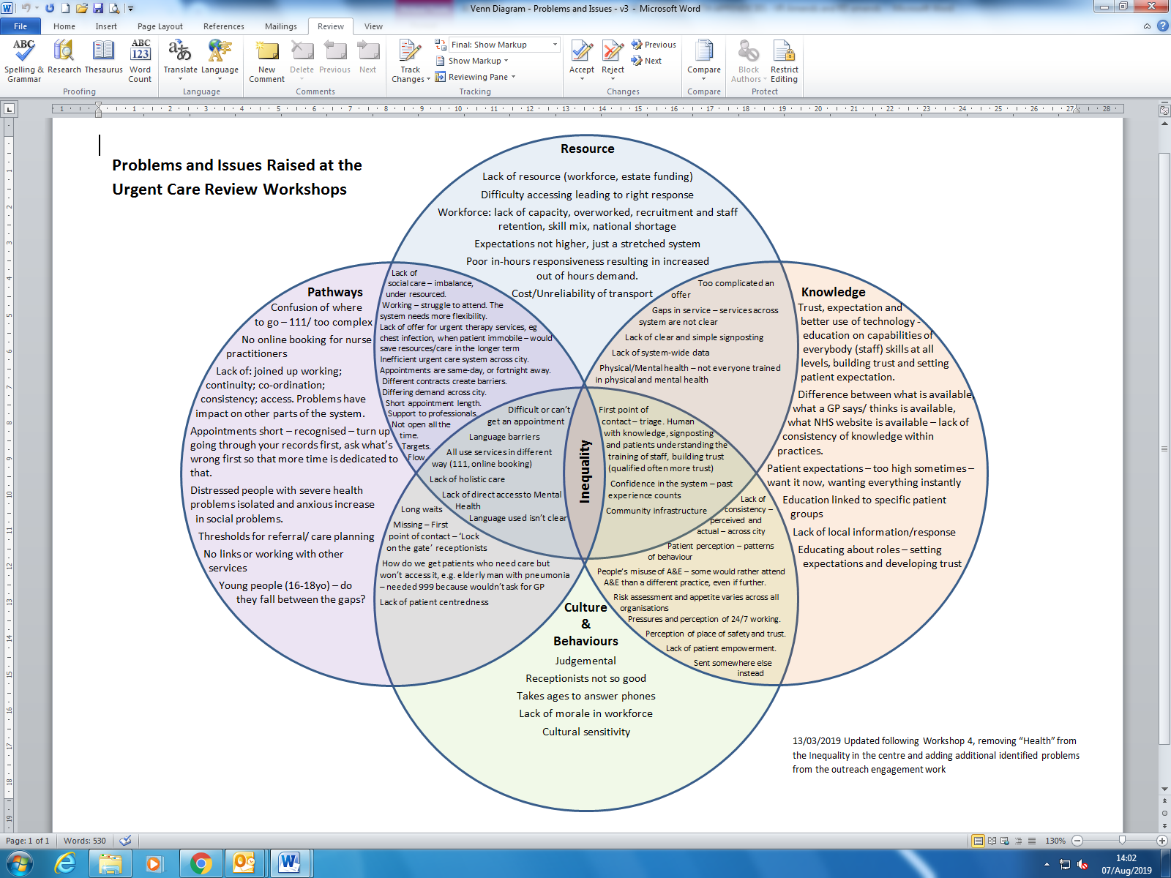

**Key Problem Themes**

***Confusing and inconsistent* PATHWAYS**

* Patients move between urgent care services but they don’t all currently work together, it’s complicated and there are many entry points. It means:
* Patients don’t know which service to go to and when,
* there's a lack of continuity and flow through the services and their journey is longer and more complicated than it should be, *especially between primary and secondary care, mental and physical care, children to adults and social care and health care.*
* Staff’s lack of knowledge about services means patients are signposted inconsistently
* *Access to GP practices in terms of lack of same day appointments, appointments not being long enough.*
* There’s inconsistency in the offer, which leads to:

***Lack of and inefficient use of* RESOURCE**

* It is a stretched health and care system, *for mental and physical* needs with a stretched workforce, and shortage of time to care, if one service can’t manage the demand, it bounces into another part of the system – day or night.
* It means patients have difficulty accessing the right services physical *and mental health* or care at the right time and staff don’t get the time they want to care for their patients appropriately.

***Inconsistent and lack of* KNOWLEDGE**

* There is a difference between what is available and what patients and staff think is available.
* Staff have difficulties referring on to other services – there is a lack of knowledge/communication about services and how to access them and signpost patients effectively

***Issues with* CULTURE *and* BEHAVIOUR *and* ENVIRONMENT**

* Patients go to what they trust and know
* Staff have different thresholds for risk management across different services
* Patients and staff can be judgemental and use services inappropriately which means ineffective use of resources and pathways are not used appropriately
* *Patient’s decisions to which service they go to are affected by their circumstances, including transport, access to phone/internet, temporary registration, carer responsibilities.*

1. <https://www.sheffieldccg.nhs.uk/get-involved/the-201718-consultation.htm>
2.