Musculoskeletal engagement event
10th September 2014

Following on from the successful musculoskeletal engagement event held in June 2014, a second event was held on 10th September 2014. The event brought together 88 individuals consisting of patients, support organisations, HealthWatch Sheffield, MSK clinicians and GPs.

What is MSK?
Musculoskeletal services support adults with over 200 different conditions affecting joints, bones, muscles and soft tissues and cover individual services like Orthopaedics, Rheumatology, Chronic Pain and Physiotherapy. It is estimated that there are over 62,000 people with a chronic MSK condition living in Sheffield.

What did we talk about?
Attendees were updated on the progress of the engagement activity since the last event, what themes had emerged so far and how the feedback had started to shape ideas about how the service would work in practice.
Attendees were asked to rank how important they felt the emerging themes were.

Themes | Number of people who ranked theme as important
Good care from skilled, caring staff | 28
Information, advice and education | 26
Accessing a system that works well | 25
Understanding their condition and how to self-manage it | 21
Listened to and heard | 19
Getting back to life | 15
Appointments | 13
Recognition of the emotional impact | 9
Pain | 8
Local services | 6
Awareness of diversity | 3

In line with the Kings Funds’ Experience Based Co-design toolkit and COBIC principles, discussions were had regarding the themes allowing the attendees to reflect on the feedback that had been received so far. The additional comments below were made about each theme.
Good care from skilled, caring staff
It was felt that people currently receive great care from staff in Sheffield and this needs to be maintained. There was a call for more time to be a clinician with less time spent on paperwork.
Information, advice and education
There are already some helplines available, but patients don’t always get an immediate answer which makes them call elsewhere “ringing every number possible”. A more immediate response and being clear what it’s for and what they can expect e.g. timescales for response could help. Education to call earlier rather than wait until really bad. Explore the use of technology to communicate better. It was felt that there was a need to be more proactive, checking how a patient was more regularly, but briefly, which technology might be able to help with.
Accessing a system that works well
It was suggested that self-referral and return referrals were essential to make the system work better for patients. There should be an expert at the front end of the service. There was recognition that community and hospital services were currently out of sync, with community services not being able to access hospital out of hours.
Understanding their condition and how to self-manage it
Patients often don’t know much about their condition and a lot of clinical time could be spent on education. The range of conditions is also a challenge. Patients do need information to help make decisions.
Listened to and heard
Repeating their stories many times is a big issue for patients.
Getting back to life
It was seen as important to understand what is unique to the patient.
Recognition of the emotional impact
Knowing what’s important to patients. Access and signposting to psychological and counselling services to support diagnoses and care. There are differences in the level of care received at GP level for mental health services.
Pain
Pain services were seen as difficult to access in Sheffield.
Local services
There should be choice earlier in the patient journey. Good information about services is needed.
Awareness of diversity
It is important that individual’s needs are met. This can be achieved by listening to and taking into full account what patients say.

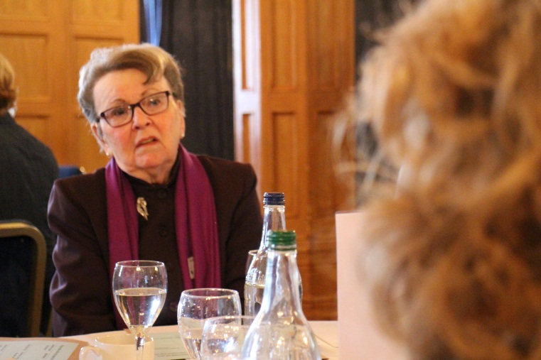
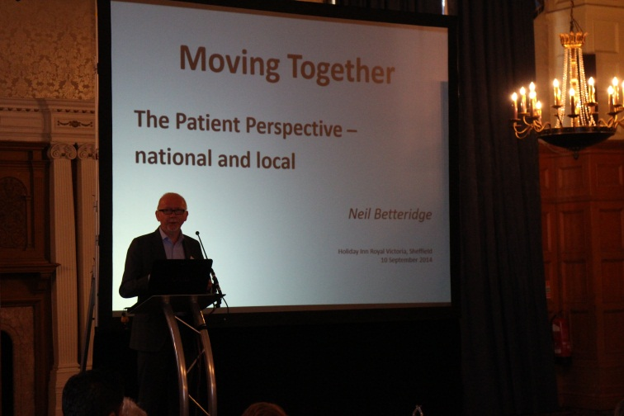

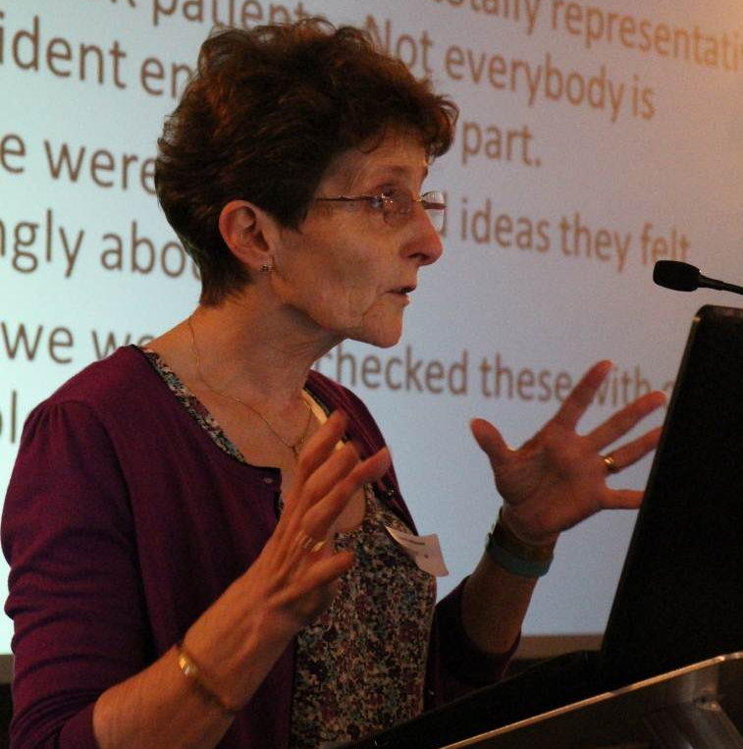
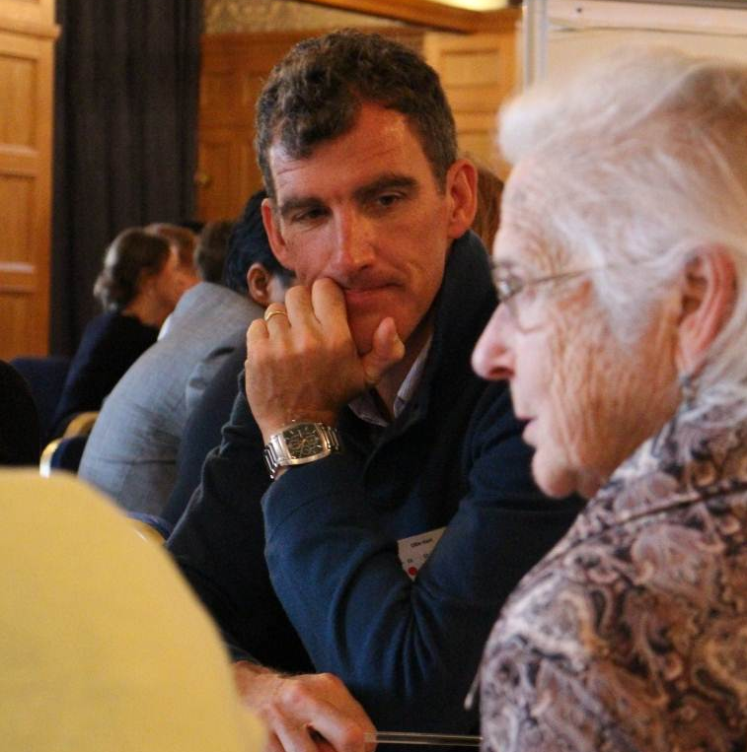

Attendees then took part in three sessions, where they were asked to discuss one of three topics. The topics were influenced by the feedback that had been received prior to the event. In total, nine separate discussions were had on the detailed topics below.
- Referral process
- Patient information and communication
- Single point of access
- Clinical Assessment of Referral Information (Triage)
- Where are services delivered
- Shared decision making between patients and professionals
- Opportunities & Challenges of working together in the community
- Long term support and moving more (Activity to meet taste & ability)
- Leaving MSK Care

