Where is our Neighbourhood?
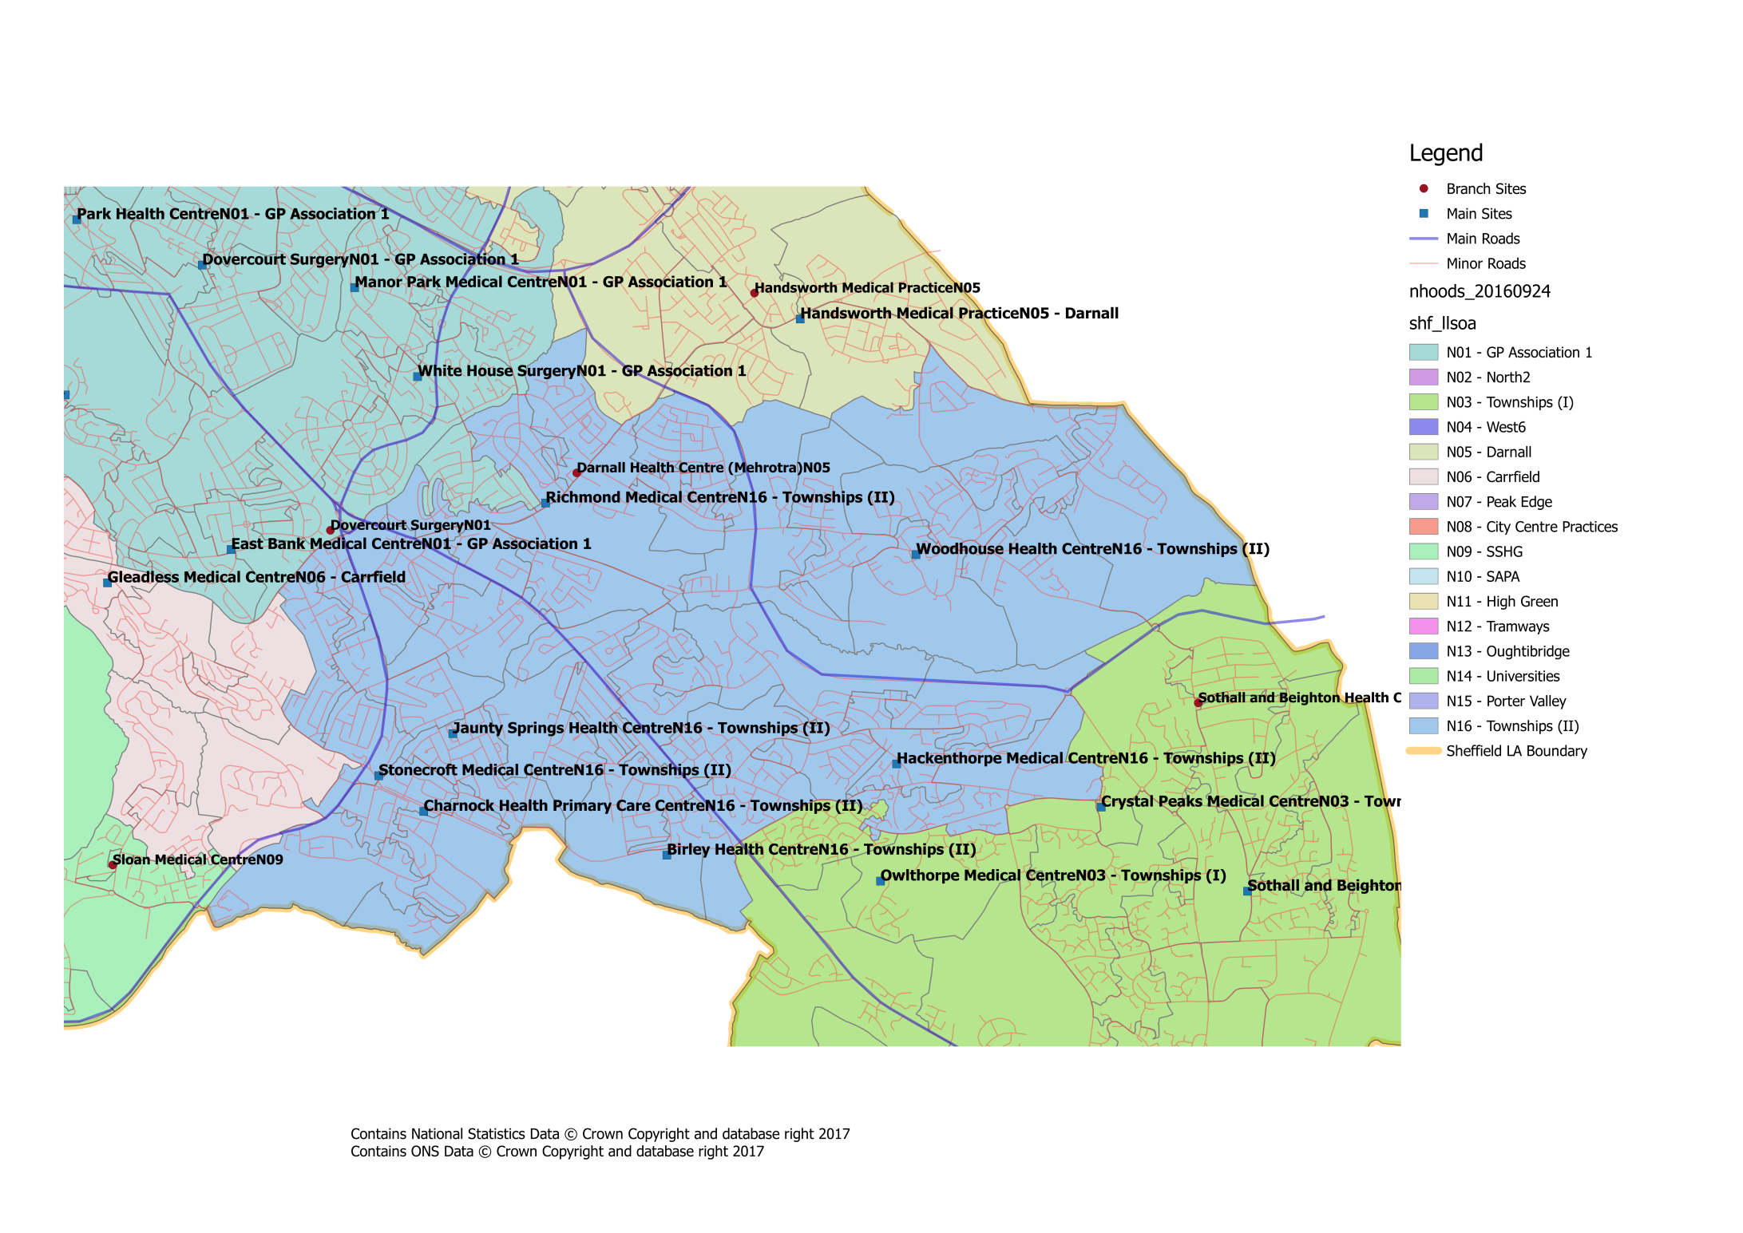


What about patient travel?
To ensure that the proposed changes made access to services equitable across the city, the travel times between practices within a neighbourhood, as well as tocurrent/proposed central services have been investigated. Within our neighbourhood the likely travel times for patients would be:
_{Townships 2 Travel Times}
GP Practice | Postcode | Car time to Birley Health Centre | Bus time to Birley Health Centre | _{Bus/Tram Nos.} | _{Bus/Tram Frequency} | Car time to Charnock Health PC Centre | Bus time to Charnock Health PC Centre | _{Bus/Tram Nos.} | _{Bus/Tram Frequency} | Car time to Jaunty Springs Health Centre | Bus time to Jaunty Springs Health Centre | _{Bus/Tram Nos.} | _{Bus/Tram Frequency} | _{Car time to MIU} | _{Bus Time to MIU} | _{Bus/Tram Nos.} | _{Bus/Tram Frequency} | _{Car time to NGH} | _{Bus Time to NGH} | _{Bus/Tram Nos.} | _{Bus/Tram Frequency} | Car time to Richmond Medical Centre | Bus time to Richmond Medical Centre | _{Bus/Tram Nos.} | _{Bus/Tram Frequency} | Car time to Richmond Road Surgery | Bus time to Richmond Road Surgery | _{Bus/Tram Nos.} | _{Bus/Tram Frequency} | Car time to Stonecroft Medical Centre | Bus time to Stonecroft Medical Centre | _{Bus/Tram Nos.} | _{Bus/Tram Frequency} | _{Car time to WIC} | _{Bus Time to WIC} | _{Bus/Tram Nos.} | _{Bus/Tram Frequency} | Car time to Woodhouse Health Centre | Bus time to Woodhouse Health Centre | _{Bus/Tram Nos.} | _{Bus/Tram Frequency}
Birley Health Centre | S12 3BP |  |  |  |  | ₄ | ₅ | _{Blue} | ₁₀ | ₅ | _{N/A} | _{N/A} | _{N/A} | ₂₆ | ₄₀ | _{Blue} | ₁₀ | ₂₉ | ₄₃ | _{Blue, 75} | _{10,15} | ₇ | ₂₇ | ₈ | ₁₀ | ₇ | ₂₇ | ₈ | ₁₀ | ₄ | _{N/A} | _{N/A} | _{N/A} | ₂₄ | ₂₈ | _{Blue} | ₁₀ | ₁₅ | ₂₆ | _{Blue, 7} | _{10,10}
Charnock Health PC Centre | S12 3GH | ₄ | ₅ | _{Blue} | ₁₀ |  |  |  |  | ₃ | _{N/A} | _{N/A} | _{N/A} | ₂₇ | ₄₀ | _{Blue} | ₁₀ | ₃₀ | ₄₅ | _{Blue,75} | _{10, 15} | ₈ | ₂₃ | ₈ | ₂₀ | ₈ | ₂₃ | ₈ | ₂₀ | ₂ | _{N/A} | _{N/A} | _{N/A} | ₂₄ | ₂₈ | _{Blue} | ₁₀ | ₁₄ | ₂₆ | _{Blue, 7} | _{10,10}
Jaunty Springs HC | S12 3DZ | ₅ | _{N/A} | _{N/A} | _{N/A} | ₃ | _{N/A} | _{N/A} | _{N/A} |  |  |  |  | ₂₈ | ₅₃ | ₅₁ | ₁₀ | ₃₀ | ₄₈ | _{8, 1} | _{20, 10} | ₆ | ₁₆ | ₈ | ₂₀ | ₆ | ₁₆ | ₈ | ₂₀ | ₃ | _{N/A} | _{N/A} | _{N/A} | ₂₆ | ₃₈ | _{Blue} | ₁₀ | ₁₀ | ₂₆ | _{8,7} | _{20,10}
Minor Inuries Unit | S10 2SZ | ₂₆ | ₄₀ | _{Blue} | ₁₀ | ₂₇ | ₄₀ | _{Blue} | ₁₀ | ₂₈ | ₅₃ | ₅₁ | ₁₀ |  |  |  |  | ₁₂ | ₃₁ | _{H1} | ₃₀ | ₂₀ | ₅₀ | ₁₂₀ | ₅ | ₂₀ | ₅₀ | ₁₂₀ | ₅ | ₁₉ | ₄₀ | ₅₁ | ₅ | ₈ | ₁₂ | ₅₂ | ₁₀ | ₂₂ | ₄₆ | _{95,7} | _{10,10}
Northern General Hospital | S5 7AU | ₂₉ | ₄₃ | _{Blue, 75} | _{10,15} | ₃₀ | ₄₅ | _{Blue,75} | _{10, 15} | ₃₀ | ₄₈ | _{8,1} | _{20, 10} | ₁₂ | ₃₁ | _{H1} | ₃₀ |  |  |  |  | ₁₉ | ₄₁ | _{97,25} | _{10,10} | ₁₉ | ₄₁ | _{97,25} | _{10,10} | ₂₀ | ₄₂ | _{20,Blue} | _{20,10} | ₁₁ | ₃₅ | _{1/1A} | ₁₀ | ₂₀ | ₆₀ | _{97,25} | _{10,10}
Richmond Medical Centre | S13 8NA | ₇ | ₂₇ | ₈ | ₁₀ | ₈ | ₂₃ | ₈ | ₂₀ | ₆ | ₁₆ | _{8/8A} | ₁₀ | ₂₀ | ₅₀ | ₁₂₀ | ₅ | ₁₉ | ₄₁ | _{97,25} | _{10,10} |  |  |  |  | ₁ | ₃ | _{N/A} | _{N/A} | ₇ | ₂₄ | _{8A} | ₂₀ | ₂₄ | ₃₆ | ₂₅ | ₁₀ | ₇ | ₁₃ | ₇ | ₁₀
Richmond Road Surgery | S13 8LZ | ₇ | ₂₇ | ₈ | ₁₀ | ₈ | ₂₃ | ₈ | ₂₀ | ₆ | ₁₆ | _{8/8A} | ₁₀ | ₂₀ | ₅₀ | ₁₂₀ | ₅ | ₁₉ | ₄₁ | _{97,25} | _{10,10} | ₁ | ₃ | _{N/A} | _{N/A} |  |  |  |  | ₇ | ₂₄ | _{8A} | ₂₀ | ₂₄ | ₃₆ | ₂₅ | ₁₀ | ₇ | ₁₃ | ₇ | ₁₀
Stonecroft Medical Centre | S12 2LJ | ₄ | _{N/A} | _{N/A} | _{N/A} | ₂ | _{N/A} | _{N/A} | _{N/A} | ₃ | _{N/A} | _{N/A} | _{N/A} | ₁₉ | ₄₀ | ₅₁ | ₅ | ₂₀ | ₄₂ | _{20,Blue} | _{20,10} | ₇ | ₂₄ | _{8A} | ₂₀ | ₇ | ₂₄ | _{8A} | ₂₀ |  |  |  |  | ₂₁ | ₂₈ | _{Blue} | ₁₀ | ₁₀ | ₃₆ | _{Blue, 7} | _{10,10}
Walk In Centre | S1 3PB | ₂₄ | ₂₈ | _{Blue} | ₁₀ | ₂₄ | ₂₈ | _{Blue} | ₁₀ | ₂₆ | ₃₈ | _{Blue} | ₁₀ | ₈ | ₁₂ | ₅₂ | ₁₀ | ₁₁ | ₃₅ | _{1/1A} | ₁₀ | ₂₄ | ₃₆ | ₂₅ | ₁₀ | ₂₄ | ₃₆ | ₂₅ | ₁₀ | ₂₁ | ₂₈ | _{Blue} | ₁₀ |  |  |  |  | ₁₈ | ₅₂ | ₅₂ | ₅
Woodhouse Health Centre | S13 7LY | ₁₅ | ₂₆ | _{Blue, 7} | _{10 ,10} | ₁₄ | ₂₆ | _{Blue, 7} | _{10 ,10} | ₁₀ | ₂₆ | _{8,7} | _{20,10} | ₂₂ | ₄₆ | _{95,7} | _{10,10} | ₂₀ | ₆₀ | _{97,25} | _{10,10} | ₇ | ₁₃ | ₇ | ₁₀ | ₇ | ₁₃ | ₇ | ₁₀ | ₁₀ | ₃₆ | _{Blue, 7} | _{10,10} | ₁₈ | ₅₂ | ₅₂ | ₅

All times are estimates only and may be subject to variation based on a number of factors (e.g. traffic, service disruption) Times/Frequencies highlighted in green indicate there may be quicker/more frequent services but the overall journey was deemed to be worse than alternatives All travel times based on Google Maps estimates during Weekday Daytime Entries with “N/A” indicate that it is significantly quicker to walk, else there is no viable public transport route

