Comments or Feedback - Have your say
We are very keen to hear your comments on this new referral process. If you would like to tell us about your experience, please contact us using the details below.

NHS Sheffield CCG
Engagement team
722 Prince of Wales Road
Sheffield
S9 4EU

Email: sheccg.engagementactivity@nhs.net
Tel: 0114 305 4609

If you need this leaflet in a different language, audio, large print or braille please contact us on sheccg.comms@nhs.net or 0114 305 1212.
www.sheffieldccg.nhs.uk
/SheffieldCCG
@NHSSheffieldCCG
#SheffCASES




Notes about my appointment:

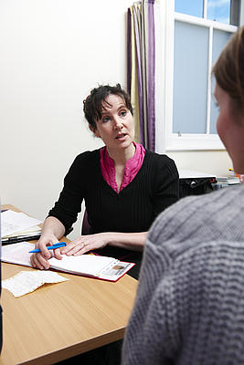




About Your Recent Referral



In the majority of cases the referral will be passed straight to the relevant hospital clinic and you will receive a letter from the CASES team advising you how to choose and book an appointment.
In some cases however the reviewing GP may be able to suggest a more suitable management option other than an outpatient appointment in a hospital. This might include:
- Additional treatment or investigation by your own GP

- A referral to a neighbouring practice for treatment

- A referral into a community service

What is this leaflet for?

Your GP has suggested you may need some specialist advice, investigation or treatment. This leaflet describes what will happen next.

What happens next?

Having made the decision to ask for additional help to manage your problem, your GP will write a letter detailing the nature of the problem and your relevant past medical history.
This will then be sent by electronic referral to the CASES team (Clinical Assessment, Services, Education and Support) at Primary Care Sheffield, which is a not for profit organisation established by Sheffield’s GPs in order to provide city-wide Primary Care Services.
Your referral will be assessed by a GP with experience in the speciality relating to your problem.
The reviewing GP will have support from a consultant specialist from Sheffield Teaching Hospitals.

How will I know what is happening?

In the majority of cases you will receive a letter from the CASES team advising you how to choose and book an appointment.
If further management or investigation from your own GP is recommended then your GP practice will contact you.

Why do we need the CASES service?
The aim of the service is to make sure that patients receive their care in the most appropriate setting from the most appropriate clinician.
This should improve patient experience and help services to operate more efficiently.

For information about CASES, please visit our website www.sheffieldccg.nhs.uk/cases.htm

For more information about Primary Care Sheffield go to www.primarycaresheffield.org.uk



